Cronfa - Swansea University Open Access Repository_______________________________________________________________________
This is an author produced version of a paper published in:
Cronfa URL for this paper:
http://cronfa.swan.ac.uk/Record/cronfa51082
_______________________________________________________________________
(2019).
http://dx.doi.org/10.1016/j.desal.2019.114072
_______________________________________________________________________
This item is brought to you by Swansea University. Any person downloading material is agreeing to abide by the terms of the repository licence. Copies of full text items may be used or reproduced in any format or medium, without prior permission for personal research or study, educational or non-commercial purposes only. The copyright for any work remains with the original author unless otherwise specified. The full-text must not be sold in any format or medium without the formal permission of the copyright holder.
Permission for multiple reproductions should be obtained from the original author.
Authors are personally responsible for adhering to copyright and publisher restrictions when uploading content to the repository.
http://www.swansea.ac.uk/library/researchsupport/ris-support/

Contemporary Antibiofouling Modifications of Reverse Osmosis Desalination Membrane : A Review

P.S. Goh*¹, A.K. Zulhairun¹, A.F. Ismail*¹ and N. Hilal²

﻿¹Advanced Membrane Technology Research Centre, School of Chemical and Energy Engineering, Faculty of Engineering, Universiti Teknologi Malaysia, 81310 Johor, Malaysia

²Centre for Water Advanced Technologies and Environmental Research (CWATER), College ofEngineering, Swansea University, Singleton Park, Swansea SA2 8PP, UK

Corresponding author: peisean@petroleum.utm.my; afauzi@utm.my

Abstract

Biofouling is a persistent and unmet challenge in reverse osmosis (RO) technology. The attachment of microorganisms on the membrane surface has severely deteriorated the performance of RO membranes hence significantly affected the overall productivity and energy consumption of the system. Different strategies have been established to mitigate the thorny issue in order to minimize the adverse impacts of biofouling. This contribution provides a comprehensive review on the contemporary strategies that are focused on RO membrane design and modification to address the biofouling issues. The strategies for the development of anti-biofouling RO membrane in terms of material characteristics and selections as well as the techniques established to render anti-biofouling properties are extensively discussed. The performance of RO membranes through approaches including coating, layer by layer, grafting immobilization and surface patterning are reviewed. Finally, this review is wrapped up with the technological issues and challenges as well as the future perspective of these strategies.

Keywords: biofouling; reverse osmosis; polyamide thin film composite; membrane modification

Outline
- Introduction
- Biofilm and biofouling mechanisms
- Contemporary Strategies for the Development of Anti-biofouling Reverse Osmosis Membrane

3.1 Material Characteristics and Selections
3.2 Approaches and Techniques
- Performance Evaluation of Anti-Biofouling Membranes Modified through Various Approaches
4.1 Coating
4.2 Layer by layer
4.3 Grafting
4.4 Immobilization within polymeric matrix
4.5 Surface patterning
4.6 Summary
- Challenges and Future Prospective
- Conclusion

- Introduction

Reverse osmosis (RO) is one of the most important and widely applied technologies to produce fresh water from seawater and brackish water as well as from industry process water and effluents [1,2]. The widespread utilization of RO technology is majorly due to its operational reliability, high quality product water, modularity and aptness for multiple applications compared to many conventional treatment methods [3]. With the breakthroughs made in the fabrication of asymmetric cellulose acetate membranes and high performance aromatic polyamide thin-film composite (TFC) membrane, RO technology has been prevailingly used for industry operations for more than half a century. In the last two decades, RO process has become increasingly popular in the modern desalination. The technology has overwhelmingly dominated the commercial desalination market due to the high product water standard and reliable performance compared to traditional thermal approaches [4]. With the excellent separation properties demonstrated by polyamide TFC RO membranes, the process can remove almost all types of molecules and ions, hence promoting it for many potable and industrial uses.

Membrane is the heart of RO process and it plays a key role in determining the efficiency of the process. Albeit being regarded as a promising desalination and wastewater treatment alternative, RO technology faces some critical challenges. While striving to reduce the energy consumption to make it competitive with other conventional wastewater treatment technologies, the sustainability and economic aspects of RO technology at commercial scale are often confounded by severe membrane fouling issue [5]. Membrane fouling can be customarily categorized into i) organic fouling, ii) particle/colloidal fouling, iii) scaling/inorganic fouling and iv) biofouling. Fouling caused by these organic, inorganic and microbial components can take place simultaneously and interact with each other [6]. Among these, biofouling has contributed more than 45% out of these membrane fouling phenomena and is known to be cumbersome to deal with [7]. The presence of biomass and organic loads found in seawater as well as permeates from food and dairy industries are the major risks that contribute to biofouling of RO membranes. Due to the rapid self-reproducing nature of microorganisms, biofouling cannot be effectively removed through pretreatment [8]. Inconsiderable number of microbes accumulated on the membrane surface is capable to multiple at the expense of biodegradable matters found in the feed water. The dead bacteria can also act as food source to exacerbate the bacterial colonization and other microorganisms such as algae and fungi [9]. Biofouling is undoubtedly a major issue in RO process because the negative implications of biofouling is tremendous [10]. In some instances, microorganisms of the biofilm might infiltrate the RO membrane and enter the permeate water, leading to the deterioration in the produced water quality [11]. The excretion of acid from biofilm can result in biodegradation of membrane, particularly ﻿on cellulose acetate. The molecular weight and deacetylation process take place simultaneous when the membranes are attacked by the microbial activities [12]. Over the last decade, the rapidly growing works on biofouling indicates that it is one of the core problems that needs to be urgently addressed in this field.

In a broad context, membrane biofouling is an irreversible, non-specific adhesion and accumulation of bioorganic matters onto the membrane surface. Pseudomonas strains have been identified as one of the most common species in biofilms deposited on the surface of RO membranes [13]. The secretion of extracellular polymeric substances (EPS) enhances the attachment of these microbes and promotes the further growth of bacterial colonies [14]. Subsequently, biofilms are formed and stabilized on the membrane surface via electrostatic interactions, hydrogen bonding and other physico-chemical interactions [15,16]. Biofilm increases the hydraulic resistance and deteriorates the flux over time, hence higher operating pressure is required to sustain the productivity [17]. The concentration polarization is aggravated as the biofilms hamper the diffusion of rejected salts thus reduce the salt rejection and flux [18]. Some general tools and indicator such as silt density index (SDI) and modified fouling index (MFI) have been used to simulate membrane fouling process and assess the probability of fouling [19]. However, despite some efforts of visualizing biofilm formation based on techniques such as ﻿heterotrophic plate counts and ﻿epifluorescence microscopy counting, the monitoring of biofouling potential remains a great challenge [20,21]. No model has been established to correlate flux decline with the occurrence of biofouling. The detection of biofouling is laborious as the uneven growth of bacterial colonies, especially in spiral wound membranes, may occur before any appreciable change in the differential pressure is observed.

The challenges in dealing with biofouling are often associated to the time-dependent, slow and complicated mechanisms of biofouling. Physical and chemical approaches have been developed to disinfect microbes, prevent adhesion, propagation and maturation of biofilm, as well as also to eliminate the biofilms and other conditions that foster further microbial growth. Some of these approaches are cleaning in place, pretreatment, spacer design, application of magnetic field and membrane modification [22–26]. The selection of anti-biofouling approach for RO systems is dictated by their effectiveness, operation and maintenance cost as well as the effects on the RO membrane structure and properties [27]. Membrane cleaning can be performed to weaken the biofilm matrix using oxidants and remove biofilm via mechanical forces such as rinsing and ultrasonication [28]. ﻿The spiking of chemical cleaning agents is periodically perform to mitigate biofouling in RO system [29]. Alkaline solutions such as sodium hydroxide control biofouling by hydrolysing and solubilizing the biofilm whereas acidic solutions such as hydrochloric acid attack and disrupt the cell wall structure bacterial cell [30]. Although strong oxidants such as chlorine and chloromines can effectively remove biofilms and recover the membrane performance [31,32], it is rare that the performance of the membrane can be recovered to the pre-cleaned condition. Moreover, harsh cleaning protocol often shortens membrane lifespan and brings the membranes closer to replacement. The amide bonds in the commercially used polyamide RO membranes are highly vulnerable towards chlorine attack and easily cleaved by chlorine treatment [33]. The polyamide layer is known to suffer seriously from decomposition upon chlorine exposure hence the residual chlorine in the feed water must be removed before passing through RO [34]. Although dechlorination has been carried out prior to RO unit in typical industrial RO process to protect the RO membranes from oxidation, those surviving bacteria can still accumulate and regrow on the RO membrane [35].

As biofouling is an inevitable phenomenon, most of the strategies are implemented to keep it under control by preventing bacteria adhesion on membrane surface. Several pre-treatment options can be implemented to reduce biofouling in RO. Physical disinfection techniques such as ozonation, ultraviolet (UV) irradiation and filtration have been commercially used as a pre-treatment unit to slow down the effects of biofouling [32,36]. However, the main pitfall of these techniques is that they only disrupt the structure of bacteria to retard reproduction or merely focus on removing bacteria according to particle size. Disinfection with chlorine derivatives is not an attractive mean to control the biofouling in polyamide membrane in practical [27]. The effectiveness of chlorination for microbial inhibition and membrane biofouling control has been doubted as evidence has shown bacterial growth in the seawater desalination RO pre-treatment stages [37]. The un-interrupted nutrient concentration during free chlorine disinfection process has posed high tendency for biological regrowth. A very recent study pointed out that ﻿the increasing chlorine dosage during disinfection stage has resulted in more severe flux reduction over a long period of operation [38]. This phenomenon is due to the ﻿drastically increased number of chlorine-resistant bacteria ﻿which produce more EPS with higher molecular weight, hence aggravating membrane biofouling.

Double barrier of microfiltration (MF) and ultrafiltration (UF) have been addressed as one of the most effective pre-treatment of RO processes. The pretreatment removes the potential foulants including particles, bacteria and large molecular weight organic maters that responsible for membranes fouling. Several cost evaluations of UF/MF upstream RO demonstrated that UF/MF is not economically feasible on the best water quality to pretreat. Additionally, UF/MF membranes with cut off generally higher than 100,000 kd are incapable to reject the smaller organic matter molecules that cause biofouling on RO membranes. Particularly, the marine bacteria with size approximately 0.1 μm and vary in shape from spherical to filamentous threads can effortlessly permeate through the membrane pores [39]. Conventional approaches such as dissolved air floatation (DAF) has also been used as seawater RO pretreatment option for organic matter removal. DAF can effectively eliminate organic matters by floating the low density organic matter flocs [40]. Compared to membrane technology that is relatively straightforward and easy to be operated, ﻿controlling the operating parameters of DAF in different feedwater environments is difficult as the performance is sensitive towards the condition of the feedwater such as the salt concentrations. The pretreatment conditions like pH and coagulant dose also have significant impacts on the DAF performance.

Compared to other anti-biofouling strategies, membrane modification is demonstrative and straight forward [41]. An RO membrane with tailored properties can be accommodated with new functionalities in its matrix to pave way for enhanced anti-biofouling performance [42,43]. Novel membrane development through incorporation of fillers into the membrane matrix, either in the substrate or selective layer, is widely described in the literature as it is a simple method to modify the RO membranes [44–46]. Physical methods such as coating, plasma and thermal treatment as well as chemical methods like grafting and cross-linking are well-established techniques to decorate membrane surface with desired functionalities [47,48]. However, there is a need of caution in the design of effective RO membranes with exceptional anti-biofouling properties. Experimental studies evidenced that hydrophilic modification or introduction of biocidal on the membrane surface or active layer would be more beneficial to the antifouling efficiency due to the increased contact possibilities with the feed water composition [5]. As such, post modification of membrane to manipulate the surface properties through physical and chemical means is more favourable [49].

A number of comprehensive reviews related to biofouling in membrane system have been published over the last two decades [9,50–54]. Nevertheless, RO anti-biofouling strategies that is focused on membrane modification is still lacking. In this review, the primary emphasis focuses on the contemporary strategies for the development of anti-biofouling RO membranes. With the new innovations and exciting findings made in the past 5 years, this review aims to provide more timely information on RO membrane modifications where the academics and industries can harness to address the issues related to biofouling in RO processes. Firstly, the mechanisms of biofouling and its core problems towards RO operation are briefly presented. The approaches and breakthrough made in the fabrications and modifications of anti-biofouling membranes are then comprehensively scrutinized by addressing the current constraints and achievements. Despite the debates revolve around the practicability and technological readiness of these approaches to be implemented at commercial stage, there are overwhelming evidences from bench-scale studies that bio-fouling can be greatly suppressed through the careful design and modification of RO membranes using advanced and functional materials. In the last section of this review, the challenges and future perspective involved in this field are highlighted.

- Biofilm and Biofouling Mechanism

Despite the complexity, elucidation of the biofilm formation and biofouling mechanism is fundamental and essential to address the problem. A comprehensive understanding of physical and chemical interaction taking place through biofilm analysis is critical to verify the presence of microbial community. The studies on the actions of biofilms during RO system operation is also of high demand because the key to successful implementation of anti-biofouling strategies is largely hinged upon a more complete understanding of the nature of biofilm formation.

Biofouling takes place when live bacteria and microorganisms as well as the nutrients essential for bacterial growth and proliferation concurrently present in the feed water and attached onto the membrane surface [55]. The favourable conditions prompt the growth and multiplication of the attached living cells and eventually contribute to biofilm formation on the RO membrane surface. Specifically, a biofilm is a heterogenous assemblage of adherent microbial cells that is ﻿enclosed in a complex EPS matrix of interlaced biological polymeric materials, particularly ﻿ polysaccharides, proteins and nucleic acids [56]. EPS serves as a host to enhance water retention, provide mechanical stability and scaffolds for biofilm cells attachment and nutrient sorption [57]. The detailed characteristics and the roles of EPS in exacerbating the occurrence of biofouling has been comprehensively discussed in many open literatures [58–60].

In general, biofilm develops through several distinctive stages i.e. i) induction phase, with rapid primary colonization, ii) ﻿logarithmical growth phase where cell grown on the surface contributes to biofilm accumulation and iii) ﻿plateau phase that involves cell multiplication (Figure 1). Biofilm growth has been majorly controlled by ﻿nutrient concentration, cell growth rate, stability of the biofilm and the effective shear forces [61]. The steps involved in biofilm development, particularly the most critical cell attachment step has been comprehensively reviewed by Palmer et al [62]. The living cells forming the biofilm can be distinguished from the freely suspended entities by the formation of an EPS matrix﻿ and the genes that are transcribed. The biofilm-related cells are also characterized with lower growth rate. Often, noncellular components such as mineral, metal ions, silt particles and macromolecules may also be embedded in the biofilm matrix [63]. The microbial colonies enclosed in the EPS matrix are separated from the suspended colonies by the water channels which ﻿allow the diffusion of nutrients and other antimicrobial agents. EPS synthesized by microbial cells may come in different chemical and physical properties such as their amount hydrophobicity/hydrophilicity and solubility but they are generally highly hydrated due to the presence of hydrogen bonding to accommodate large amounts of water into its structure [64].The amount of EPS also tends to increase with the increasing age of the biofilm. Another important EPS property that has remarkable effect on the biofilm is the conformation of the polysaccharides in which the more rigid and less deformable structure often leads to poor solubility.

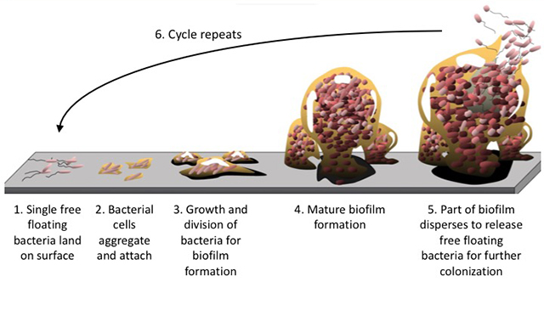

Figure 1: The stages of biofilm development. (Open resource; Credit: Bay Area Lyme Foundation)

Majority of EPS are polyanionic due to the presence of uronic acids or ketal-linked pyruvate and inorganic residues such as phosphate. While some EPS can also be neutrally charged but only a very few EPS are polycationic macromolecules [65]. It has been observed that the bacteria resided in the center of the biofilm can resist foreign substances while still receiving nutrients that transported through the highly permeable channels in the biofilm [66]. While microbial cells deposited on the membrane surface has directly contributed to biofouling, the decline of water flux is mainly due to the formation of gel-like EPS that cross-link with the membrane surface. The rough and viscoelastic properties of EPS reduce the void fraction between cells in the biofilm such that the water permeation through membrane is significantly hampered [61]. ﻿EPS creates diffusion resistance over convectional mass transport and reduce turbulent flow near the membrane surface, consequently leading to increased concentration polarization on the membrane and decreased salt rejection [67].
﻿
﻿
Microbial attachment and the architecture of biofilm that comprised of cell and EPS are complex phenomena governed by multiples conditions. The biofilm structure and heterogeneity are constantly changed by various external and internal processes of the environment [68]. The fate of the bacterial colonies growth in biofilm is determined by biotic and physical variables like growth medium, substratum, chemistry and hydrodynamics of the feed water medium as well as the topology and properties of cell surface. The interactions of microorganisms within the biofilm allows the modification of their habitat where the stability, function and structure of the microbial communities within biofilms can be easily altered [69]. Additionally, external variables involving pretreatment conditions, pH and temperature also influence the development of biofilm. It is known that an increase in flow velocity, water temperature and nutrient concentration often responsible to the increased biofilm thickness [70]. The ideal environment at the solid-liquid interface between membrane surface and feed water medium facilitates the attachment and growth of microorganisms. Regardless of the feed water nature, the RO membrane surface exposed to the aqueous medium can be almost immediately conditioned by organic materials and has direct effects on the microbial growth rate and the extent of attachment [56]. It is generally agreed that the attachment of biofilm will readily take place and exaggerated on rough and hydrophobic membrane surfaces. ﻿ Uneven flow distribution can be easily induced on a membrane surface with irregularities and micrometer-scale roughness, subsequently act as a shielding site to entrap bacteria and protein sources [71]. The larger surface areas resulted from the rough surface peak and valley structures also unfavourably increase the binding site for the adhesion of biofilm [72].

﻿
Inspection and estimation of the severity of membrane biofouling is an important undertaking for RO plant operation. For any RO processes, the variation of the microbiological quality in terms of their microbial features, persistency and growth in the feed water is a serious concern in tackling biofouling issue. The microorganisms can present at the start-up of the RO membrane installation or can be introduced into the process due to the contamination from the environment. It has also been suggested that the multiple stage treatment process in the RO plant can potentially change the chemical and physical qualities of water as well as the community of microorganisms in distinctive ways. As the assessment of membrane antifouling efficiency in actual water treatment plant condition are tedious, time-consuming and impractical for large number of different surfaces, measurement of bacterial deposition kinetic is more favourable and has been commonly reported in open literature. Using well-define ﻿hydrodynamic conditions, the bacterial attachment kinetic simulates the critical initial stage of biofouling and offers a direct measurement of the bacteria adhesion on the membrane the surface. By observing the ﻿anti-biofouling activity of commercial RO membranes grafted with negatively charged, positively charged and zwitterionic hydrophilic polymers ﻿on different bacterial strains, Berstein et al. observed reduced bacterial deposition but enhanced biofilm formation with the RO membrane modified with negatively charged ﻿sulfonatedglycidyl methacrylate [73]. In contrast, ﻿ the positively charged modified RO membrane enhanced initial deposition but has shown significant inhibition of biofilm formation. It can be reasonably concluded that bacteria adhered to the membrane surface has no direct correlation with the biofouling resistance of the surface. One important point to be emphasized is that from the moment biofoulant deposition and biofilm adhesion is initiated, the solute-foulant interaction immediately takes over the effect of solute-membrane interaction, the antifouling strategy is no longer effective in preventing the propagation of fouling. Therefore, both robust polymer structure and effective surface modification strategies are equally important to impart effective anti-biofouling characteristics to the membrane surface.

﻿

- Contemporary Strategies for the Development of Anti-biofouling Reverse Osmosis Membrane

As discussed in the preceding section, the shortcomings of RO pretreatment and membrane cleaning approaches prompt the search for better strategies. The design of low fouling membrane is a feasible way of countering membrane fouling effects. Low fouling membranes, such as Hydranautic LFC® series commercialized by AMI Inc, can be commonly found in the market. Low fouling membranes can generally reduce the fouling rates and maintain membrane efficiency by restoring the nominal performance after cleaning. With the increase in membrane durability and higher tolerance towards harsh chemical cleaning, the emergence of low fouling membranes can significantly lengthen the membrane lifespan and reduce the cost of membrane replacement.

In terms of biofouling, the efforts have been focused on the strategies that capable of inhibiting EPS excretion or biofilm formation. Tailoring the membrane surface characteristics to minimize its tendency for bacterial deposition provides more rooms for biofouling control. Enormous publications have appeared in recent years documenting innovative membrane surface construction for enhanced antifouling properties [74–76]. From economical and technical points of view, surface modification of RO membranes without altering other desired bulk properties through molecular design biofouling mitigation is preferable [77]. In this section, the potential materials and their selection criteria as well as the techniques adopted for anti-biofouling membrane modification are presented.

3.1 Material Characteristics and Selections
Resistance to microorganism adhesion is a vital factor in biofouling suppression as the attachment of microbes is responsible to the subsequent colonization and biofilm formation [78]. Hence, extensive studies have been focused in altering the surface functionalities and properties to make the membrane less receptive to microbe attachment [79]. Improving the surface hydrophilicity has been addressed as a feasible and effective method to mitigate biofouling. The formation of hydration layer on the hydrophilic membrane surface can act as an energetic barrier to prevent the adhesion of organic matters such as proteins, cells and bacteria without imparting significant conformational changes [80]. Other membrane surface chemistry associated criteria include neutral charge and stable surface hydration with the absence of hydrogen bond-donating groups. Poly(ethylene glycol) (PEG), a hydrophilic polymeric material, is of the ﻿most efficient antifouling materials that could fulfil the required antifouling criteria to improve resistance towards nonspecific protein adsorption [81,82]. Zwitterionic polymers such as polysulfobetaine and carboxybetains as well as inorganic nanomaterials such as titanium dioxide and graphene oxide have also been widely studied for the modification of polyamide layer. Compared to PEG, these alternatives are attractive for non-fouling surface engineering due to their higher hydrolytic and oxidative stability.

Zwitterionic materials that are highly resistant to protein adsorption and microbe adhesion have been widely explored in marine anti-biofouling application [83]. In recent years, there has been a rapid rise in the use of zwitterionic polymers to tackle biofouling issues in RO [84–86]. Structurally resemble to the zwitterionic phosphatidylcholine ionic groups that are abundantly found in the cell membrane phospholipid layer, zwitterionic polymers contain both positively and negatively charged species that are uniformly distributed on the same monomer unit, hence result in overall charge neutrality [87]. The antifouling behavior of zwitterionic materials at the membrane-water interface involves two major mechanisms, i.e. formation of hydration shell and steric hindrance effects [80]. Zwitterionic materials are capable to interact with water molecules via electrostatically induced hydration without disrupting the hydrogen bonding between water molecules [88,89]. This can in turn establish strong and stable bonding to give rise in denser and tighter adsorbed water. As the maximum Gibbs free energy of zwitterion-modified surfaces is higher than that of neat surfaces, the adsorption of foulant is a thermodynamically unfavourable hence unlikely to take place. Compared to conventionally used PEG-based polymeric antifouling materials, zwitterionic species can better resist biological macromolecule foulants and are more biocompatible because the hydration shell created through electrostatic interactions demonstrates feature that is more similar to free water [90]. Additionally, the long chain zwitterionic polymers usually form dense and smooth coverage to reduce surface roughness and improve biofouling resistance [91,92]. Currently, zwitterionic polymers have been feasibly introduced to the membrane surfaces via grafting, adhesion and coating approaches.

The most straight forward way to modify RO membrane is through the functionalization of membranes with antimicrobial materials. The ability of antimicrobial nanomaterials to penetrate into biofilms offers an attractive method to inhibit biofilm formation. Metal and metal oxides nanoparticles inherited with antimicrobial properties have attracted great attentions in various applications [93]. A typical example of antimicrobial metallic nanomaterial is unquestionably silver nanoparticles (AgNP) that that has a long history of usage for wound management [94]. AgNP with a wide spectrum antimicrobial properties is a proven antimicrobial agent towards bacteria, fungi and virii [95,96]. ﻿ Many studies have evidenced that, co- or post-deposition of functional groups on the AgNP surface can effectively suppress and control the releasing rate of Ag ions, hence prolonging the effectiveness of AgNPs and extending the antibacterial activities of the membrane [97–99]. The mechanistic studies of the antibacterial activity of AgNP and other similar biocides are essential to foster understanding and further predict their behaviour as antimicrobial agents. In order to initiate the antimicrobial activities, the biocidal nanoparticles need to be in contact with the bacterial cells and cross through the cell membrane [100]. The possible forms of interaction include electrostatic attraction, van der Waals forces, hydrophobic interactions and receptor–ligand bonding [101]. The antimicrobial mechanism of nanoparticles can be generally associated to three established models, namely oxidative stress induction, metal ion release and non-oxidative mechanisms that can take place independently or simultaneously. Scientists have reached a general conclusion on the antimicrobial mechanisms of the most commonly used AgNP. The surface of AgNP are prone to oxidation in the environmental and biological system, causes the release of toxic silver ions. Debates have been made in identifying the roles of AgNPs and silver ions release, as well as the extent of the metal form and ionic form of Ag has contributed on the antibacterial activities. The few possible ﻿antibacterial action and toxicity of AgNP, in which some of them are also associated to the release of Ag are: i) uptake of free silver ions by the bacterial cells followed by disruption of adenosine triphosphate (ATP) formation and DNA replication, ii) generation of reactive oxygen species (ROS) by both AgNP and silver ions, and iii) direct action of AgNP that damages the cell membrane (Figure 2(a)) [102]. While these mechanisms can be generalized for most metal and metal oxide nanoparticles, it is known that the toxicity of metal oxides is commonly attributed to ROS.

TiO₂, ZnO and MgO nanoparticles are commonly studied metal oxides that show antimicrobial activities. These inorganic biocides can be used in their as-synthesized nanoparticle form, or deposited onto supports such as halloysite nanotubes, alumina and zeolite to confer higher stability and reusability, thereby improving the long-term antibacterial efficiency [103–105]. Upon light activation, semiconductor nanoparticles such as TiO₂ generated reactive holes and electrons; superoxide ions as well as hydroxyl, hydrogen peroxide and hydroperoxyl radicals that act as ROS to destroy cell membrane and eventually result in cell material leakage, loss of functional activity such as enzyme inhibition, protein deactivation and electrolyte imbalance, consequently leading to cell death [106]. Strong antibacterial activity has been observed for MgO in the absence of any ROS production and oxidative stress. In this circumstance, the membrane damage was attributed due to the attachment of MgO to the cell membrane, in combination with the effects of pH change and magnesium ion release [107]. Although it has been demonstrated that action of biocidal can inhibit the production of EPSs, interfere with biofilm integrity by interacting with EPSs and ﻿affect the rates of bacterial adhesion and biofilm formation, the ﻿specific mechanisms of these actions are not conclusively understood.

Carbon-based nanomaterials have demonstrated satisfactory bacterial inactivation efficiency. Carbon nanotubes (CNTs), graphene oxide (GO) and carbon dots (C-Dots) have demonstrated strong capacity in disrupting microbial membranes [108–112]. In addition to the production of ROS that causes toxic reactions in bacterial cells, ﻿there are strong evidences that carbon-based nanomaterials can act as effective sorbents of bacteria and viruses [113]. There is growing support for the claim that various forms of nano-structured carbon materials have much improved anti-microbial capacity compared to traditional adsorbents [114]. Graphene and GO nanosheets can adsorb, wrap around and isolate the targeted bacteria such as E. coli, hence preventing the diffusion of nutrient across the cell membrane and thereby retarding growth [115]. The large surface areas increase the contact area and interaction with the microorganisms. However, from a toxicological perspective, the antibacterial efficiency does not purely relying on the surface areas, but also many important factors such as their shapes, size, chemical composition and surface structure [116]. For instance, the carbon-based nanomaterials synthesized in tubular, sheets and spherical geometries, which can be classically represented by CNT, GO and fullerene, respectively may exhibit different degree of deposition and interactions with the microorganisms [117]. Some results also provide confirmatory evidence that, despite sharing the similar tubular geometry, SWNTs demonstrated much higher toxicity to bacteria than MWNTs [118]. Figure 2 (b) shows the possible antimicrobial mechanisms of GO which involve various physical or chemical interactions between GO and the bacterial cell [119]. Hydrazine-reduced GO nanosheets are featured with sharper edges that can damage cell membrane by mediating charge transfer between bacterial cells through physical interaction. However, Gram-negative bacteria has been found to be more resistant to this effect compared to Gram-positive bacteria due to the presence of outer cell membrane [120]. Other possible interactions include oxidative stress, penetration through lipid bilayer and lipid extraction by graphene sheet.

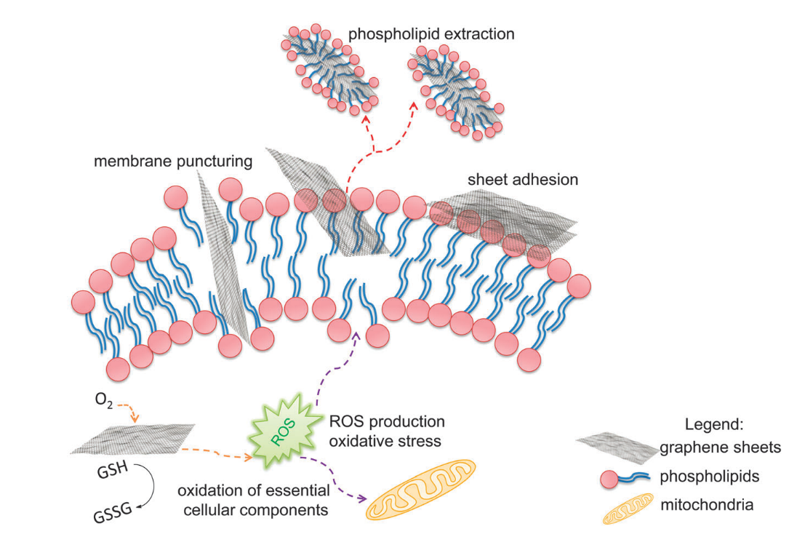
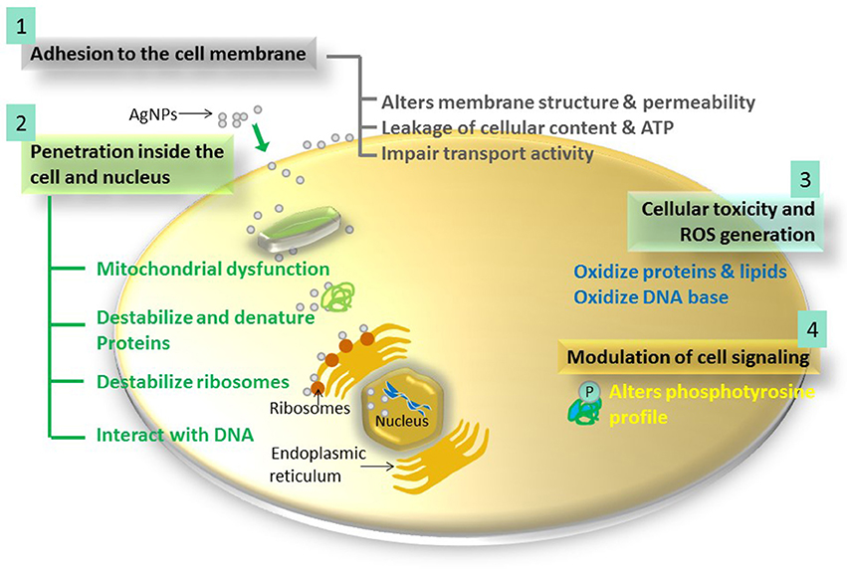
(a)
(a)

﻿

﻿

Figure 2: The possible microbial mechanisms of (a) AgNP [102] and (b) GO [119]. The ﻿antibacterial activities of these biocidal nanomaterials are arisen from different physical or chemical interactions between the nanomaterials and bacterial cell.

An important aspect for the development of antimicrobial nanoparticles is the synergistic effect that formulated when two or more nanomaterials are combined. GO have been extensively explored for its hybridization with other functional nanomaterials. GO provides an anchoring site for nanoparticles such as AgNP and many of these studies have evidenced that the dispersion and antibacterial activity of the nanoparticles could be enhanced when they are anchored on the GO nanosheets. The antimicrobial activity of AgNPs and GO sheets hybrid was found superior towards the growth of E. coli [121–123]. The hybrids of graphene and reduced GO with metal oxides such as Fe₃O₄ and TiO₂ have been explored as an antimicrobial agent for the disinfection and sensitization of water [124]. Metal organic framework (MOF) is another class of compound that demonstrate superior antimicrobial properties against Gram-negative and Gram-positive bacteria [125]. Compared to the abovementioned inorganic microbial compounds, MOF takes advantage from its highly tunable structure with diversified metal center and organic ligand. An attractive feature harnessed from its structure is the release of metal ions from the framework to render antimicrobial activities. Silver and cobalt containing MOFs have been synthesized as a source of antibiocidal ions [126,127]. ﻿Assembly of silver-based MOFs onto surface functionalized TFC membrane has been demonstrated where the Ag-MOF nanoparticles rendered antibacterial activities to the membrane hence resulting almost complete removal of live bacteria [128].

Other than the conventionally used classes of antimicrobial nanomaterials, some other emerging biocidals that can be potentially used for RO membrane modification include biomimetic materials, antibiotic, enzymes and biocidal polymer. Surface modification of biomimetic polydopamine (PDA) evolved from the observation of the universal adhesive properties of mussel fibers. A PDA layer can be deposited through self-assembly and oxidative cross-linking on any substrate that is immersed in the dopamine monomer solution [129]. The resultant PDA layer, which is featured as a durable, hydrophilic and nano-scale coating, is tightly adhered to the surface by strong covalent and hydrogen bonding interactions [130]. The antibiofouling potential of PDA for RO membrane modification has also been explored. The functional groups of dopamine, such as amine and phenol, can react with acyl chloride groups of TMC monomer, hence forming dense thin coating on the polyamide layer [131]. The antibacterial property of PDA is arisen from the protonated amine groups that can cause bacteria lysis upon contact with the cell wall. Karkhanechi et al. observed that ﻿the anti-biofouling properties of the PDA coated RO membrane was ascribed to the increase of anti-adhesion properties meanwhile the membrane surface hydrophilicity and charge density were not significantly affected by the PDA coating [132]. On the other hand, some studies have demonstrated the adverse effects of PDA coating in which self-polymerized PDA tends to block surface pores of membrane [133]. Antimicrobial activity of chitosan against bacteria, fungi and yeasts have been widely demonstrated whether it has been used alone or in the form of biocomposite [134,135]. Chitosan can be feasibly hybridized with other components owing to its large number of surface pendant groups such as -OH and -NH₂ [136]. Recently, carboxylated chitosan is favourably used due to the availability of more hydrophilic hydroxyl and carboxyl groups to facilitate dissolution in neutral medium such as water [137]. Chitosan containing guanidine or bi-guanidine groups have also gained attentions for antimicrobial application [138].

Membrane-disrupting antibiotics that are active against Gram-positive and Gram-negative bacteria can also be attractive candidates for RO membrane modification [139]. Antibiotics with potent and effective bactericidal characteristics such as aminoglycoside and tetracyclines can lead to cell death by either disrupting the cell outer membranes or inhibiting protein synthesis process [140,141]. Enzymes such as protease and lysozyme are effective to degrade and remove biofilms. ﻿The lysozyme-immobilized membrane has demonstrated long lasting antibacterial activity against the Gram positive bacteria ﻿by lysing the adsorbed bacteria and retarded their growth [20]. Amphipathic antimicrobial peptide with various chain lengths has also been attempted to suppress biofilm formation [142]. However, the stumbling blocks for the feasibility of enzymes and peptide for large scale membrane modification are the material cost as well as the possible degradation or inactivation of the substances during the fabrication or filtration processes. Polymer containing quaternary ammonium (N⁺) groups that are covalently grafted onto or electrostatically interacted with the membrane surface can disrupt the growth of bacteria based on the direct contact process with the bacteria [143,144]. The guanidinylated polymers are cationic antimicrobial polymers that show toxicity through direct contact with the anionic cell surface of bacteria containing phospholipids and proteins, hence result in bacterial death. Guanidine containing biocidal polymer can be readily protonated in a wider pH range and able to establish stronger interaction with the bacterial cell membrane surface through bidentate hydrogen-bonded ion pairing [145]. N-halamine with high stability and effective antimicrobial properties toward a wide range of microorganisms have also been studied [146]. An N-halamine compound contains one or more nitrogen−halogen covalent bonds which confer the polymer biocidal properties based of the +1 oxidation state of Cl or Br in the chemical bond. These oxidizing halogens can act in two actions, i.e. i) through transfer of biocidal element to the bacterial cell and ii) through dissociation to free halogen in aqueous media. By introducing the N-H containing precursor of N-halamine on the polyamide layer, ﻿ the reversible transition between the N–H and N-can regenerate the anti-biofouling properties of the membrane within the presence of chlorine source. In a typical RO system, the presence of free chlorine in pretreatment can advantageously enable this transition to take place [147]. Some findings have pointed out that the antimicrobial activities of these antimicrobial polymers were significantly decreased after being crosslinked or insolubilized [148].

The use of quorum sensing (QS) inhibitors for biofouling control in wastewater treatment is prevailing in the past few years [149–151]. ﻿Biofilm formation is controlled by QS systems where signalling molecules, also known as auto-inducer, are secreted by bacteria to ﻿govern communication with the neighbouring bacteria. ﻿The function of QS inhibitor is therefore to interfere QS pathways through signalling molecule degradation, signal production blockage or competition with signalling molecule to prevent their binding to the receptor protein [152]. Biofouling control based on QS inhibitor is highly effective and it prevents bacterial resistance. The deposition of a beneficial biofilm consisting QS signal-negative strain on the surface of commercial membrane was proven effective to prevent the secretion of nitric oxide which act as biofilm dispersal agent during the dispersal stage of biofilm formation [153]. Based on the bacteria group isolated from RO membranes installed at Carlsbad Desalination pilot plant and Perth Desalination plant, Katebian et al. evidenced that the use of commercially available and non-toxic vanillin and cinnamaldehyde at 1200 mg/L could effectively act as QS inhibiting compounds to mitigate biofilm formation by more than 79% and 70%, respectively [154]. Recently, Li et al. demonstrated that the addition of methyl anthranilate in feed water of RO process could effectively inhibit Pseudomonas quinolone signal and reduce the lever of EPS, hence mitigating biofilm growth and reduce the cell number in the biofilm [155].

﻿Table 1 summarizes the antimicrobial behavior, advantages and limitations of various antimicrobial materials. These materials exhibit multiple anti-biofouling mechanisms based on the nature and physical characteristics of the materials. While these materials generally demonstrating attractive anti-biofouling features, the selection of an appropriate material for the modification of RO membranes largely depending on several factors such as cost, technological feasibility in terms of mass production and reproducibility. For emerging material like QS inhibitor, it remains a wide knowledge gap in their interactions and mechanisms towards bacteria cells after being incorporated into membrane structure.

  - Approaches and Techniques

Physical adsorption of materials such as surfactants and dendrimers can significantly improve the hydrophilicity and membrane antifouling properties. However, the weak boundary layer introduced through non-covalent attachment may result in the coated material leaching particularly during long-term operation. On the other hand, chemical modification through establishment of stable covalent bonding can provide more stable surface modification. Yet, with the use of complex, non-versatile and non-scalable chemistry that normally only specific to particular membrane surface material, chemical modification is not a practical method for commercial membrane manufacturing [77]. Different physical and chemical approaches including direct incorporation into polymer matrix, coating, grafting, polymerization, self-assembly, chemical coupling and irradiation have been established to introduce new functionalities into RO membrane in order to enhance their microbial resistance. Despite the preparation convenience of embedding the filler or surface modifier into the polymer matrix during membrane fabrication, depositing an anti-biofouling coating is a more versatile strategy. Coating is a conventional surface modifications approach that can well preserve the optimized bulk property of the substrates. One significant advantage of RO membrane surface coating in relative to nanofiller incorporation is that the former method is normally performed on the surface of optimized commercial RO membrane, hence impart minimum impact on the integrity of the membrane selective layer. This aspect is of major concern because the formation of defects, even at the scale of pinholes can increase the surface roughness and accelerate the attachment of bacteria. Furthermore, ﻿it can be integrated as a post-fabrication step and optimized independently during membrane manufacturing without interfering the established TFC membrane manufacturing process. However, some debates have called into question on the grounds that the additional coating layer may potentially induce an additional hydraulic resistant layer on the membrane surface, which responsible for the water flux decline.

Layer by layer (LbL) is drawing growing attention in performing surface coating due to its versatility compared to conventionally used coating technique to control the nano-scale ﻿formation of thin film on the membrane support [156,157]. First proposed by Iler, the concept of LbL has been later widely applied as a highly versatile technique to fabricate ordered nanostructured thin film that has been extensively used in areas spanning from polymer science to biological, photocatalysis and electronics devices [158]. As shown in Figure 3 (a), LbL assembly involves the deposition and interaction of cationic and anionic nanostructured polyelectrolyte layers on the support [159]. Owing to its simplicity, robustness and high reproducibility, it has been recognized as an alternative for modifying membrane surfaces. LbL offers a high degree of freedom to fabricate and optimize the nanostructured thin film as it allows the layer properties to be optimized independently. The surface charge moieties can be tailored by selecting the outermost layer with the purpose of meeting the criteria required by the application. The LbL coating of oppositely charged polyelectrolytes on a membrane substrate can be performed using methods such as dip-coating, spray coating and spin-coating. Among these, dip-coating is the most commonly employed method as it requires only short processing time and consumes low amount of liquids for large surface area coating [160]. Ma et al. demonstrated spray- and spin-assisted LbL (SSLbL) assembly for ﻿controllable and uniform bilayer of polyethyleneimine-coated copper NPs ﻿as a polycation and poly(acrylic) acid as polyanion. The time taken for SSLbL ﻿(32s/ bilayer deposition) was remarkably faster than the commonly used dipping ﻿(60s/ bilayer deposition) [161]. Membrane surface modified LbL assembled layers can be further enhanced with surface multi-functionalization based on the existing binding sites for hierarchical interactions with functional nanomaterials. Unlike the extra resistance introduced by the conventionally coated functional layer, the extra layers introduced through LbL assembly are architecture in molecular level, hence poses minimum impact on the hydraulic resistance. The flux decline issue can also be alleviated by controlling the bilayer number and adjusting the chemical compositions of the polyelectrolytes. ﻿ In fact, other than the membrane permeation capability, the number of polyelectrolyte multilayers has marked influences on film thickness, surface charge, hydrophilicity and roughness [51].

Surface grafting, which can be further divided into ‘grafting to’ and ‘grafting from’ is performed by incorporating the functional polymer chains such as anti-biofouling zwitterionic polymer and biocidal polymer onto the membrane surface through stable chemical bonding [162,163]. In the ‘grafting to’ approach, the molecules with tailored functionalities is pre-fabricated prior to the attachment on the membrane substrate surface meanwhile for ‘grafting from’ method, the functional groups are directly polymerized onto the membrane surface via chain propagation reaction as shown in Figure 3 (b) [164]. This approach allows the stable and durable architecture of complex molecule. It also enables accurately controllable grafted surface thickness and density, molecular weight dispersity and chain length [165]. On the other hand, due to the better practicability and higher flexibility in the design of polymers or molecules that cannot be obtained from direct polymerization, ‘grafting to’ approach is also attracting considerable attentions in introducing functional polymers groups onto the polyamide surface [162]. In some practices, oxygen plasma treatment was performed to create dangling bond to create strong interface between the depositing film and the RO membrane surface. Atom transfer radical polymerization (ATRP) is a common ‘grafting from’ method to incorporate zwitterionic polymers onto membrane surface [166]. In typical surface initiated-ATRP, an organohalide initiator such as 2-bromoisobutyryl bromide (BIBB) is immobilized onto the membrane surface to initiate the polymerization [167]. As the as-fabricated polyamide surface is generally characterized by small number of terminal group and less reactive with the initiator, functional groups such as 3-aminopropyltrimethoxysilane (APTES) and diethanolamine (DEA) are used to enhance the surface reactivity and facilitate the immobilization of initiator [168]. However, this modification can be omitted for commercial membranes such as Filmtec SW30HR that has polyamide layer readily coated with hydrophilic hydroxyl group layer.

﻿Compared to ex-situ modification methods, in-situ method through immobilization of biocidal nanomaterials within the polyamide layer of TFC membrane can avoid the issues related to layer detachment or loss of antimicrobial functionalities during chemical washing [169]. Two main processes have been implemented i.e. i) incorporation of as-synthesized and ii) in-situ formation of biocidal nanomaterials during the polymeric membrane fabrication. One of the most straightforward way of incorporating as-synthesized nanomaterials is shown in Figure 3 (c), where the biocidal materials are blended into organic phase or/and aqueous phase of the selective layer monomers such as meta-phenylene diamine (MPD) and trimesoyl chloride (TMC) used for polyamide layer formation via interfacial polymerization process [170]. In-situ formation of biocidal nanomaterials alongside with membrane formation can be performed through sol gel process and in situ reduction [171]. The former involves the controlled hydrolysis and polycondensation reaction of precursor followed by polymer solidification meanwhile the later involves the use of reducing agents to reduce the inorganic precursor. ﻿NaBH₄ is a commonly used reducing agent as the highly reactive NaBH₄ can rapidly reduce metal and does not react with the constituents of the polymeric substrate of polyamide selective layer [172]. In both cases, the inorganic precursor or reducing agents can be added into the casting solution or in the coagulation bath. The main challenges to be tackled in these modification approaches are to suppress the agglomeration of nanoparticles, improve the compatibility between nanoparticles and polymers as well as to prevent nanoparticles leaching from the polymeric matrix.

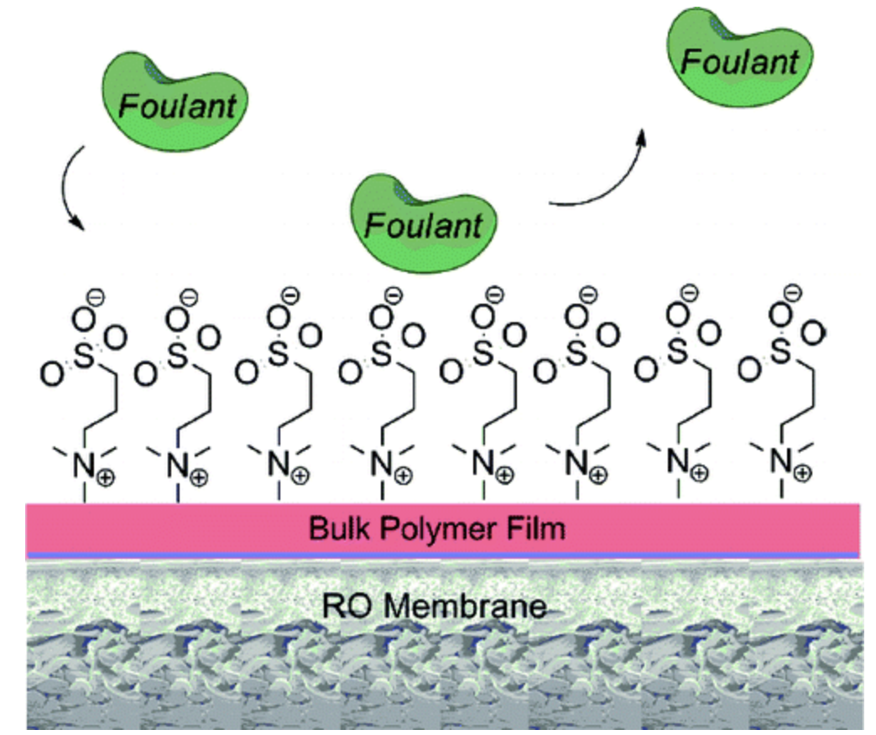
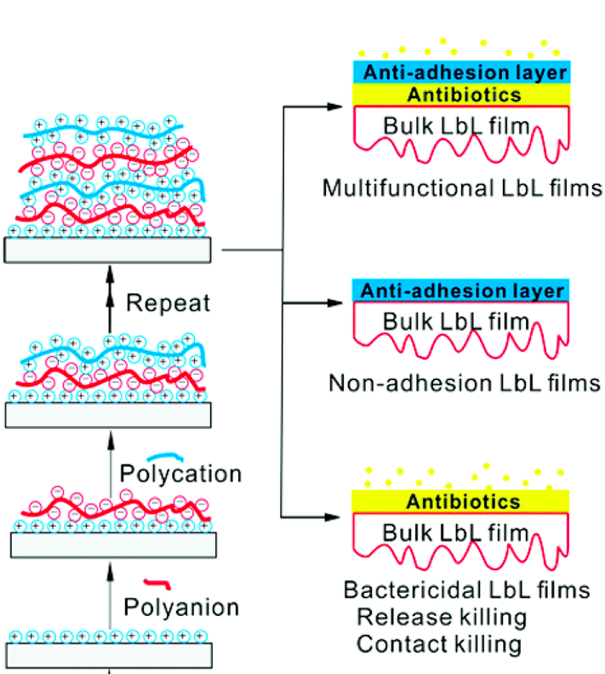
(a)
(b)
(c)

Figure 3: Schematic illustration of the fabrication techniques of antibiofouling RO membranes based on (a) LbL of polycation and polyanion with non-adhesion and bacteriacidal properties [159], (b) grafting of zwitterionic polymers onto the membrane substrate [164] and (c) incorporation of biocidal nanomaterials within the polyamide layer to form TFN membrane during interfacial polymerization process [170].
Membrane surface patterning has been explored to create well-defined patterns that can in turn modify the hydrodynamic, roughness, hydrophobicity and charges of the membrane surface [173,174]. These surface characteristics have been closely associated to the membrane fouling propensity. Currently, the established surface-patterning methods are mainly based on two major categories i.e. template-based micro-molding and direct printing [79]. In the former method, the periodic surface patterns are first obtained using a master mould through lithographic processing before replicated onto the membranes meanwhile the latter involves the use of ink-jet printing or three-dimensional microstereolithography printing. A growing body of literature has also been dedicated to examine the use of electro-responsive membrane to mitigate biofouling [175]. The application of electrical potential over conductive polymer coating such as polyaniline (PANI) and polypyrrole (PPy) induced local unstable and unfavourable conditions that could reduce microbial cell viability hence prevent the bacterial adhesion [176]. Although smooth surface is generally favourable to prevent bacteria adhesion, surface patterns can induce local turbulence and higher shear stress due to the alteration in local hydrodynamics [79]. As a result, bacterial adhesion and biofilm formation can be suppressed.

- Performance Evaluation of Anti-Biofouling Membranes Modified through Various Approaches

4.1 Coating

﻿A thin film of AgNP was coated on polyamide active layer through in situ reduction of ﻿AgNO₃ solution using NaBH₄ [177]. During the reduction process, the negatively charged carboxylic groups exist on the polyamide surface form electrostatic pairs with silver ions thus facilitated the nucleation of AgNP on the TFC RO membrane surface. Owing to the specificity of NaBH_{4,} the surface properties of the polyamide layer were not significantly affected in terms of the surface roughness, hydrophilicity, charges and salt rejection. A reduction up to 17% in water permeability was observed, mainly due to the decrease in membrane surface area for water passage. The dissolution and release of silver ion rendered strong antibacterial activity, leading to reduction of the number of ﻿E. coli, P. aeruginosa, and S. aureus bacteria colonies by 78 %, 91 %, and 96 %, respectively, compared to the unmodified membrane. As a result, the biovolume reduced by 73%, 38%, and 25% for live cell, dead cell and EPS respectively. When the same approach was also performed to introduce a thin layer of CuNP on TFC RO membrane [178], similar antimicrobial improvement was achieved where ﻿the number of live E. coli attached to the modified surface was reduced by 89.6 % compared to the pristine membrane. It was also observed the stronger antibacterial activity of Cu-NPs compared to Cu ions due to the penetration and dissolution of CuNPs into toxic ions within the bacteria cell.

﻿

Armendáriz-Ontiveros et al. ﻿evaluated the antibiofouling resistance of polyamide commercial RO membranes coated with iron nanoparticles (FeNP) and GO [179]. ﻿An ex-situ coating method was applied to introduce the GO-FeNP atop of the microporous substrate as shown in Figure 4(a). This approach can advantageously control the desired size of GO sheets and prevent their oxidation, The unoxidized -OH groups along the GO planar facilitated the anchoring of FeNP. The uniform dispersion of FeNP reduced the surface roughness GO–FeNP coated membrane hence lowering the tendency of microorganisms adhesion capacity onto the membrane surface. The antibiofouling properties of the RO membranes were evaluated using bacteria from real seawater sample collected from the Sea of Cortez. The comparison in Figure 4(b) suggested that the biofilm layers formed on the coated membranes were thinner than that of uncoated membrane, suggesting greater repulsion against bacteria deposition by the coated membrane. ﻿ The coverage of membrane surface with GO-FeNPs that could generate reactive oxygen species and cause cell wrapping has reduced the amount of live cells by 44% in FeNPs and by 68% in GO–FeNPs with respect to the unmodified membrane (Figure 4(c)). Despite the improved anti-biofouling properties, a critical issue to be looked into is the significant decline in water flux by 75% compared to unmodified membrane, due to the decrease in membrane surface hydrophilicity and presence of coating layer that added resistance for the transport of water through membrane.

﻿

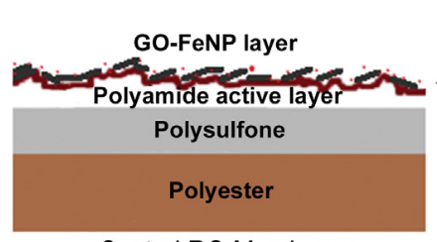
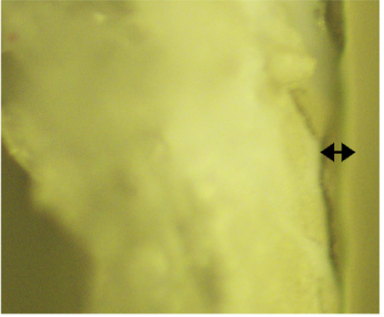
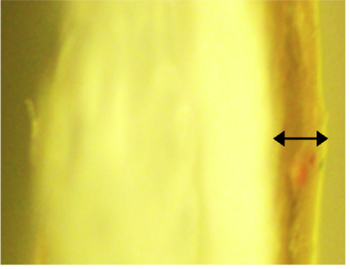
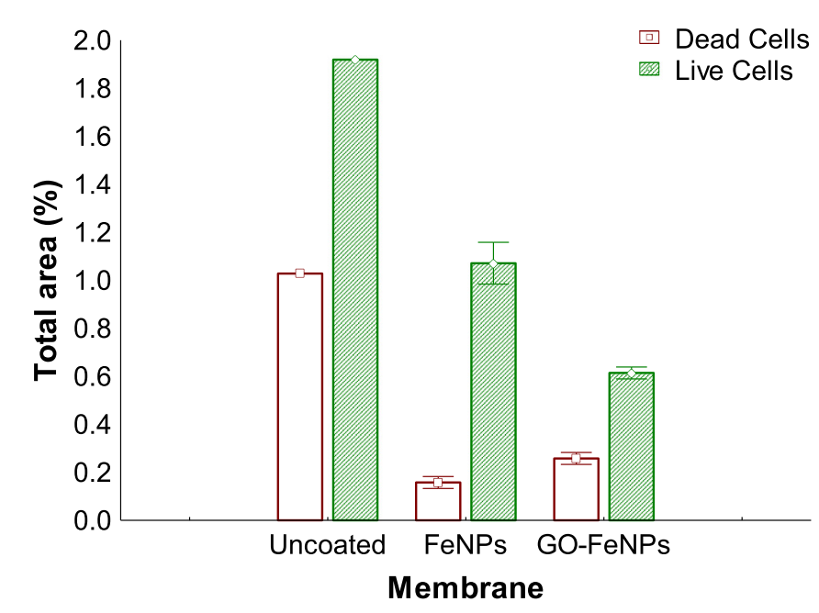
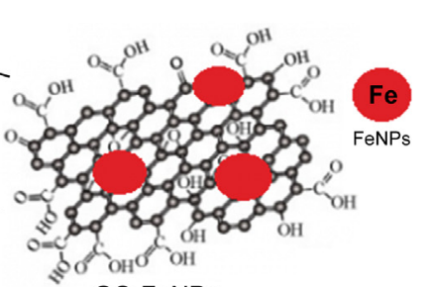
(a)
(b)
(c)
(d)

Figure 4: (a) The schematic illustration of Dow Filmtech RO membrane dip-coated with GO-FeNP layer, (b) The biofilm of uncoated membrane is much thicker compared to that of GO-FeNP membranes and (c) The number of dead cells and live cells attached on the membranes was significantly reduced with the presence of coating layer with anti-biofouling properties [179].

Katebian et al. ﻿introduced two types of QS inhibitors, namely vanillin and cinnamaldehyde ﻿through physical adsorption ﻿of the QSI solution that was performed in a crossflow cell [180]. The RO TFC membrane modified with QS inhibitor experienced slightly lower pure water permeate flux and ﻿initial permeate flux due to the low water solubility of the QS inhibitors. ﻿In the antibiofouling study using mixture of Alteromonas sp. and Shewanella sp. isolated from the fouled RO membranes installed at Carlsbad desalination pilot plant, ﻿the live cell biomass was reduced by 58.39% and thickness by 97.83% as compared to pristine membrane. The modified membrane exhibited a significantly slow decline of permeate flux compared to the unmodified membranes due to the ﻿ability of the QS inhibitor to disrupt bacterial communication and reduce biofilm formation. Over the filtration period of the QS inhibitor layer was found reducing, probably due to the detachment of the layer from the membrane surface or the binding of QS inhibitor with bacteria. Very recently, Hirsch et al. deposited AgNPs on polyamide surface through plasma enhanced magnetron sputtering to reduce the chemical used for the reduction of AgNP [181]. The bacterial efficiency was maintained around 64% even after the membrane was contacted with ﻿P. fluorescen in steady-state cultivation for 14 days.

4.2 Layer by Layer Assembly

Wang et al. assembled several bilayers of ﻿ ﻿poly acrylic acid/﻿tobramycin (PAA/TOB) by alternating the deposition of TOB and PAA on the surface of commercial membrane where ﻿N-hydroxysuccinimide (NHS) and 1-ethyl-3-[3-dimethylaminopropyl]carbodiimide hydrochloride (EDC) crosslinkers were used to stabilize the LbL layer by converting the electrostic force to covalent bonds, as shown in Figure 5(a) [182]. PAA/TOB assembled RO membranes were endowed with amphoteric surface due to the presence of surface carboxylic acid and amine groups. Continuous flux drop was observed when the number of PAA/TOB bilayer was increased more than three due to the domination of water passage resistance. The optimum salt rejection of 99.5% and water flux of 47.7 Lm⁻²h⁻¹ was achieved with 3-bilayer PAA/ TOB-modified membranes. The membrane has also demonstrated FRR of 40% higher than that of unmodified membrane, which was 87.5% for BSA (Figure 5(b)). TOB, a form of aminoglycoside antibiotic, act as the bacteriacidal ﻿for E. coli ad B. subtilis in the bilayer. In the plate count assay, the 3-bilayer PAA/ TOB-modified membranes exhibited bacteria motility rate of 99.0% as shown in Figure 5 (c), which was more effective than commonly reported AgNP modified RO membrane.

Kim et al. grafted bilayer of chlorhexidine, a non-oxidising biocidal, onto the surface of polyamide layer using glutaraldehyde as crosslinker to establish a strong chemical binding to allow LbL deposition of chlorhexidine at molecular level [183]. The stable covalent amide bonds between chlorhexidine and the polyamide layer allowed the modified membrane to stably sustain chemical exposure and chemical cleaning. In the static antimicrobial tests using drip-flow cells, the modified membranes exhibited high anti-bacterial potential due to the dense and complete coverage of the bilayer chlorhexidine. However, a noticeable decrease in water flux of about 20% was observed due to the increased hydrophobic characteristic of the modified surface which originated from the ﻿hexamethylene chains in chlorhexidine structure. The bilayer deposition of chlorhexidine has also considerably contributed to extra resistance for water passage across the membrane. Similar observation was made in the study where TiO₂ nanoparticles and GO nanosheets were LbL assembled onto polyamide membrane surfaces through hydrogen bonding ﻿between carbonyl group and surface hydroxyl group [184]. The water flux increased with the increasing bilayer number due to the ﻿improved surface hydrophilicity of TiO₂/GO and the nanochannels provided by GO layers to facilitate water transport. However, the water flux decreased dramatically from ﻿23.6 Lm⁻²h⁻¹ for 6 bilayer coating to 14.0 Lm⁻²h⁻¹ for 10 bilayer coating, which implied that the resistance introduced by the bilayer coating has more dominant effects when the bilayer number was increased beyond 6. When the antibiofouling properties were evaluated in filtration testing after the membranes were immersed in UV-irradiated E. coli suspension for up to 3 days, the water flux of TiO₂/GO modified membrane and unmodified membrane was declined by 24% and 63%, respectively.

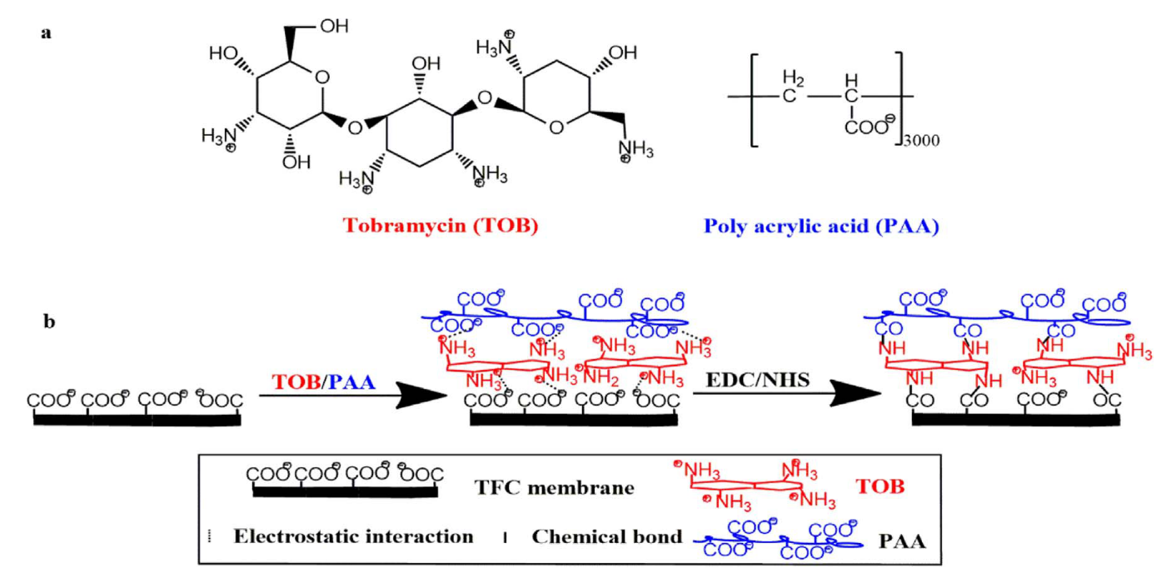

(a)
(c)
(b)
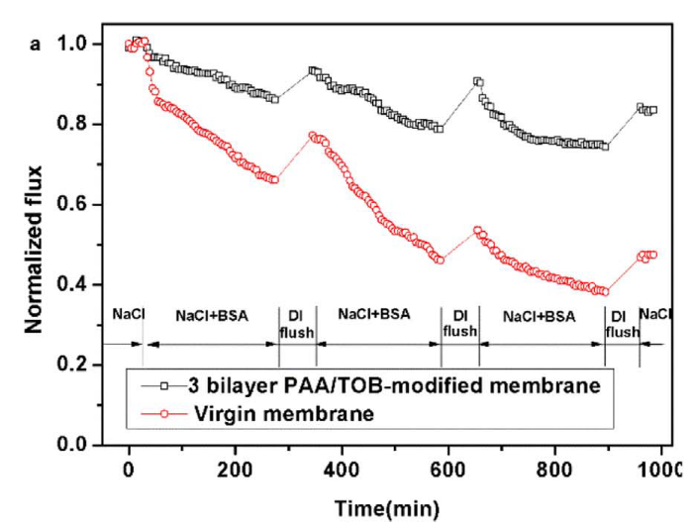
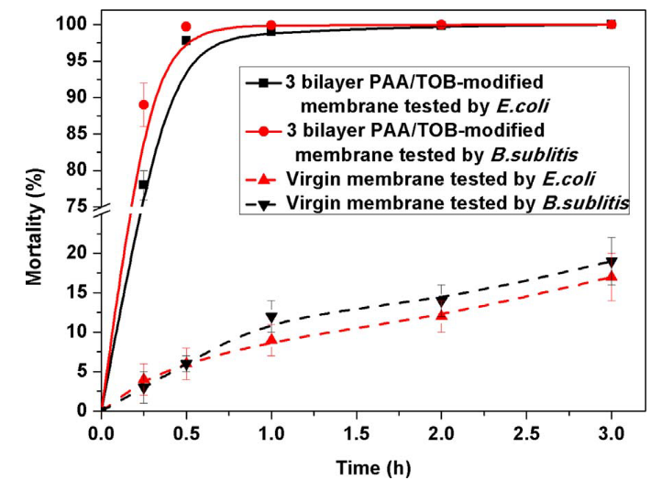

Figure 5: (a) Schematic diagram of the LbL assembly of TOB/PAA bilayer stabilized by crosslinkers, (b) ﻿ 3 bilayer PAA/TOB-modified membrane exhibited FRR of 87.5% in the presence of BSA, which was 40% better than unmodified RO membrane, (c) ﻿The mortality rate of 99% was achieved upon the contact of E. coli and B. subtilis with 3 bilayer PAA/ TOB-modified membrane and unmodified RO membrane [182].

4.3 Grafting

Ginic-Markovic et al. applied the industrially favorable ATRP method to create a durable poly﻿sulfobetaine coating on commercial RO membranes [185].The polysulfobetaine coating layer with thickness less than 40 nm has increased the hydrophilicity and reduced the membrane surface roughness. Approximately 80% reduction in microbial abundance was achieved in both 3-month static aquarium test and hydrodynamic test conducted with ﻿sodium alginate in cross-flow filtration mode. Regardless of the type of commercial RO membrane, the polysulfobetaine modified membrane exhibited flux and rejection that were comparable to the neat membranes. Zwitterionic ﻿copolymer films of poly(4-vinylpyridine-co-ethylene glycol diacrylate) (p(4-VP-co-EGDA)) coatings has also been performed on the polyamide surface of TFC-HR commercial RO membrane via iCVD technique [84]. In the static antibacterial test where the membrane coupons were exposed to bacterial suspensions of P. aeruginosa and B. licheniformis for 2 hours, ﻿the zwitterion grafted membrane surface demonstrated reduced adhesion of bacteria by 98% compared to the neat RO membranes. ﻿Molecular force mapping has further verified that the low magnitude of adhesion force between the biofoulants and the zwitterion modified membranes due to ﻿the high resistance of ﻿zwitterionic moieties-associated hydration layer to the adsorption of biopolymers.

﻿Marré Tirado et al. assessed the biofouling resistance of ﻿2-[(methacryloyloxy)ethyl] dimethyl-(3-sulfopropyl) ammonium hydroxide (SPE) grafted commercial RO membranes [186]. The introduction of SPE layer through UV-assisted radical grafting has favourably changed the surface charged and hydrophilicity of the membrane surface to reduce the tendency of bacteria adhesion. The short term study indicated that a significant improvement in the biofouling resistance was achieved by the SPE grafted RO membranes in which the permeation flux remained stable compared to the neat counterpart. The less severe biofouling was due to the weak adhesion of EPS on the PSPE-grafted RO membrane surface. However, with prolonged operation and thickening of biofilm, similar trend of flux decline was observed in both modified and neat membranes, suggesting that the anti-biofouling zwitterionic coatings could not sustain the antimicrobial performance in long run. The possible reason was the acclimatization capabilities of the antimicrobial community which has overwhelmed the alteration in surface properties through the zwitterionic modification. ﻿The similarity in the adhesive properties of the EPS extracted from the biofilms developed on PSPE-grafted and neat RO membranes after long operation suggested that other factors such as differences in EPS amount and surface coverage by PSPE may be dominant factors in governing the biofouling behavior.

Hirsch et al. compared the anti-biofouling efficiency of 3 commonly used zwitterionic polymers, namely hydroxyethyl methacrylate (HEMA), 2-methacryloyloxyethyl phosphorylcholine (MPC) and [2-(methacryloyloxy)ethyl]-dimethyl-(3-sulfopropyl) ammonium hydroxide (SBMA) [166]. The surface of polyamide layer was activated by plasma and subsequently functionalized with brominated alkyl groups prior to the surface grafting of the oligomer layers via surface initiated-ATRP (SI-ATRP). The microscopic observation of the percentage of biofilm coverage after steady state and batch cultivation, the formation of biofilms of P. fluorescens on the zwitterion coated TFC has been drastically reduced compared to the high concentration of bacteria colonies deposited on the neat TFC. The increase of water flux by 13-33% was mainly attributed to the enhanced surface hydrophilicity while the salt rejection was maintained. Yang et al. applied the same technique to graft poly[(2-methacryloy- loxy)ethyl]dimethyl[3-sulfopropyl]ammonium hydroxide (pMEDSAH) on the APTES-functionalized RO membrane surface [91]. They found that the chain length of the grafted pMEDSAH has significant influence on the biofouling behavior where longer chain of pMEDSAH was capable to reduce tendency of bacterial adhesion and biofilm growth. This improvement was attributed to the increased hydrophilicty and smooth surface that prevented bacteria adhesion. However, the formation of a thick layer of pMEDSAH on the membrane surface was found detrimental to water permeation.

﻿Single-step gamma irradiation using cobalt-60 source was performed to graft N-isopropyl acrylamide and ZnO nanoparticles onto polyamide TFC RO membrane [187]. The enhancement of surface hydrophilicity and surface negative charge that accompanied with increasing surface roughness was due to the deposition of hydrophilic surface modifier. The flux declines of 43% for the pristine membrane and 10.3% for the modified RO membrane were observed, suggesting that the modification has improved ﻿the overall fouling resistance. A novel polymerization-nanoparticle loading method has been introduced by Khajouei et al. to graft PANI/CuNP on polyamide layer of RO TFC membrane [188]. The in situ polymerization of PANI initiated by aniline oligomers provided sufficient surface functional groups for the deposition of CuNP. ﻿Coating of PANI formed a dense and small nodule-size structure that also led to the smoother polyamide active layer. The interaction of PANI with the entrapped CuNP prevent the release of nanoparticles from the membrane. PANI/CuNP ﻿rendered surface hydrophilicity and reduce the surface roughness of the membrane, which in turn resulted in the increase in water flux from ﻿17.24 Kg m⁻²h⁻¹ for pristine membrane to 13.44 Kg m⁻²h⁻¹ for the modified membrane. Upon immersion of the neat and modified membrane into E. coli suspension for 8 h, the inhibition zone around the PANI/Cu modified membrane was larger compared to that of pristine membrane. A flux recovery of 89% and stable performance up to 6 days were also reported in this study. ﻿ Similar concept has also been reported by Ma et al. who performed covalent grafting of cysteamine (Cys) thiol-derivative on the surface of RO membrane to act as bridging agents between CuNP biocide and the membrane surface [189]. The Cys surface with high metal affinity ﻿provided more reactive sites for the in-situ formation of CuNP thus led to the formation of small and even distribution of nanoparticles on the membrane surface. ﻿Despite the fact that Cys alone does not exhibit antimicrobial activity, RO membrane modified with Cys cross-linked﻿ CuNPs ﻿maintained 72% E. coli inactivation, which was also 33% better than the same RO membrane modified with CuNP alone. Similarly, ﻿Zhang et al. introduced a covalently bound layer of carboxylated chitosan which act as reducing agent for the chelation of CuNPs onto polyamide layer of TFC RO membrane [190]. The carboxylated chitosan also served as a capping agent to control the uniform growth of nanosized CuNPs and the slow release of copper ions into the aqueous medium to ensure ﻿long-lasting antibacterial activities, which was ﻿lower than 0.12 μgcm⁻²day⁻¹ after 1 week immersion in water.
﻿

Bio-active 2-aminoimidazole was grafted onto the polyamide layer of commercial RO membranes through the activation of free carboxylate groups in the polyamide layer using EDC [191]. The anti-biofouling property was mainly rendered by the non-biocidal 2-aminoimidazole compound which has disrupted the bacterial regulatory system that governs the biofilm development and cell attachment across different classes of bacteria. With the antimicrobial activity demonstrated by 2-aminoimidazole, the growth of P. aeruginosa biofilms was inhibited by up to 96%. It was also interesting to note that, in contradict to the commonly reported findings, the alterations in surface charge, hydrophobicity and roughness upon the grafting did not significantly contribute to the biofilm inhibition. However, the decrease in initial permeability suggested that optimization of the grafting approach is required to counter the trade-off effect. Part et al. ﻿grafted the polyamide layer of TFC RO membrane with nonionic triclosan (TC) through amination followed by ﻿amide formation reaction with ﻿the acyl chloride on the polyamide surface [192]. ﻿The grafted TC reduced bacterial adhesion thus suppressing biofilm formation. ﻿With 4% TC grafted on the TFC membrane, the number of live bacteria was reduced by 79 %, 45 % ﻿and 76 % for E. coli, P. aeruginosa and S. aureus, respectively. The ﻿biofilm thickness was also significantly reduced from 11.91 μm for the unmodified membrane to 3.82 μm for the TC grafted membrane. However, Despite the ﻿slight reduction in NaCl rejection from 99.8% to 98.5%, severe reduction in water flux by 40% from ﻿28.7 Lm⁻²h⁻¹ to 17.2 Lm⁻²h⁻¹ was also observed. The former was ﻿due to the swelling and loosening of the polyamide network caused by the solvent used in the modification, meanwhile the latter was ascribed to the decreased water wettability and additional transport resistance upon introduction of hydrophobic organic layer atop the selective layer.
﻿
Using second interfacial polymerization (SIP) technique, Wang et al. introduced a layer of ﻿amine functional hydantoin derivative that was chemically bonded onto polyamide membrane surface [193]. Compared to the unmodified polyamide RO membrane, the modification of PA membrane surface using low concentration of ﻿amine functional hydantoin derivative (0.05%) has increased the water flux from 47.2 L m⁻² h⁻¹ to 53.8 L m⁻² h⁻¹, without compromising the rejection performance. The hydrogel nature of hydantoin copolymer has facilitated water adsorption, which in turn improved the flux. In the static antimicrobial assay using 10 strains E. coli, the 1 minute contact hydantoin modified polyamide TFC has resulted in 99.9% removal. During the antimicrobial mechanism, the release of chlorine has resulted in the conversion of N-halamine to the precursor N-H group. However, the consumption of free chlorine present in pretreatment system has enabled the regeneration of N-halamine to perform subsequent cycle of antimicrobial activities. Worth mentioning that the pilot-scale demonstration in this study has revealed the potential of applying SIP as a facile technique to prepare antibiofouling membrane. The grafting of dense quaternary ammonium cations and salicylaldimines can render combined effects of chlorine and biofouling resistance [194]. The synergistic disinfection and sterilization functions of the two biocides have improved the bacterial adhesion resistance and exhibited bacteria cell contact killing capability. The modified membrane that was exposed to microbial cell suspension for 24 hours only experienced negligible decrease in the water flux, suggesting the strong anti-microbial activities of the modified membrane.

Based on the antimicrobial properties of ﻿guanidine-based polymer, Gao et al. modified the surface of ﻿BW30FR membrane with ﻿(guanidine-hexamethylenediamine-PEI) (poly(GHPEI)) ﻿via PDA immobilization, as depicted in Figure 6(a) [195]. The grafting of 2 wt% of poly(GHPEI) in 2 hour reaction time has formed a layer of reduced roughness (Figure 6(b)) with thickness of 234 nm atop of polyamide layer (Figure 6(c)). The antibacterial mechanism of poly(GHPEI) was rendered by the dendritic structure with abundant amine and guanidine groups that can be readily protonated to enhance the electrostatic attractions with the negatively charged bacterial surface. The grafting of poly(GHPEI) has resulted in the alteration of the polyamide layer surface properties to hinder bacteria adhesion, i.e. improved surface hydrophilicity, smaller roughness parameter and neutral surface charge. The bacteriacidal efficiency of the modified membrane against E. coli and B. subtilis based on static bacteria count as illustrated in Figure 6(d) was 98.6% and 96.5%, respectively. During filtration, ﻿the permeate flux of poly(GHPEI) grafted membrane only decreased by 9.8% ﻿after immersing into bacterial suspension, indicating its excellent antibiofouling propensity.

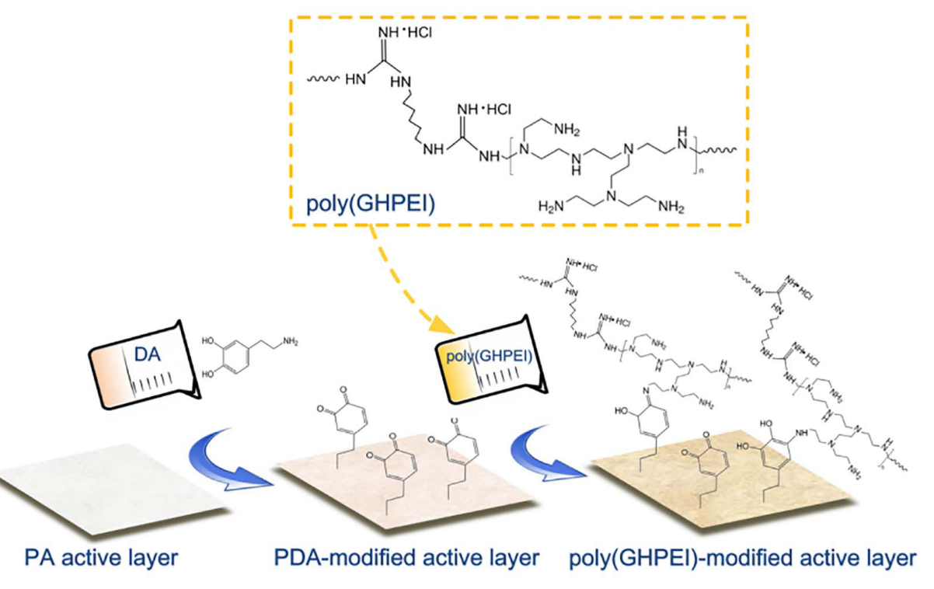
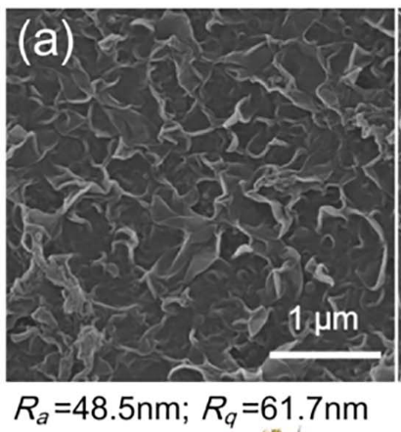
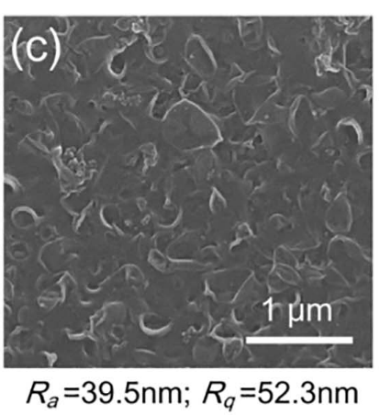
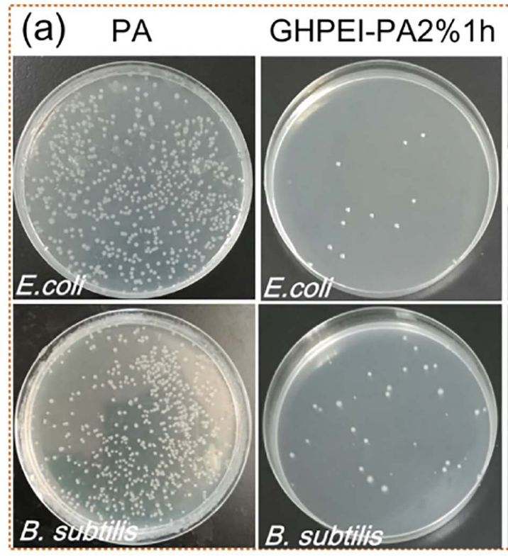
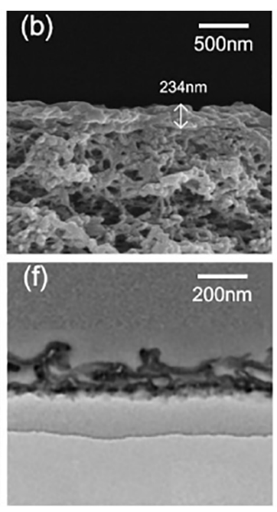
(a)
(b)
(c)
(d)

Figure 6: (a) schematic illustration of the modification route of BW30FR membrane with PDA followed by poly (GHPEI), (b-c) surface roughness of membrane was reduced with the grafted poly (GHPEI) (c-d) The thickness of the grafted poly (GHPEI) layer was estimated as 234 nm (e) bacteria colonies of poly (GHPEI) modified samples was significantly less than the unmodified membrane [195].

4.4 Immobilization within polymeric matrix

﻿Liao et al. incorporated polypyrrole (PPy) nanosphere ﻿with uniform sizes of less than 200 nm into ﻿TMC/hexane solution during the formation of polyamide layer via interfacial polymerization [196]. Owing to the their compatibility, PPy nanospheres were tightly wrapped by the polyamide matrix. The structure of PPy incorporated polyamide was remained intact and conserve the high salt rejection of 97%. ﻿ Remarkably improved water flux by 118% compared to unmodified membrane was associated to the combined factors of i) enhanced membrane hydrophilicity upon the incorporation of hydrophilic PPy nanospheres, ii) lowered polyamide crosslinking degree resulted in the creation of more hydrophilic carboxyl group on the membrane surface and iii) enhanced water passage for diffusion in the loose polyamide structure. The static bacteria count study showed the antimicrobial activity of the membrane against E. coli where mortality rate of 89.1% was attained. The biocidal properties of PPy nanospheres was arisen from the intrinsic positive charge of the nanosheet which can disrupt the negatively charged cytoplasmic cell membrane, causing the leakage of internal compositions and eventually the death of E. coli. Bera et al. incorporated melamine and PEG into polyamide network of RO membrane [197]. During membrane fabrication, melamine and MPD terminated-PEG were added into MPD solution for the interfacial polymerization with TMC. The surface hydrophilicity was enhanced owing to the hydrophilicity of PEG whereas the reduced surface roughness was due to the reducing amount of polyamide network with the addition of low reactivity melamine. The heterocyclic aromatic ring of melamine with antibacterial activity and the hydrophilicity of PEG have contributed to the increased water flux and improved antibiofouling towards ﻿ E. coli and B. subtilis bacteria. While increasing the water flux from 26 to 38 Lm⁻²h⁻¹, the triazine ring and PEG modified membrane have significantly reduced bacterial adhesion by 100 times compared to the pristine membrane.

A coaxial arc plasma deposition (APD) technique (Figure 7(a)) was used by Park et al. to partially incorporate AgNPs within polyamide layer RO TFC membrane as shown in Figure (Figure 7(b)) [198]. The surface modification performed with 60 APD pulse shots exhibited water flux increment by 40% to 38.27 L m⁻² h⁻¹ while maintaining the NaCl rejection at ﻿98.8%. The improvement was attributed by the enhanced surface hydrophilicity and increased structural flexibility of the polyamide selective layer during the APD process. The positive alteration of these characteristics has facilitated the passage of water molecules across the membrane. As summarized in Figure 7(c), the AgNP immobilized RO membrane exhibited high bacterial viability of 95%, 80% and 85%, for E. coli, P. aeruginosa and S. aureus, respectively, demonstrating its capability of inhibiting both Gram positive and gram negative bacteria. ﻿The monitoring of the releasing rate of silver ions from the Ag-TFC membrane indicated that ﻿the antibacterial effect of AgNP immobilized TFC membrane could be sustained up to 3 months. GO nanosheets have been embedded into the polysulfone (PSf) substrate and polyamide layer of TFC RO membrane to attain synergistic effects for separation performance and antibiofouling propensity [199]. The GO nanosheets was added into the casting solution subsequently embedded into PSf via non-solvent induced phase separation meanwhile the inclusion of GO nanosheet ﻿was carried out by introducing the nanosheet into the MPD solution during interfacial polymerization with TMC to form the polyamide layer. The incorporation of GO nanosheet in both substrate and active layer has resulted in increased hydrophilicity and surface negative charge. These features not only increased the water flux by 70% compared to neat TFC membranes, the hydrophilic and negatively charged membrane surface has also resulted in the electrostatic repulsion of hydrophobic and negatively charged bacteria. Consequently, the biovolumes of cells attached to the GO modified membrane was ﻿reduced by 99%. Similar improvement was also achieved by introducing ﻿GO in the TMC solution during interfacial polymerization [200]. It has also been pointed out that the GO nanosheets synthesized by Staudenmaier method can simultaneously achieve high permeability and selectivity while exhibiting antimicrobial and antifouling properties, compared to GO synthesized using modified Hummer’s method. ﻿The biofilm volume on the membrane was reduced from 0.61 μm³mm⁻² for pristine TFC to 0.38 μm³mm⁻² for GO embedded membrane. Other than anti-adhesion effect, contact-mediated antimicrobial effect of GO was also observed, suggesting that GO immobilized with polyamide layer could play the same role as ﻿biocide-releasing coatings.

Prior to the incorporation within PA layer, GO can also readily modified with tannic acid to improve miscibility with the polymer matrix and antimicrobial activities [201]. Tannic acid coated GO combined the oxidative stress capability of GO and radical scavenging properties of tannic acid to synergistically improve the antimicrobial activities. While exhibiting water flux that was improved by 26% compared to neat TFC membrane, the RO membrane modified with tannic acid coated GO could effectively reduce the number of viable cells compared to TFC and GO modified RO membrane counterparts. Zhang et al. added ﻿palygorskite clay (Pal) and TiO₂ photocatalytic into ﻿MPD solution and followed by interfacial polymerization with TMC to form Pal/TiO2 modified polyamide layer [202]. The modified RO membrane exhibited improvements in terms of surface hydrophilicity, flux and rejection. Pal with tubular structure provided additional water channels to speed up water transport trough the dense PA matrix. Under UV irradiation, the Pal/TiO₂ modified RO membrane achieved bactericidal rate of 98.2%. ﻿The UV illumination generated oxidative species such as hydroxyl radical and hydrogen peroxide that could destroy the outer membrane of bacteria.

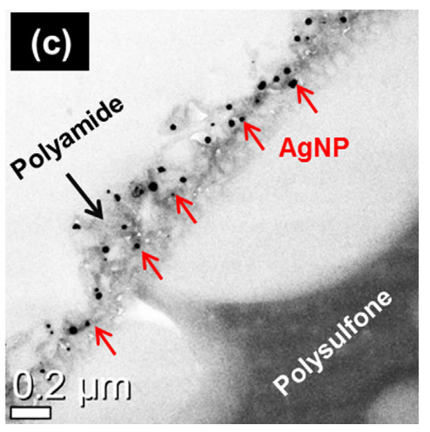
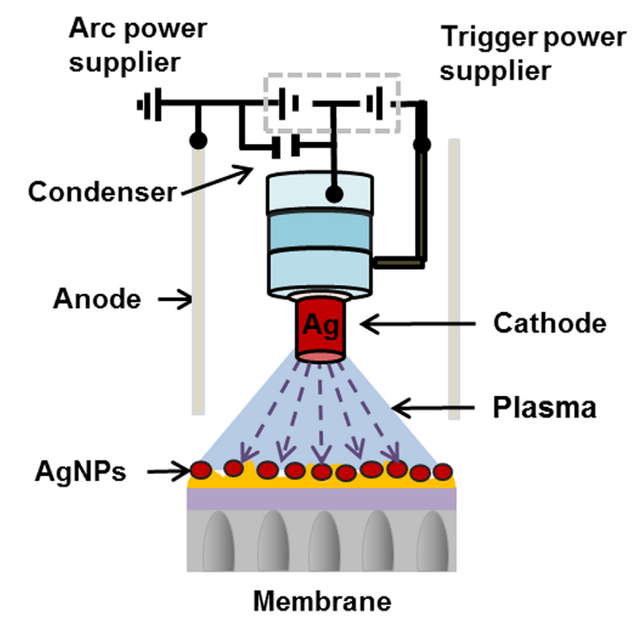
(a)
(b)

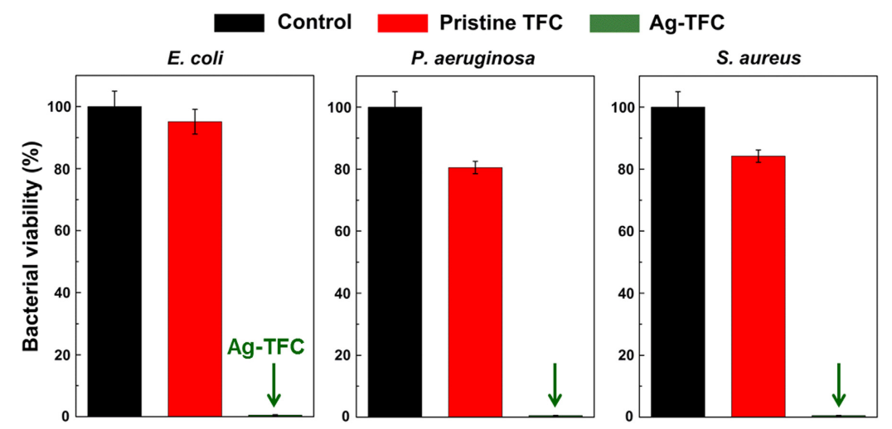
(c)

Figure 7: (a) ﻿Schematic illustration of the deposition of AgNPs using APD technique, (b) TEM image evidenced the partial immobilization of AgNP within the polyamide selective layer and (c) Comparison of antibacterial properties of unmodified and AgNP modified TFC membrane against E. coli, P. aeruginosa and S. aureus [198].

  - surface Patterning

Using a sol−gel based nanoimprinting technique as shown in Figure 8(a), Choi et al. created submicron TiO₂ pillar patterns on PA layer formed by LbL approach. ﻿The coating of TiO₂ pattern material significantly increased the membrane hydrophilicity and reduced the ﻿density of negatively charged groups on the membrane surface. Owing to the robustness of the pattern, ﻿the TiO₂ pillar morphology as shown in Figure 8(b) was well conserved even after filtration test. However, like other coated membranes, the patterned membrane suffered from serious decrease in water flux from 29.5 Lm⁻² h⁻¹ for un-patterned membrane to 10.8 Lm⁻² h⁻¹ for patterned membrane due to the increased hydrodynamic resistance resulted from the TiO₂ coating layer. Nevertheless, the patterned membranes have significantly better antibiofouling resistance against ﻿ P. aeruginosa compared to the pristine membrane. ﻿ Throughout 24 hours filtration, the patterned membrane has experienced minimum flux decline compared to its non-patterned counterpart (Figure 8(c)). No apparent biofilm formation but only sparsely distributed bacteria were found adhering on the patterned polyamide surface.
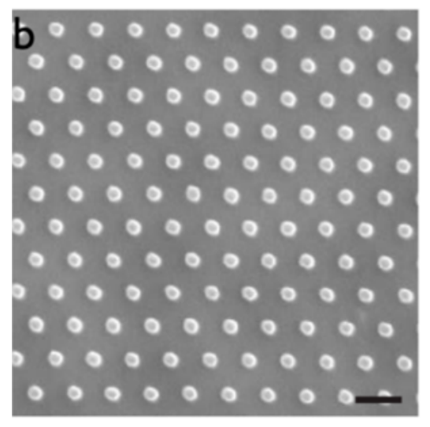
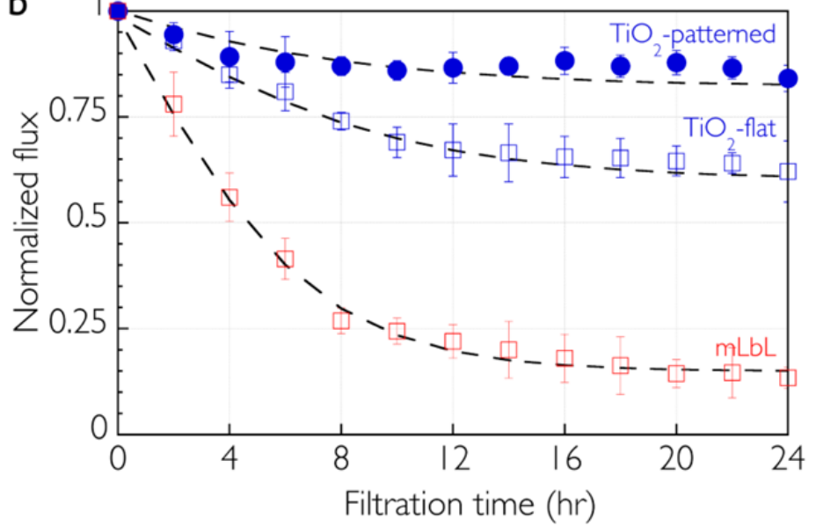
(a)
(b)
(c)

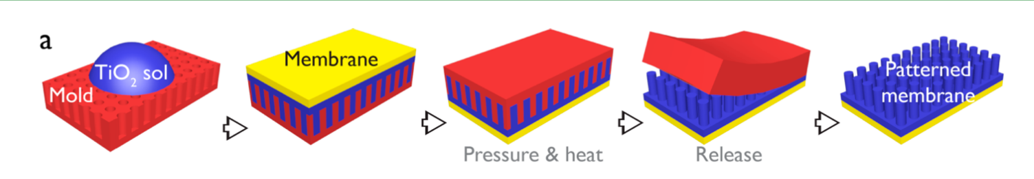

Figure 8: (a) ﻿Schematic illustration of the fabrication of TiO2-patterned membrane via sol−gel based nanoimprinting technique (b) surface morphology of TiO2-patterned membrane and (c) ﻿ Water flux desline of the TiO2-patterned membranes with the addition of P. aeruginosa was least severe compared to the non-pattern counterparts [203]

  - Summary

﻿The separation and antimicrobial performances of RO membranes modified via coating, grafting, LbL, immobilization and surface patterning have been evaluated and summarized in Table 2. Amongst these approaches, grafting has been favourably applied to introduce zwitterionic and organic biocides possessing abundant functional groups. However, in most of the reported studies, despite the decrease in surface hydrophilicity, the surface coating or grafting approaches have reduced the permeate flux of the membrane in different extends. On the other hand, immobilization is more common for nanomaterials that can favourably alter the physico-chemical properties of membrane such as hydrophilicity, surface charge and water permeability. GO is one of the most studied nanomaterials for RO membrane modification through immobilization. From antibiofouling point of view, immobilization of antimicrobial materials within the polymeric matrix is generally less favourable than others ex-situ modification methods due to several concerns associated to the structural integrity of polyamide layer, efficiency and regeneration of the embedded biocidal. It should be noted that, the biofilm formation was majorly supressed through the creation of hydrophilicity surface which in turn prevent the adhesion of bacteria. As the immobilized biocidals are almost entirely wrapped within the polyamide matrix, the release of oxidising ions, hence the bacterial killing action is restricted. Although contact-mediated antimicrobial effect has been observed in some studies, the effectiveness of such action has not been widely performed. While surface patterning has been common for asymmetric membranes and thin film composite, the modification of RO membrane through surface patterning for antibiofouling purpose has been scarcely reported.

- Challenges and Future Prospective

﻿
﻿The monitoring and control of biofouling require proper and systematic sampling of membrane surface. However, the monitoring and detection of membrane biofouling are still challenged by factors such as cost and feasibility. To date, various studies on biofouling monitoring have been performed but real-time monitoring of biofouling is still an under-explored areas. Particularly, the direct detection or measurement of biofoulants on RO membrane is not technically sound due to the high operating pressure and spiral-wound membrane modules. ﻿The development of more useful and reliable tools to further explore the key characteristics of thin biofilm are of great demand. Ultrasonic time domain reflectometry (UTDR), a ﻿non-invasive acoustical technique, has been used in-situ to assess the initial biofilms development process ﻿and monitor the growth of a fouling layer and cleaning process of membrane [204]. UTDR has been adapted to monitor biofouling by periodic dosing of colloidal silica that acts as acoustic enhancer so that the detection can be performed ﻿in high pressure membrane processes [205]. Real time monitoring of RO biofouling using electrical impedance spectroscopy (EIS) has also been attempted [206]. The key signals obtained from the EIS measurements such as the Nyquist plot and the conductivity of the diffusion polarization layer provide considerable insights into the biofilm formation on the membrane surface. However, the employment of EIS for biofouling monitoring is still relatively new hence needs more attentions for further improvement. Since biofouling of RO membrane cannot be completely avoided in a long run operation, biofouling control strategies have been focused on delaying the biofilm formation or minimizing the impacts on biofilms on membrane performance. Membrane modification seems serving this purpose well. Developing new and innovative anti-biofouling RO membranes serves as an interesting alternative to reduce the dependency on pretreatment processes and chemical disinfection.

The advancement of materials sciences has so much to offer for membrane modifications. The last two decades have witnessed the huge growth of efforts combating RO membrane biofouling through membrane surface modifications using nanoparticles. AgNP has been widely used in membrane modification to attain antimicrobial activities. However, the antibacterial effect of most of the reported AgNP modified TFC could last for average 120 days [177,198,207], ﻿which is still much shorter compared to the average membrane lifetime of 5 years. This suggests that huge efforts are still desired in extending the antibacterial efficiency of the modified membranes. One of the possible way to do so is by suppressing the dissolution and releasing rate of biocidal ion such as silver ion via the control of feed water chemistry (pH and dissolved substances) and hydrodynamic conditions of RO operation (pressure and flow rate). Despite their attractive antimicrobial activities, the antimicrobial activities of some semiconductor metal oxides like TiO₂ are largely depending on the presence of UV light to activate their antimicrobial properties. The limitation has become a major hindrance for the RO membranes modified by such biocides to be practically applied for commercial operation. The development of visible light responsive metal oxide biocidal is expected to become an attractive solution to resolve the limitation. On the other hand, with the positive outcomes and well understood ﻿fundamental aspects of their interaction with cells and bacteria, material scientists have seen zwitterion as one of the most effective anti-biofouling materials for membrane modification. Nevertheless, looming challenges in terms of the complexity and time consumption in the modification procedures are still deserving serious attentions. QS inhibitor is an emerging material for biofouling control. However, the application of QS inhibitor as membrane modifier is still scares. Research should be directed to explore the methods for RO surface modification that can maintain QS inhibitor activity during the modification and under harsh operating condition. Focus should also be placed on understanding the mechanisms and behaviour of membrane modified with QS inhibitors upon contact with bacteria cells found in the feed water.

﻿
Important observation has been made where AgNP showed higher toxicity effects on E. coli than S. aureus due to differences in in their cell wall structure. Such finding emphasizes a new aspect where the antibacterial activity of the nanoparticles also depends on the target microorganisms species [208]. Many studies have also interestingly pointed out that the size of AgNP is an important parameter for the toxicity release. For biomolecules such as chitosan, the ability to inhibit microorganisms is also influenced by its molecular weight and presence of immobilized foreign substances like metal oxide [209]. Another example is GO nanosheet that is known to display membrane transport properties as the function of its sheet size. GO synthesized from Staudenmaier method has also been proven to have higher biologically reactivity compared to other synthesis such as modified Hummer’s method [210]. These findings imply that the selection of an all-rounder material that is aimed to one-size-fits-all may not be a viable option in membrane modification due to the mix-species biofilm nature. Hence, systematic studies are required to assess and compare the antimicrobial activities of the identified biocidals prior to their uses in membrane modification.

There are also some considerable ambiguities regarding the currently applied synthesis and modification approaches to attain antimicrobial properties. Modification of membrane surface through coating and grafting has been feasibly reported in many studies but the loss of bio-fouling resistance and separation performance has also been associated to the leaching of the loosely adhered species from the membrane surface. The detachment of these functional groups can severely take place after several cycles of filtration and cleaning, especially for the functional groups rich in hydroxyl and carboxylate ester group which show high degree of hydrolysis [83]. The long term flux decline and flux recovery after washing are critical parameters to be considered for a techno-economical feasible RO operation. The ex-situ modification often requires multiple reactions and extra post-treatment process, resulting in time- and cost-consuming fabrication process. In fact modification based on the coating of anti-adhesive layer is hard to implement in roll-to-roll fabrication of TFC membrane at commercial scale. The significant reduction in membrane permeance due to the resistance introduced by the coating layer can be a concerning matter [211].

﻿Much work on the potential of embedding nanomaterials in the polyamide layer of RO membrane has been carried out, yet there are still some critical issues to be addressed. The modifications based on biocidal incorporation often lead to the alteration of membrane performance. One of the most critical challenges for in-situ approach is the agglomeration and nonuniform distribution of the nanomaterials within the selective layer due to the incompatibility and inadequate dispersion in the organic or aqueous phase. The agglomeration has inevitably led to the formation of pin holes or more severe defects on the polyamide layer, hence compromising the salt rejection capability. ﻿ Various surface modifications on the nanomaterials prior to the immobilization process can alleviate the issues, but the additional costs and efforts can be detrimental to the practicability of this modification approach. Additionally, the embedded biocidal in polyamide layer may compromise their antibacterial efficiency [212]. Nonconventional membrane surface modification through surface patterning is interesting due to its sustainable effects in mitigating biofouling. Currently, membrane patterning have been majorly limited to porous micro and ultra-filtration membranes. The surface patterning of RO membrane is largely restricted by the fragility of delicate and ultrathin polyamide selective layer . It is also technically challenging to perform surface patterning on polyamide layer formed from conventional interfacial polymerization technique that results in intrinsically rough surface and with nonconformal growth mechanism.

The use of biocides for RO membrane modification is a straightforward approach to kill or inactivate the microbes. Despite the considerable number of publication touting the fascinating antimicrobial effects of various biocides, the mechanisms by which these biocides exert antimicrobial activity when they are attached onto or incorporated into membranes has been rarely elucidated. Problematically, several detrimental effects may be provoked if the bacteria and biofilms are not adequately removed. Long term usage of biocides has commonly led to the adaptation of microbes to be immunized from the biocide effects. The biocides may undesirably promote biofilm formation by triggering a protective response from bacteria. Also, the biofouling may be accelerated and intensified when the dead bacteria release various organic matters such as proteins and lipids that could serve as a breeding ground for further biofouling. To maximize the biocidal activity and extend the membrane lifespan, research should also be directed to the design of membranes with dual-action biocidal materials and surfaces where the materials with synergistic actions that combine contact-disruption and released-based biocidal mechanisms. Most of the well-established biofouling control materials and modification strategies is known to be highly effective at the initial stage. Some claims on the antimicrobial performance of nanoparticles also seemed to be exaggerated as it has been demonstrated that biocidal-modified membranes show a decreasing trend of antimicrobial effect with prolonged usage due to the adaptability of the biofilm to the environment and conditions imposed. ﻿Temporal control of biofilm formation will require more in depth understanding and correlation on the stages and characteristics of biofilm formation. Hence, whether a conventional or a distinctly novel approach that is reliable and highly reproducible is highly desired. The interdisciplinary research that encompasses separation engineering and biomedical science should be adopted to fuel innovations in this field.

In most of the reported bench-scaled anti-biofouling studies, investigations were commonly conducted using synthesis feed water such as protein-containing water and bacterial suspended water. Although static antimicrobial assay using bacterial culture can closely mimic the chemistry and biology of seawater, the hydrodynamic conditions have been neglected. The biofilm studies are also limited by the use of model strains and bacteria that retrieved from the RO membrane. There have been dissentients views on the reliability of the anti-biofouling membranes because most lab-scale biofouling tests were majorly assessed based on the direct contact of the membranes with feed water with unrealistically high bacteria colonies. There is insufficient research on the performance evaluation using real water source and desalination plant operating conditions to draw any firm conclusions about the efficiency of the developed anti-biofouling RO membranes. While the findings may shed some lights on the effectiveness of the developed strategies, such systems have failed to reflect and address the real biofouling behaviours which involve bacterial attachment and growth as well as biofilm formation on the membrane surface. Hence, the results may not be orthodox in the real conditions where complex seawater and brackish water are involved. In fact, the determination of the predominant microorganism that causes biofilm formation in a specific feedwater is tedious and challenging because the bacterial species vary with the changes in feed water quality, temperature and process control, as well as from one RO plant to another in different process-specific operating conditions. Currently, only a scrap of published works looked into the sustainability aspects through long-term cross-flow filtration tests to examine the robustness of the established approach. To reflect the actual filtration system, the effects of shear and pressure conditions that are encountered in typical spiral-wound membrane systems operated at commercial plant should be the one of the major scopes in studies related to anti-fouling membrane development.

Despite having well-funded research and engineering to upgrade to new advancements at academic level, the implementation of new RO membrane on an industrial scale will require considerable investments in scale up as well as performance and risk related validations. As the utilization of membrane is not the only viable way to combat biofouling, the switching from conventional membrane to highly biofouling resistant novel membranes must be justified by substantial increase in the efficiency and overall cost reduction. Therefore, while leveraging the benefits of various RO membrane modification approaches in tackling biofouling issues, it is prudent to assess the economical commitment to avoid any financial setbacks while moving forward. The economic feasibility involves a complex computation that is determined by various factors, including cost of chemicals, cost of technique upscaling to perform the modification to fulfil the demands in commercial scale. The justification of the selections will be more convincing if the cost-benefit assessment is performed to provide an indication in terms of investment and operating costs for these possible technological solutions. As a rule of thumb, the approach used for RO membrane modification has to be less expensive to produce. The utilization of RO membrane with enhanced antimicrobial activities can only be considered as a feasible technology if the long term saving offset the additional economic costs.

One important aspect that goes beyond the cost and technical feasibility is the implications on health and environments. Although much progress has been made toward mitigating biofouling using inorganic nanoparticles and their composites, there has been some disagreement concerning the safety and reliability of these antibacterial nano-sized agents. They are frequently associated to the high cost of production, instability and high tendency of leaching into the water body. It is worth to point out that, the findings from cytotoxicity studies of nanomaterials such as CNTs are often contradictory, probably due to difference in the purities and degree of functionalization. Like most inorganic nanomaterials, the formalization of biocide in wastewater treatment is also hampered by their potential environmental, ecological and toxicological hazards. Therefore, to foster the acceptance of biocide or nanomaterials modified RO membranes, the impact of the leached nanomaterials and biocides on the receiving environment needs to be carefully assessed. It has been evidenced that biocides like AgNP ﻿not only capable in destroying microorganism, but also poses unintended threat to higher organisms. As has been repeatedly pointed out in many preceding publications, innovators and users should remain cautious of the new risks that nanomaterials could probably introduce to humans or the environment with their widespread utilization. In depth studies to assess the design, usage, and discharge of these potential hazardous nanomaterials are necessary. A shift towards the use of abundantly accessible and inexpensive biomolecules which are also characterized with excellent biodegradability and non-toxicity will be a wise choice to minimize the environmental impact.

- Conclusion

Demands for high quality fresh water will continue to hike in the coming decades. Desalination based on RO technology is an unarguably promising way that has gained worldwide industry acceptance to produce freshwater from saline water. Despite all the advancements made, RO technology, like other membrane-based processes, suffer from inevitable fouling. Research on anti-biofouling RO processes is proceeding on many fronts and design of biofouling resistant membranes is one of the focuses in this field. This review is concerned with the issue of biofouling in RO membrane where the recent findings of contemporary approaches for RO membrane modification have been comprehensively reviewed. On the basis of the complexity of bio-fouling mechanism, it seems reasonable to conclude that no single mitigation approach can serve as the ultimate solution to remediate the issues related to this phenomenon. The limitations of the existing materials and approaches for anti-biofouling membrane design will act as the driving force to motivate continual search for simple and versatile strategies. Such a progress will not only push innovation in the development of anti-biofouling RO membranes but also accelerating the progress of adopting the technology for industry operations. Unarguably, the mitigation of biofouling based on membrane design and modification is not likely to be the sole game changer of RO processes at industry level. While agreeing that membrane improvement stands out to be one of the most straightforward and effective ways to deal with biofouling, it is also worth mentioning that other approaches such as pre-treatment can definitely complement and add values as part of the holistic solution. A combination of pre-treatment, cleaning and membrane modification strategies is deemed to provide the most rational way to combat biofouling issues. The industries will take advantages of the strength of each approach to create a stronger integrated offering for an efficient and economically sound solution to address biofouling issue in RO technology. Nevertheless, within the next few years, membrane modification is destined to continue becoming an important component in RO research. The efforts in developing anti-biofouling membrane continue to blossom as the year progressed. It is likely to see a considerable rise in the generation of insightful and mind-blowing ideas that are adequate to meet the criteria required to address the issue.

Acknowledgement

The authors would like to acknowledge Universiti Teknologi Malaysia and financial support provided by the Ministry of Education Malaysia under Malaysia Research University Network Grant (Vot number: 4L862) and Fundamental Research Grant Scheme (Vot number: 4F920).

References

[1] D. Li, H. Wang, Recent developments in reverse osmosis desalination membranes, J. Mater. Chem. 20 (2010) 4551. doi:10.1039/b924553g.
[2] S.H. Joo, B. Tansel, Novel technologies for reverse osmosis concentrate treatment: A review, J. Environ. Manage. 150 (2015) 322–335. doi:10.1016/j.jenvman.2014.10.027.
[3] D.M. Warsinger, S. Chakraborty, E.W. Tow, M.H. Plumlee, C. Bellona, S. Loutatidou, L. Karimi, A.M. Mikelonis, A. Achilli, A. Ghassemi, L.P. Padhye, S.A. Snyder, S. Curcio, C.D. Vecitis, H.A. Arafat, J.H. Lienhard, A review of polymeric membranes and processes for potable water reuse, Prog. Polym. Sci. 81 (2018) 209–237. doi:10.1016/j.progpolymsci.2018.01.004.
[4] B. Mayor, Growth patterns in mature desalination technologies and analogies with the energy field, Desalination. 457 (2019) 75–84. doi:10.1016/j.desal.2019.01.029.
[5] R. Zhang, Y. Liu, M. He, Y. Su, X. Zhao, M. Elimelech, Z. Jiang, Antifouling membranes for sustainable water purification: Strategies and mechanisms, Chem. Soc. Rev. 45 (2016) 5888–5924. doi:10.1039/c5cs00579e.
[6] P.S. Goh, W.J. Lau, M.H.D. Othman, A.F. Ismail, Membrane fouling in desalination and its mitigation strategies, Desalination. 425 (2018). doi:10.1016/j.desal.2017.10.018.
[7] R. Komlenic, Rethinking the causes of membrane biofouling, Filtr. Sep. 47 (2010) 26–28. doi:10.1016/S0015-1882(10)70211-1.
[8] S.F. Anis, R. Hashaikeh, N. Hilal, Reverse osmosis pretreatment technologies and future trends: A comprehensive review, Desalination. 452 (2019) 159–195. doi:10.1016/j.desal.2018.11.006.
[9] J. Mansouri, S. Harrisson, V. Chen, Strategies for controlling biofouling in membrane filtration systems: challenges and opportunities, J. Mater. Chem. 20 (2010) 4567. doi:10.1039/b926440j.
[10] A. Ruiz-García, N. Melián-Martel, V. Mena, Fouling characterization of RO membranes after 11 years of operation in a brackish water desalination plant, Desalination. 430 (2018) 180–185. doi:10.1016/j.desal.2017.12.046.
[11] S. Bucs, N. Farhat, J.C. Kruithof, C. Picioreanu, M.C.M. van Loosdrecht, J.S. Vrouwenvelder, Review on strategies for biofouling mitigation in spiral wound membrane systems, Desalination. 434 (2018) 189–197. doi:10.1016/j.desal.2018.01.023.
[12] C. Abrusci, D. Marquina, A. Santos, A. Del Amo, T. Corrales, F. Catalina, Biodeterioration of cinematographic cellulose triacetate by Sphingomonas paucimobilis using indirect impedance and chemiluminescence techniques, Int. Biodeterior. Biodegradation. 63 (2009) 759–764. doi:10.1016/j.ibiod.2009.02.012.
[13] J.S. Baker, L.Y. Dudley, Biofouling in membrane systems - a review, Desalination. 118 (1998) 81–89. doi:10.1016/S0011-9164(98)00091-5.
[14] J. Wu, C. Zhang, S. Xu, X. Pang, G. Cai, J. Wang, Preparation of Zwitterionic Polymer-Functionalized Cotton Fabrics and the Performance of Anti-Biofouling and Long-Term Biofilm Resistance, Colloids Interface Sci. Commun. 24 (2018) 98–104. doi:10.1016/j.colcom.2018.02.001.
[15] O. Sánchez, Microbial diversity in bio fi lms from reverse osmosis membranes : A short review, 545 (2018) 240–249. doi:10.1016/j.memsci.2017.09.082.
[16] V. Carniello, B.W. Peterson, H.C. van der Mei, H.J. Busscher, Physico-chemistry from initial bacterial adhesion to surface-programmed biofilm growth, Adv. Colloid Interface Sci. 261 (2018) 1–14. doi:10.1016/j.cis.2018.10.005.
[17] S.E. Kwan, E. Bar-Zeev, M. Elimelech, Biofouling in forward osmosis and reverse osmosis: Measurements and mechanisms, J. Memb. Sci. 493 (2015) 703–708. doi:10.1016/j.memsci.2015.07.027.
[18] T. Nguyen, F.A. Roddick, L. Fan, Biofouling of water treatment membranes: A review of the underlying causes, monitoring techniques and control measures, Membranes (Basel). 2 (2012) 804–840. doi:10.3390/membranes2040804.
[19] J.M. Veza, M. Ortiz, J.J. Sadhwani, J.E. Gonzalez, F.J. Santana, Measurement of biofouling in seawater: some practical tests, Desalination. 220 (2008) 326–334. doi:10.1016/j.desal.2007.01.037.
[20] M.M.T. Khan, P.S. Stewart, D.J. Moll, W.E. Mickols, M.D. Burr, S.E. Nelson, A.K. Camper, Assessing biofouling on polyamide reverse osmosis (RO) membrane surfaces in a laboratory system, J. Memb. Sci. 349 (2010) 429–437. doi:10.1016/j.memsci.2009.12.006.
[21] W.B. Krantz, A.H. Taheri, T.H. Chong, S.T.V. Sim, L.N. Sim, A.G. Fane, L. Lai, A review of fouling indices and monitoring techniques for reverse osmosis, Desalination. 434 (2017) 169–188. doi:10.1016/j.desal.2017.12.009.
[22] S. Jamaly, N.N. Darwish, I. Ahmed, S.W. Hasan, A short review on reverse osmosis pretreatment technologies, Desalination. 354 (2014) 30–38. doi:10.1016/j.desal.2014.09.017.
[23] W.J. Lau, P.S. Goh, A.F. Ismail, S.O. Lai, Ultrafiltration as a pretreatment for seawater desalination : A review, Membr. Water Treat. 5 (2014) 15–29. doi:10.12989/mwt.2014.5.1.015.
[24] S.C. Chen, G.L. Amy, T.S. Chung, Membrane fouling and anti-fouling strategies using RO retentate from a municipal water recycling plant as the feed for osmotic power generation, Water Res. 88 (2016) 144–155. doi:10.1016/j.watres.2015.10.008.
[25] A. Saeed, R. Vuthaluru, H.B. Vuthaluru, Impact of Feed Spacer Filament Spacing on Mass Transport and Fouling Propensities of RO Membrane Surfaces, Chem. Eng. Commun. 202 (2015) 634–646. doi:10.1080/00986445.2013.860525.
[26] C. Piyadasa, H.F. Ridgway, T.R. Yeager, M.B. Stewart, C. Pelekani, S.R. Gray, J.D. Orbell, The application of electromagnetic fields to the control of the scaling and biofouling of reverse osmosis membranes - A review, Desalination. 418 (2017) 19–34. doi:10.1016/j.desal.2017.05.017.
[27] C.-F. de Lannoy, D. Jassby, K. Gloe, A.D. Gordon, M.R. Wiesner, Aquatic Biofouling Prevention by Electrically Charged Nanocomposite Polymer Thin Film Membranes, Environ. Sci. Technol. 47 (2013) 2760–2768. doi:10.1021/es3045168.
[28] F. Reuter, S. Lauterborn, R. Mettin, W. Lauterborn, Ultrasonics Sonochemistry Membrane cleaning with ultrasonically driven bubbles, Ultrason. - Sonochemistry. 37 (2017) 542–560. doi:10.1016/j.ultsonch.2016.12.012.
[29] Y. Jung, A.B. Alayande, S. Chae, I.S. Kim, Applications of nisin for biofouling mitigation of reverse osmosis membranes, Desalination. 429 (2018) 52–59. doi:10.1016/j.desal.2017.12.003.
[30] J.S. Vrouwenvelder, H. Sanawar, S.S. Bucs, J. Zlopasa, M.C.M. van Loosdrecht, J.C. Kruithof, I. Pinel, N.M. Farhat, G.J. Witkamp, Enhanced biofilm solubilization by urea in reverse osmosis membrane systems, Water Res. X. 1 (2018) 100004. doi:10.1016/j.wroa.2018.10.001.
[31] N.M. Farhat, E. Loubineaud, E.I.E.C. Prest, J. El-Chakhtoura, C. Salles, S.S. Bucs, J. Trampé, W.B.P. Van den Broek, J.M.C. Van Agtmaal, M.C.M. Van Loosdrecht, J.C. Kruithof, J.S. Vrouwenvelder, Application of monochloramine for wastewater reuse: Effect on biostability during transport and biofouling in RO membranes, J. Memb. Sci. 551 (2018) 243–253. doi:10.1016/j.memsci.2018.01.060.
[32] J. Yu, Y. Baek, H. Yoon, J. Yoon, New disinfectant to control biofouling of polyamide reverse osmosis membrane, J. Memb. Sci. 427 (2013) 30–36. doi:10.1016/j.memsci.2012.09.057.
[33] R. Verbeke, V. Gómez, I.F.J. Vankelecom, Chlorine-resistance of reverse osmosis (RO) polyamide membranes, Prog. Polym. Sci. 72 (2017) 1–15. doi:10.1016/j.progpolymsci.2017.05.003.
[34] I.M. Stoica, E. Vitzilaiou, H. Lyng Røder, M. Burmølle, D. Thaysen, S. Knøchel, F. van den Berg, Biofouling on RO-membranes used for water recovery in the dairy industry, J. Water Process Eng. 24 (2018) 1–10. doi:https://doi.org/10.1016/j.jwpe.2018.05.004.
[35] M.T. Khan, P.-Y. Hong, N. Nada, J.P. Croue, Does chlorination of seawater reverse osmosis membranes control biofouling?, Water Res. 78 (2015) 84–97. doi:10.1016/j.watres.2015.03.029.
[36] C. Marconnet, A. Houari, D. Seyer, M. Djafer, G. Coriton, V. Heim, P. Di Martino, Membrane biofouling control by UV irradiation, Desalination. 276 (2011) 75–81. doi:10.1016/j.desal.2011.03.016.
[37] A. Belila, J. El-Chakhtoura, N. Otaibi, G. Muyzer, G. Gonzalez-Gil, P.E. Saikaly, M.C.M. van Loosdrecht, J.S. Vrouwenvelder, Bacterial community structure and variation in a full-scale seawater desalination plant for drinking water production, Water Res. 94 (2016) 62–72. doi:10.1016/j.watres.2016.02.039.
[38] Y.H. Wang, Y.H. Wu, X. Tong, T. Yu, L. Peng, Y. Bai, X.H. Zhao, Z.Y. Huo, N. Ikuno, H.Y. Hu, Chlorine disinfection significantly aggravated the biofouling of reverse osmosis membrane used for municipal wastewater reclamation, Water Res. 154 (2019) 246–257. doi:10.1016/j.watres.2019.02.008.
[39] A.R. Guastalli, F.X. Simon, Y. Penru, A. de Kerchove, J. Llorens, S. Baig, Comparison of DMF and UF pre-treatments for particulate material and dissolved organic matter removal in SWRO desalination, Desalination. 322 (2013) 144–150. doi:10.1016/j.desal.2013.05.005.
[40] Y. Shutova, B.L. Karna, A.C. Hambly, B. Lau, R.K. Henderson, P. Le-Clech, Enhancing organic matter removal in desalination pretreatment systems by application of dissolved air flotation, Desalination. 383 (2016) 12–21. doi:10.1016/j.desal.2015.12.018.
[41] A. Al Ashhab, M. Herzberg, O. Gillor, Biofouling of reverse-osmosis membranes during tertiary wastewater desalination: Microbial community composition, Water Res. 50 (2014) 341–349. doi:10.1016/j.watres.2013.10.044.
[42] N. Misdan, A.F. Ismail, N. Hilal, Recent advances in the development of (bio)fouling resistant thin film composite membranes for desalination, Desalination. 380 (2016) 105–111. doi:10.1016/j.desal.2015.06.001.
[43] J.M. Gohil, P. Ray, A review on semi-aromatic polyamide TFC membranes prepared by interfacial polymerization: Potential for water treatment and desalination, Sep. Purif. Technol. 181 (2017) 159–182. doi:10.1016/j.seppur.2017.03.020.
[44] M. Asadollahi, D. Bastani, S.A. Musavi, Enhancement of surface properties and performance of reverse osmosis membranes after surface modi fi cation : A review, Desalination. 420 (2017) 330–383. doi:10.1016/j.desal.2017.05.027.
[45] I. Gehrke, A. Geiser, A. Somborn-Schulz, Innovations in nanotechnology for water treatment, Nanotechnol. Sci. Appl. 8 (2015) 1–17. doi:10.2147/NSA.S43773.
[46] D. Firouzjaei, A. Rahimpour, J. Eke, I.C. Escobar, L.F. Greenlee, A.R. Esfahani, A. Sadmani, N. Koutahzadeh, Nanocomposite membranes for water separation and purification : Fabrication , modification , and applications, Sep. Purif. Technol. 213 (2018) 465–499. doi:10.1016/j.seppur.2018.12.050.
[47] P. Sagitha, C.R. Reshmi, S.P. Sundaran, A. Sujith, Recent advances in post-modification strategies of polymeric electrospun membranes, Eur. Polym. J. 105 (2018) 227–249. doi:10.1016/j.eurpolymj.2018.05.033.
[48] L. Upadhyaya, X. Qian, S. Ranil Wickramasinghe, Chemical modification of membrane surface — overview, Curr. Opin. Chem. Eng. 20 (2018) 13–18. doi:10.1016/j.coche.2018.01.002.
[49] X. Zhao, R. Zhang, Y. Liu, M. He, Y. Su, C. Gao, Z. Jiang, Antifouling membrane surface construction: Chemistry plays a critical role, J. Memb. Sci. 551 (2018) 145–171. doi:10.1016/j.memsci.2018.01.039.
[50] A. Matin, Z. Khan, S.M.J. Zaidi, M.C. Boyce, Biofouling in reverse osmosis membranes for seawater desalination: Phenomena and prevention, Desalination. 281 (2011) 1–16. doi:10.1016/j.desal.2011.06.063.
[51] J. Saqib, I.H. Aljundi, Membrane fouling and modification using surface treatment and layer-by-layer assembly of polyelectrolytes: State-of-the-art review, J. Water Process Eng. 11 (2016) 68–87. doi:10.1016/j.jwpe.2016.03.009.
[52] J. Zhu, J. Hou, Y. Zhang, M. Tian, T. He, J. Liu, V. Chen, Polymeric antimicrobial membranes enabled by nanomaterials for water treatment, J. Memb. Sci. 550 (2018) 173–197. doi:10.1016/j.memsci.2017.12.071.
[53] V. Kochkodan, N. Hilal, A comprehensive review on surface modified polymer membranes for biofouling mitigation, Desalination. 356 (2015) 187–207. doi:10.1016/j.desal.2014.09.015.
[54] C.S. Ong, P.S. Goh, W.J. Lau, N. Misdan, A.F. Ismail, Nanomaterials for biofouling and scaling mitigation of thin film composite membrane: A review, Desalination. 393 (2016). doi:10.1016/j.desal.2016.01.007.
[55] J. Lee, I.S. Kim, Microbial community in seawater reverse osmosis and rapid diagnosis of membrane biofouling, Desalination. 273 (2011) 118–126. doi:10.1016/j.desal.2010.12.005.
[56] R.M. Donlan, Biofilms: Microbial Life on Surfaces, Emerg. Infect. Dis. 8 (2002) 881–890. doi:10.3201/eid0809.020063.
[57] J.-M. Allain, C. Even, J.-M. Ghigo, C. Marlière, E. Raspaud, A. Marcellan, Recent advances in studying single bacteria and biofilm mechanics, Adv. Colloid Interface Sci. 247 (2017) 573–588. doi:10.1016/j.cis.2017.07.026.
[58] T. Seviour, N. Derlon, M.S. Dueholm, H.-C. Flemming, E. Girbal-Neuhauser, H. Horn, S. Kjelleberg, M.C.M. van Loosdrecht, T. Lotti, M.F. Malpei, R. Nerenberg, T.R. Neu, E. Paul, H. Yu, Y. Lin, Extracellular polymeric substances of biofilms: Suffering from an identity crisis, Water Res. 151 (2019) 1–7. doi:10.1016/j.watres.2018.11.020.
[59] Y. Xiao, F. Zhao, Electrochemical roles of extracellular polymeric substances in biofilms, Curr. Opin. Electrochem. 4 (2017) 206–211. doi:10.1016/j.coelec.2017.09.016.
[60] Y. Shi, J. Huang, G. Zeng, Y. Gu, Y. Chen, Y. Hu, B. Tang, J. Zhou, Y. Yang, L. Shi, Exploiting extracellular polymeric substances (EPS) controlling strategies for performance enhancement of biological wastewater treatments: An overview, Chemosphere. 180 (2017) 396–411. doi:10.1016/j.chemosphere.2017.04.042.
[61] Hans-Curt Flemming, Reverse Osmosis Membrane Biofouling, Exp. Therm. Fluid Sci. 1777 (1997) 382–391.
[62] J. Palmer, S. Flint, J. Brooks, Bacterial cell attachment, the beginning of a biofilm, J. Ind. Microbiol. Biotechnol. 34 (2007) 577–588. doi:10.1007/s10295-007-0234-4.
[63] V. Lazarova, Biofilm characterization and activity analysis in water and wastewater treatment, Water Res. 29 (1995) 2227–2245. doi:10.1016/0043-1354(95)00054-O.
[64] I.W. Sutherland, Biofilm exopolysaccharides: a strong and sticky framework, Microbiology. 147 (2001) 3–9. doi:10.1099/00221287-147-1-3.
[65] I.W. Sutherland, A natural terrestrial biofilm, J. Ind. Microbiol. Biotechnol. 17 (1996) 281–283. doi:10.1007/BF01574702.
[66] M. De Volder, R. Losick, J.N. Wilking, D.A. Weitz, V. Zaburdaev, M.P. Brenner, Liquid transport facilitated by channels in Bacillus subtilis biofilms, Proc. Natl. Acad. Sci. 110 (2012) 848–852. doi:10.1073/pnas.1216376110.
[67] J. Imbrogno, J.J. Keating, J. Kilduff, G. Belfort, Critical aspects of RO desalination: A combination strategy, Desalination. 401 (2017) 68–87. doi:10.1016/j.desal.2016.06.033.
[68] L. Iliasafov, D. Bilanovic, L. Kolik, E. Kurzbaum, M. Butnariu, R. Armon, J. Starosvetsky, From the Titanic and other shipwrecks to biofilm prevention: The interesting role of polyphenol-protein complexes in biofilm inhibition, Sci. Total Environ. 658 (2018) 1098–1105. doi:10.1016/j.scitotenv.2018.12.197.
[69] G. Matar, H. Maab, G. Gonzalez-Gil, P. Le-Clech, S. Nunes, P.E. Saikaly, J. Vrouwenvelder, Temporal changes in extracellular polymeric substances on hydrophobic and hydrophilic membrane surfaces in a submerged membrane bioreactor, Water Res. 95 (2016) 27–38. doi:10.1016/j.watres.2016.02.064.
[70] M.M. Cowan, T.M. Warren, M. Fletcher, Mixed‐species colonization of solid surfaces in laboratory biofilms, Biofouling. 3 (1991) 23–34. doi:10.1080/08927019109378159.
[71] L.C. Powell, N. Hilal, C.J. Wright, Atomic force microscopy study of the biofouling and mechanical properties of virgin and industrially fouled reverse osmosis membranes, Desalination. 404 (2017) 313–321. doi:10.1016/j.desal.2016.11.010.
[72] J. Landaburu-Aguirre, R. García-Pacheco, S. Molina, L. Rodríguez-Sáez, J. Rabadán, E. García-Calvo, Fouling prevention, preparing for re-use and membrane recycling. Towards circular economy in RO desalination, Desalination. 393 (2016) 16–30. doi:10.1016/j.desal.2016.04.002.
[73] R. Bernstein, V. Freger, J.H. Lee, Y.G. Kim, J. Lee, M. Herzberg, “Should I stay or should I go?” Bacterial attachment vs biofilm formation on surface-modified membranes, Biofouling. 30 (2014) 367–376. doi:10.1080/08927014.2013.876011.
[74] J. Ayyavoo, T.P.N. Nguyen, B.M. Jun, I.C. Kim, Y.N. Kwon, Protection of polymeric membranes with antifouling surfacing via surface modifications, Colloids Surfaces A Physicochem. Eng. Asp. 506 (2016) 190–201. doi:10.1016/j.colsurfa.2016.06.026.
[75] J. Zhao, X. Zhao, Z. Jiang, Z. Li, X. Fan, J. Zhu, H. Wu, Y. Su, D. Yang, F. Pan, J. Shi, Biomimetic and bioinspired membranes: Preparation and application, Prog. Polym. Sci. 39 (2014) 1668–1720. doi:10.1016/j.progpolymsci.2014.06.001.
[76] T.A. Otitoju, R.A. Saari, A.L. Ahmad, Progress in the modification of reverse osmosis (RO) membranes for enhanced performance, J. Ind. Eng. Chem. 67 (2018) 52–71. doi:10.1016/j.jiec.2018.07.010.
[77] G. Kang, Y. Cao, Development of antifouling reverse osmosis membranes for water treatment: A review, Water Res. 46 (2012) 584–600. doi:10.1016/j.watres.2011.11.041.
[78] D. Pavithra, M. Doble, Biofilm formation, bacterial adhesion and host response on polymeric implants - Issues and prevention, Biomed. Mater. 3 (2008). doi:10.1088/1748-6041/3/3/034003.
[79] O. Heinz, M. Aghajani, A.R. Greenberg, Y. Ding, Surface-patterning of polymeric membranes: fabrication and performance, Curr. Opin. Chem. Eng. 20 (2018) 1–12. doi:10.1016/j.coche.2018.01.008.
[80] M. He, K. Gao, L. Zhou, Z. Jiao, M. Wu, J. Cao, X. You, Z. Cai, Y. Su, Z. Jiang, Zwitterionic materials for antifouling membrane surface construction, Acta Biomater. 40 (2016) 142–152. doi:10.1016/j.actbio.2016.03.038.
[81] Q. Zhang, C. Zhang, J. Xu, Y. Nie, S. Li, S. Zhang, Effect of poly(vinyl alcohol) coating process conditions on the properties and performance of polyamide reverse osmosis membranes, Desalination. 379 (2016) 42–52. doi:10.1016/j.desal.2015.10.012.
[82] X. Cheng, Y. Bai, Y. Zhang, Y. Xu, L. Shao, X. Yang, H. Sun, Segregation-induced in situ hydrophilic modification of poly (vinylidene fluoride) ultrafiltration membranes via sticky poly (ethylene glycol) blending, J. Memb. Sci. 563 (2018) 22–30. doi:10.1016/j.memsci.2018.05.046.
[83] Q. Xie, Q. Xie, J. Pan, C. Ma, G. Zhang, Biodegradable Polymer with Hydrolysis-Induced Zwitterions for Antibiofouling, ACS Appl. Mater. Interfaces. 10 (2018) 11213–11220. doi:10.1021/acsami.8b00962.
[84] H.Z. Shafi, A. Matin, Z. Khan, A. Khalil, K.K. Gleason, Surface modification of reverse osmosis membranes with zwitterionic coatings: A potential strategy for control of biofouling, Surf. Coatings Technol. 279 (2015) 171–179. doi:10.1016/j.surfcoat.2015.08.037.
[85] M. Qiu, C. He, Novel zwitterion-silver nanocomposite modified thin-film composite forward osmosis membrane with simultaneous improved water flux and biofouling resistance property, Appl. Surf. Sci. 455 (2018) 492–501. doi:10.1016/j.apsusc.2018.06.020.
[86] W.F. Chan, E. Marand, S.M. Martin, Novel zwitterion functionalized carbon nanotube nanocomposite membranes for improved RO performance and surface anti-biofouling resistance, J. Memb. Sci. 509 (2016) 125–137. doi:10.1016/j.memsci.2016.02.014.
[87] S. Jiang, Z. Cao, Ultralow-fouling, functionalizable, and hydrolyzable zwitterionic materials and their derivatives for biological applications, Adv. Mater. 22 (2010) 920–932. doi:10.1002/adma.200901407.
[88] J.B. Schleno, Zwitteration: Coating Surfaces with Zwitterionic Functionality to Reduce Nonspecific Adsorption, Langmuir. 30 (2014) 9625–9636. doi:10.1021/la500057j.
[89] W.J. Lee, P.S. Goh, W.J. Lau, C.S. Ong, A.F. Ismail, Antifouling zwitterion embedded forward osmosis thin film composite membrane for highly concentrated oily wastewater treatment, Sep. Purif. Technol. 214 (2019) 40–50. doi:10.1016/j.seppur.2018.07.009.
[90] R. Bernstein, S. Belfer, V. Freger, Bacterial Attachment to RO Membranes Surface-Modified by Concentration-Polarization Enhanced Graft Polymerization, Environ. Sci. Technol. 45 (2011) 5973–5980.
[91] Z. Yang, D. Saeki, H. Matsuyama, Zwitterionic polymer modification of polyamide reverse-osmosis membranes via surface amination and atom transfer radical polymerization for anti-biofouling, J. Memb. Sci. 550 (2018) 332–339. doi:10.1016/j.memsci.2018.01.001.
[92] A.J. Blok, R. Chhasatia, J. Dilag, A. V. Ellis, Surface initiated polydopamine grafted poly([2-(methacryoyloxy)ethyl]trimethylammonium chloride) coatings to produce reverse osmosis desalination membranes with anti-biofouling properties, J. Memb. Sci. 468 (2014) 216–223. doi:10.1016/j.memsci.2014.06.008.
[93] P.S. Goh, A.F. Ismail, N. Hilal, Nano-enabled membranes technology: Sustainable and revolutionary solutions for membrane desalination?, Desalination. (2015). doi:10.1016/j.desal.2015.06.002.
[94] N. Durán, M. Durán, M.B. de Jesus, A.B. Seabra, W.J. Fávaro, G. Nakazato, Silver nanoparticles: A new view on mechanistic aspects on antimicrobial activity, Nanomedicine Nanotechnology, Biol. Med. 12 (2016) 789–799. doi:10.1016/j.nano.2015.11.016.
[95] C. Marambio-Jones, E.M.V. Hoek, A review of the antibacterial effects of silver nanomaterials and potential implications for human health and the environment, J. Nanoparticle Res. 12 (2010) 1531–1551. doi:10.1007/s11051-010-9900-y.
[96] K.K. Soumya, R. Gopal, J.K. Pandey, R.K. Swarnkar, P. Dwivedi, M.K. Singh, S. Sundaram, Silver Nanoparticles Synthesized by Pulsed Laser Ablation: as a Potent Antibacterial Agent for Human Enteropathogenic Gram-Positive and Gram-Negative Bacterial Strains, Appl. Biochem. Biotechnol. 174 (2014) 1021–1031. doi:10.1007/s12010-014-0934-y.
[97] V.K. Sharma, K.M. Siskova, R. Zboril, J.L. Gardea-Torresdey, Organic-coated silver nanoparticles in biological and environmental conditions: Fate, stability and toxicity, Adv. Colloid Interface Sci. 204 (2014) 15–34. doi:10.1016/j.cis.2013.12.002.
[98] X. Wang, Z. Ji, C.H. Chang, H. Zhang, M. Wang, Y.P. Liao, S. Lin, H. Meng, R. Li, B. Sun, L. Van Winkle, K.E. Pinkerton, J.I. Zink, T. Xia, A.E. Nel, Use of coated silver nanoparticles to understand the relationship of particle dissolution and bioavailability to cell and lung toxicological potential, Small. 10 (2014) 385–398. doi:10.1002/smll.201301597.
[99] J. Yin, Y. Yang, Z. Hu, B. Deng, Attachment of silver nanoparticles ( AgNPs ) onto thin- fi lm composite ( TFC ) membranes through covalent bonding to reduce membrane biofouling, J. Memb. Sci. 441 (2013) 73–82. doi:10.1016/j.memsci.2013.03.060.
[100] S. Chede, N.M. Anaya, V. Oyanedel-Craver, S. Gorgannejad, T.A.L. Harris, J. Al-Mallahi, M. Abu-Dalo, H.A. Qdais, I.C. Escobar, Desalination using low biofouling nanocomposite membranes: From batch-scale to continuous-scale membrane fabrication, Desalination. (2017). doi:10.1016/j.desal.2017.05.007.
[101] L. Wang, C. Hu, L. Shao, The antimicrobial activity of nanoparticles: Present situation and prospects for the future, Int. J. Nanomedicine. 12 (2017) 1227–1249. doi:10.2147/IJN.S121956.
[102] T.C. Dakal, A. Kumar, R.S. Majumdar, V. Yadav, Mechanistic basis of antimicrobial actions of silver nanoparticles, Front. Microbiol. 7 (2016) 1–17. doi:10.3389/fmicb.2016.01831.
[103] M.S. Yee, P.S. Khiew, Y.F. Tan, W.S. Chiu, Y. Kok, C. Leong, Low temperature, rapid solution growth of antifouling silver-zeolite nanocomposite clusters, Microporous Mesoporous Mater. 218 (2015) 69–78. doi:10.1016/j.micromeso.2015.07.004.
[104] C. Tendero, A.M. Lazar, D. Samélor, O. Debieu, V. Constantoudis, G. Papavieros, A. Villeneuve, C. Vahlas, Nanocomposite thin film of Ag nanoparticles embedded in amorphous Al2O3 on optical sensors windows: Synthesis, characterization and targeted application towards transparency and anti-biofouling, Surf. Coatings Technol. 328 (2017) 371–377. doi:10.1016/j.surfcoat.2017.08.061.
[105] K.A. Rieger, H.J. Cho, H.F. Yeung, W. Fan, J.D. Schiffman, Antimicrobial Activity of Silver Ions Released from Zeolites Immobilized on Cellulose Nanofiber Mats, ACS Appl. Mater. Interfaces. 8 (2016) 3032–3040. doi:10.1021/acsami.5b10130.
[106] L. Yang, Z. Wen, N. Junfeng, C. Yongsheng, Mechanism of Photogenerated Reactive Oxygen Species and Correlation with the Antibacterial Properties of Engineered Metal-Oxide Nanoparticles, ACS Nano. 6 (2012) 5164–5173. doi:10.1021/nn300934k.
[107] Y.H. Leung, A.M.C. Ng, X. Xu, Z. Shen, L.A. Gethings, M.T. Wong, C.M.N. Chan, M.Y. Guo, Y.H. Ng, A.B. Djurišic̈, P.K.H. Lee, W.K. Chan, L.H. Yu, D.L. Phillips, A.P.Y. Ma, F.C.C. Leung, Mechanisms of antibacterial activity of mgo: Non-ros mediated toxicity of mgo nanoparticles towards escherichia coli, Small. 10 (2014) 1171–1183. doi:10.1002/smll.201302434.
[108] A. Anand, B. Unnikrishnan, S.C. Wei, C.P. Chou, L.Z. Zhang, C.C. Huang, Graphene oxide and carbon dots as broad-spectrum antimicrobial agents-a minireview, Nanoscale Horizons. 4 (2019) 117–137. doi:10.1039/c8nh00174j.
[109] Q. Liu, G.R. Xu, Graphene oxide (GO) as functional material in tailoring polyamide thin film composite (PA-TFC) reverse osmosis (RO) membranes, Desalination. 394 (2016) 162–175. doi:10.1016/j.desal.2016.05.017.
[110] R. Das, M.E. Ali, S.B.A. Hamid, S. Ramakrishna, Z.Z. Chowdhury, Carbon nanotube membranes for water purification: A bright future in water desalination, Desalination. 336 (2014) 97–109. doi:10.1016/j.desal.2013.12.026.
[111] D.L. Zhao, T.S. Chung, Applications of carbon quantum dots (CQDs) in membrane technologies: A review, Water Res. 147 (2018) 43–49. doi:10.1016/j.watres.2018.09.040.
[112] H.M. Hegab, L. Zou, Graphene oxide-assisted membranes: Fabrication and potential applications in desalination and water purification, J. Memb. Sci. 484 (2015) 95–106. doi:10.1016/j.memsci.2015.03.011.
[113] S.C. Smith, D.F. Rodrigues, Carbon-based nanomaterials for removal of chemical and biological contaminants from water: A review of mechanisms and applications, Carbon N. Y. 91 (2015) 122–143. doi:10.1016/j.carbon.2015.04.043.
[114] P. Zhang, J. Liu, Y. Qu, D. Li, W. He, Y. Feng, Nanomaterials for facilitating microbial extracellular electron transfer: Recent progress and challenges, Bioelectrochemistry. 123 (2018) 190–200. doi:10.1016/j.bioelechem.2018.05.005.
[115] S. Liu, J. Kong, T.H. Zeng, J. Wei, R. Jiang, M. Hofmann, Y. Chen, E. Burcombe, Antibacterial Activity of Graphite, Graphite Oxide, Graphene Oxide, and Reduced Graphene Oxide: Membrane and Oxidative Stress, ACS Nano. 5 (2011) 6971–6980. doi:10.1021/nn202451x.
[116] S. Kang, M. Herzberg, D.F. Rodrigues, M. Elimelech, Antibacterial Effects of Carbon Nanotubes: Size Does Matter!, Langmuir. 24 (2008) 6409–6413. doi:10.1021/la800951v.
[117] K. Goh, H.E. Karahan, L. Wei, T.H. Bae, A.G. Fane, R. Wang, Y. Chen, Carbon nanomaterials for advancing separation membranes: A strategic perspective, Carbon N. Y. 109 (2016) 694–710. doi:10.1016/j.carbon.2016.08.077.
[118] A. Kumar, J. Dalal, S. Dahiya, R. Punia, K.D. Sharma, A. Ohlan, A.S. Maan, In situ decoration of silver nanoparticles on single-walled carbon nanotubes by microwave irradiation for enhanced and durable anti-bacterial finishing on cotton fabric, Ceram. Int. 45 (2019) 1011–1019. doi:10.1016/j.ceramint.2018.09.280.
[119] F. Perreault, A. Fonseca De Faria, M. Elimelech, Environmental applications of graphene-based nanomaterials, Chem. Soc. Rev. 44 (2015) 5861–5896. doi:10.1039/c5cs00021a.
[120] O. Akhavan, E. Ghaderi, Toxicity of graphene and graphene oxide nanowalls against bacteria, ACS Nano. 4 (2010) 5731–5736. doi:10.1021/nn101390x.
[121] J. Ma, J. Zhang, Z. Xiong, Y. Yong, X.S. Zhao, Preparation, characterization and antibacterial properties of silver-modified graphene oxide, J. Mater. Chem. 21 (2011) 3350–3352. doi:10.1039/c0jm02806a.
[122] E. Yang, I.S. Kim, J. Song, C.-M. Kim, A.B. Alayande, Laminar reduced graphene oxide membrane modified with silver nanoparticle-polydopamine for water/ion separation and biofouling resistance enhancement, Desalination. 426 (2017) 21–31. doi:10.1016/j.desal.2017.10.023.
[123] C. Song, X.-F. Sun, S.-G. Wang, J. Qin, P.-F. Xia, B.-B. Guo, C.-M. Yang, Graphene oxide–silver nanoparticle membrane for biofouling control and water purification, Chem. Eng. J. 281 (2015) 53–59. doi:10.1016/j.cej.2015.06.059.
[124] R.K. Upadhyay, N. Soin, S.S. Roy, Role of graphene/metal oxide composites as photocatalysts, adsorbents and disinfectants in water treatment: A review, RSC Adv. 4 (2014) 3823–3851. doi:10.1039/c3ra45013a.
[125] N. Bhardwaj, S.K. Pandey, J. Mehta, S.K. Bhardwaj, K.H. Kim, A. Deep, Bioactive nano-metal-organic frameworks as antimicrobials against Gram-positive and Gram-negative bacteria, Toxicol. Res. (Camb). 7 (2018) 931–941. doi:10.1039/c8tx00087e.
[126] X. Lu, J. Ye, D. Zhang, R. Xie, R.F. Bogale, Y. Sun, L. Zhao, Q. Zhao, G. Ning, Silver carboxylate metal-organic frameworks with highly antibacterial activity and biocompatibility, J. Inorg. Biochem. 138 (2014) 114–121. doi:10.1016/j.jinorgbio.2014.05.005.
[127] J. Quirós, K. Boltes, S. Aguado, R.G. de Villoria, J.J. Vilatela, R. Rosal, Antimicrobial metal-organic frameworks incorporated into electrospun fibers, Chem. Eng. J. 262 (2015) 189–197. doi:10.1016/j.cej.2014.09.104.
[128] S.F. Seyedpour, A. Rahimpour, G. Najafpour, Facile in-situ assembly of silver-based MOFs to surface functionalization of TFC membrane: A novel approach toward long-lasting biofouling mitigation, J. Memb. Sci. 573 (2019) 257–269. doi:10.1016/j.memsci.2018.12.016.
[129] M. Vaselbehagh, H. Karkhanechi, R. Takagi, H. Matsuyama, Effect of polydopamine coating and direct electric current application on anti-biofouling properties of anion exchange membranes in electrodialysis, J. Memb. Sci. 515 (2016) 98–108. doi:10.1016/j.memsci.2016.05.049.
[130] N. Shahkaramipour, T.N. Tran, S. Ramanan, H. Lin, Membranes with surface-enhanced antifouling properties for water purification, Membranes (Basel). 7 (2017) 1–18. doi:10.3390/membranes7010013.
[131] J. Zhao, Y. Su, X. He, X. Zhao, Y. Li, R. Zhang, Z. Jiang, Dopamine composite nanofiltration membranes prepared by self-polymerization and interfacial polymerization, J. Memb. Sci. 465 (2014) 41–48. doi:10.1016/j.memsci.2014.04.018.
[132] H. Karkhanechi, R. Takagi, H. Matsuyama, Biofouling resistance of reverse osmosis membrane modified with polydopamine, Desalination. 336 (2014) 87–96. doi:10.1016/j.desal.2013.12.033.
[133] L. Shao, Z.X. Wang, Y.L. Zhang, Z.X. Jiang, Y.Y. Liu, A facile strategy to enhance PVDF ultrafiltration membrane performance via self-polymerized polydopamine followed by hydrolysis of ammonium fluotitanate, J. Memb. Sci. 461 (2014) 10–21. doi:10.1016/j.memsci.2014.03.006.
[134] M. Kong, X.G. Chen, K. Xing, H.J. Park, Antimicrobial properties of chitosan and mode of action: A state of the art review, Int. J. Food Microbiol. 144 (2010) 51–63. doi:10.1016/j.ijfoodmicro.2010.09.012.
[135] E. Szymańska, K. Winnicka, Stability of chitosan - A challenge for pharmaceutical and biomedical applications, Mar. Drugs. 13 (2015) 1819–1846. doi:10.3390/md13041819.
[136] P. Mujeeb Rahman, V.M. Abdul Mujeeb, K. Muraleedharan, S.K. Thomas, Chitosan/nano ZnO composite films: Enhanced mechanical, antimicrobial and dielectric properties, Arab. J. Chem. 11 (2018) 120–127. doi:10.1016/j.arabjc.2016.09.008.
[137] J. Shen, B. Jin, Y. cheng Qi, Q. ying Jiang, X. feng Gao, Carboxylated chitosan/silver-hydroxyapatite hybrid microspheres with improved antibacterial activity and cytocompatibility, Mater. Sci. Eng. C. 78 (2017) 589–597. doi:10.1016/j.msec.2017.03.100.
[138] Y.R. Su, S.H. Yu, A.C. Chao, J.Y. Wu, Y.F. Lin, K.Y. Lu, F.L. Mi, Preparation and properties of pH-responsive, self-assembled colloidal nanoparticles from guanidine-containing polypeptide and chitosan for antibiotic delivery, Colloids Surfaces A Physicochem. Eng. Asp. 494 (2016) 9–20. doi:10.1016/j.colsurfa.2016.01.017.
[139] K.B. Steinbuch, M. Fridman, Mechanisms of resistance to membrane-disrupting antibiotics in Gram-positive and Gram-negative bacteria, Medchemcomm. 7 (2016) 86–102. doi:10.1039/c5md00389j.
[140] M.E. El-Naggar, A.M. Abdelgawad, C. Salas, O.J. Rojas, Curdlan in fibers as carriers of tetracycline hydrochloride: Controlled release and antibacterial activity, Carbohydr. Polym. 154 (2016) 194–203. doi:10.1016/j.carbpol.2016.08.042.
[141] H. Mu, J. Duan, H. Niu, A. Zhang, L. Zhang, Inhibitory effects of chitosan in combination with antibiotics on Listeria monocytogenes biofilm, Food Control. 38 (2013) 215–220. doi:10.1016/j.foodcont.2013.10.032.
[142] C. Mao, G. Mohanraj, N.S. Kandiyote, R. Kasher, C.J. Arnusch, UV mediated attachment of short Arginine-Tryptophan antimicrobial peptides on reverse osmosis membrane surfaces inhibit Pseudomonas aeruginosa biofilm, Desalination. 431 (2018) 73–79. doi:10.1016/j.desal.2017.12.027.
[143] D. Druvari, N. Koromilas, V. Bekiari, G. Bokias, J. Kallitsis, Polymeric Antimicrobial Coatings Based on Quaternary Ammonium Compounds, Coatings. 8 (2017) 8. doi:10.3390/coatings8010008.
[144] M.R. Hibbs, L.K. McGrath, S. Kang, A. Adout, S.J. Altman, M. Elimelech, C.J. Cornelius, Designing a biocidal reverse osmosis membrane coating: Synthesis and biofouling properties, Desalination. 380 (2016) 52–59. doi:10.1016/j.desal.2015.11.017.
[145] C. Mattheis, H. Wang, C. Meister, S. Agarwal, Effect of guanidinylation on the properties of poly(2-aminoethylmethacrylate)-based antibacterial materials, Macromol. Biosci. 13 (2013) 242–255. doi:10.1002/mabi.201200217.
[146] F. Hui, C. Debiemme-Chouvy, Antimicrobial N -Halamine Polymers and Coatings: A Review of Their Synthesis, Characterization, and Applications, Biomacromolecules. 14 (2013) 585–601. doi:10.1021/bm301980q.
[147] J. Xu, Z. Wang, L. Yu, J. Wang, S. Wang, A novel reverse osmosis membrane with regenerable anti-biofouling and chlorine resistant properties, J. Memb. Sci. 435 (2013) 80–91. doi:10.1016/j.memsci.2013.02.010.
[148] Y. Xue, H. Xiao, Y. Zhang, Antimicrobial polymeric materials with quaternary ammonium and phosphonium salts, Int. J. Mol. Sci. 16 (2015) 3626–3655. doi:10.3390/ijms16023626.
[149] M.F. Siddiqui, M. Rzechowicz, W. Harvey, A.W. Zularisam, G.F. Anthony, Quorum sensing based membrane biofouling control for water treatment: A review, J. Water Process Eng. 7 (2015) 112–122. doi:10.1016/j.jwpe.2015.06.003.
[150] W. Zhang, C. Li, Exploiting quorum sensing interfering strategies in gram-negative bacteria for the enhancement of environmental applications, Front. Microbiol. 6 (2016) 1–15. doi:10.3389/fmicb.2015.01535.
[151] M. Aslam, R. Ahmad, J. Kim, Recent developments in biofouling control in membrane bioreactors for domestic wastewater treatment, Sep. Purif. Technol. 206 (2018) 297–315. doi:10.1016/j.seppur.2018.06.004.
[152] H.S. Oh, C.H. Tan, J.H. Low, M. Rzechowicz, M.F. Siddiqui, H. Winters, S. Kjelleberg, A.G. Fane, S.A. Rice, Quorum quenching bacteria can be used to inhibit the biofouling of reverse osmosis membranes, Water Res. 112 (2017) 29–37. doi:10.1016/j.watres.2017.01.028.
[153] T.L. Wood, R. Guha, L. Tang, M. Geitner, M. Kumar, T.K. Wood, Living biofouling-resistant membranes as a model for the beneficial use of engineered biofilms, Proc. Natl. Acad. Sci. 113 (2016) E2802–E2811. doi:10.1073/pnas.1521731113.
[154] L. Katebian, E. Gomez, L. Skillman, D. Li, G. Ho, S.C. Jiang, Inhibiting quorum sensing pathways to mitigate seawater desalination RO membrane biofouling, Desalination. 393 (2016) 135–143. doi:10.1016/j.desal.2016.01.013.
[155] C. Li, J. Liang, Y. Yang, J. Pu, L. an Hou, Novel insights into the role of Pseudomonas quinolone signal in the control of reverse osmosis membrane biofouling, J. Memb. Sci. 563 (2018) 505–512. doi:10.1016/j.memsci.2018.06.005.
[156] G.R. Xu, S.H. Wang, H.L. Zhao, S.B. Wu, J.M. Xu, L. Li, X.Y. Liu, Layer-by-layer (LBL) assembly technology as promising strategy for tailoring pressure-driven desalination membranes, J. Memb. Sci. 493 (2015) 428–443. doi:10.1016/j.memsci.2015.06.038.
[157] I.S. Elizarova, P.F. Luckham, Layer-by-layer adsorption: Factors affecting the choice of substrates and polymers, Adv. Colloid Interface Sci. 262 (2018) 1–20. doi:10.1016/j.cis.2018.11.003.
[158] R.K. Iler, Multilayers of colloidal particles, J. Colloid Interface Sci. 21 (1966) 569–594. doi:10.1016/0095-8522(66)90018-3.
[159] X. Zhu, X. Jun Loh, Layer-by-layer assemblies for antibacterial applications, Biomater. Sci. 3 (2015) 1505–1518. doi:10.1039/c5bm00307e.
[160] N. Joseph, P. Ahmadiannamini, R. Hoogenboom, I.F.J. Vankelecom, Layer-by-layer preparation of polyelectrolyte multilayer membranes for separation, Polym. Chem. 5 (2014) 1817–1831. doi:10.1039/C3PY01262J.
[161] W. Ma, A. Soroush, T. Van Anh Luong, G. Brennan, M.S. Rahaman, B. Asadishad, N. Tufenkji, Spray- and spin-assisted layer-by-layer assembly of copper nanoparticles on thin-film composite reverse osmosis membrane for biofouling mitigation, Water Res. 99 (2016) 188–199. doi:10.1016/j.watres.2016.04.042.
[162] T. Cai, X. Li, C. Wan, T.-S. Chung, Zwitterionic polymers grafted poly(ether sulfone) hollow fiber membranes and their antifouling behaviors for osmotic power generation, J. Memb. Sci. 497 (2016) 142–152. doi:10.1016/j.memsci.2015.09.037.
[163] Y. Wang, Z. Wang, J. Wang, S. Wang, Triple antifouling strategies for reverse osmosis membrane biofouling control, J. Memb. Sci. 549 (2018) 495–506. doi:10.1016/j.memsci.2017.12.047.
[164] R. Yang, J. Xu, G. Ozaydin-Ince, S.Y. Wong, K.K. Gleason, Surface-Tethered Zwitterionic Ultrathin Antifouling Coatings on Reverse Osmosis Membranes by Initiated Chemical Vapor Deposition, Chem. Mater. 23 (2011) 1263–1272. doi:10.1021/cm1031392.
[165] K. Matyjaszewski, J. Xia, Atom Transfer Radical Polymerization, Chem. Rev. 101 (2001) 2921–2990. doi:10.1021/cr940534g.
[166] U. Hirsch, M. Ruehl, N. Teuscher, A. Heilmann, Antifouling coatings via plasma polymerization and atom transfer radical polymerization on thin film composite membranes for reverse osmosis, Appl. Surf. Sci. 436 (2018) 207–216. doi:10.1016/j.apsusc.2017.12.038.
[167] M. Kopeć, J. Spanjers, E. Scavo, D. Ernens, J. Duvigneau, G. Julius Vancso, Surface-initiated ATRP from polydopamine-modified TiO2 nanoparticles, Eur. Polym. J. 106 (2018) 291–296. doi:10.1016/j.eurpolymj.2018.07.033.
[168] L. Mao, X. Liu, M. Liu, L. Huang, D. Xu, R. Jiang, Q. Huang, Y. Wen, X. Zhang, Y. Wei, Surface grafting of zwitterionic polymers onto dye doped AIE-active luminescent silica nanoparticles through surface-initiated ATRP for biological imaging applications, Appl. Surf. Sci. 419 (2017) 188–196. doi:10.1016/j.apsusc.2017.05.041.
[169] X. Guo, S. Fan, Y. Hu, X. Fu, H. Shao, Q. Zhou, A novel membrane biofouling mitigation strategy of D-amino acid supported by polydopamine and halloysite nanotube, J. Memb. Sci. 579 (2019) 131–140. doi:10.1016/j.memsci.2019.02.039.
[170] J. Yin, B. Deng, Polymer-matrix nanocomposite membranes for water treatment, J. Memb. Sci. 479 (2015) 256–275. doi:10.1016/j.memsci.2014.11.019.
[171] X. Li, A. Sotto, J. Li, B. Van der Bruggen, Progress and perspectives for synthesis of sustainable antifouling composite membranes containing in situ generated nanoparticles, J. Memb. Sci. 524 (2017) 502–528. doi:10.1016/j.memsci.2016.11.040.
[172] M. Periasamy, M. Thirumalaikumar, Methods of enhancement of reactivity and selectivity of sodium borohydride for applications in organic synthesis, J. Organomet. Chem. 609 (2000) 137–151. doi:10.1016/S0022-328X(00)00210-2.
[173] M. Xie, W. Luo, S.R. Gray, Surface pattern by nanoimprint for membrane fouling mitigation: Design, performance and mechanisms, Water Res. 124 (2017) 238–243. doi:10.1016/j.watres.2017.07.057.
[174] N. Lu, W. Zhang, Y. Weng, X. Chen, Y. Cheng, P. Zhou, Fabrication of PDMS surfaces with micro patterns and the effect of pattern sizes on bacteria adhesion, Food Control. 68 (2016) 344–351. doi:10.1016/j.foodcont.2016.04.014.
[175] P. Formoso, E. Pantuso, G. De Filpo, F.P. Nicoletta, Electro-conductive membranes for permeation enhancement and fouling mitigation: A short review, Membranes (Basel). 7 (2017). doi:10.3390/membranes7030039.
[176] B. Zhang, A.R. Nagle, G.G. Wallace, T.W. Hanks, P.J. Molino, Functionalised inherently conducting polymers as low biofouling materials, Biofouling. 31 (2015) 493–502. doi:10.1080/08927014.2015.1065487.
[177] M. Ben-Sasson, E. Bar-Zeev, K.R. Zodrow, S. Nejati, X. Lu, G. Qi, E.P. Giannelis, M. Elimelech, In situ formation of silver nanoparticles on thin-film composite reverse osmosis membranes for biofouling mitigation, Water Res. 62 (2014) 260–270.
[178] M. Ben-Sasson, X. Lu, S. Nejati, H. Jaramillo, M. Elimelech, In situ surface functionalization of reverse osmosis membranes with biocidal copper nanoparticles, Desalination. 388 (2016) 1–8. doi:10.1016/j.desal.2016.03.005.
[179] M.M. Armendáriz-Ontiveros, A. García García, S. de los Santos Villalobos, G.A. Fimbres Weihs, Biofouling performance of RO membranes coated with Iron NPs on graphene oxide, Desalination. 451 (2019) 45–58. doi:10.1016/j.desal.2018.07.005.
[180] L. Katebian, M.R. Hoffmann, S.C. Jiang, Incorporation of Quorum Sensing Inhibitors onto Reverse Osmosis Membranes for Biofouling Prevention in Seawater Desalination, Environ. Eng. Sci. 35 (2018) 261–269. doi:10.1089/ees.2017.0129.
[181] U.M. Hirsch, N. Teuscher, M. Rühl, A. Heilmann, Plasma-enhanced magnetron sputtering of silver nanoparticles on reverse osmosis membranes for improved antifouling properties, 16 (2019) 1–7.
[182] Y. Wang, Z. Wang, X. Han, J. Wang, S. Wang, Improved flux and anti-biofouling performances of reverse osmosis membrane via surface layer-by-layer assembly, J. Memb. Sci. 539 (2017) 403–411. doi:10.1016/j.memsci.2017.06.029.
[183] T.S. Kim, S.H. Park, D. Park, J.H. Lee, S. Kang, Surface immobilization of chlorhexidine on a reverse osmosis membrane for in-situ biofouling control, J. Memb. Sci. 576 (2019) 17–25. doi:10.1016/j.memsci.2019.01.030.
[184] F. Shao, C. Xu, W. Ji, H. Dong, Q. Sun, L. Yu, L. Dong, Layer-by-layer self-assembly TiO 2 and graphene oxide on polyamide reverse osmosis membranes with improved membrane durability, Desalination. 423 (2017) 21–29. doi:10.1016/j.desal.2017.09.007.
[185] M. Ginic-Markovic, T.G. Barclay, K.T. Constantopoulos, E. Markovic, S.R. Clarke, J.G. Matisons, Biofouling resistance of polysulfobetaine coated reverse osmosis membranes, Desalination. 369 (2015) 37–45. doi:10.1016/j.desal.2015.04.024.
[186] M.L. Marré Tirado, M. Bass, M. Piatkovsky, M. Ulbricht, M. Herzberg, V. Freger, Assessing biofouling resistance of a polyamide reverse osmosis membrane surface-modified with a zwitterionic polymer, J. Memb. Sci. 520 (2016) 490–498. doi:10.1016/j.memsci.2016.07.027.
[187] M.B. El-Arnaouty, A.M. Abdel Ghaffar, M. Eid, M.E. Aboulfotouh, N.H. Taher, E.-S. Soliman, Nano-modification of polyamide thin film composite reverse osmosis membranes by radiation grafting, J. Radiat. Res. Appl. Sci. 11 (2018) 204–216. doi:10.1016/j.jrras.2018.01.005.
[188] M. Khajouei, M. Jahanshahi, M. Peyravi, Biofouling mitigation of TFC membrane by in-situ grafting of PANI/Cu couple nanoparticle, J. Taiwan Inst. Chem. Eng. 85 (2018) 237–247. doi:10.1016/j.jtice.2018.01.027.
[189] W. Ma, A. Soroush, T.V.A. Luong, M.S. Rahaman, Cysteamine- and graphene oxide-mediated copper nanoparticle decoration on reverse osmosis membrane for enhanced anti-microbial performance, J. Colloid Interface Sci. 501 (2017) 330–340. doi:10.1016/j.jcis.2017.04.069.
[190] A. Zhang, Y. Zhang, G. Pan, J. Xu, H. Yan, Y. Liu, In situ formation of copper nanoparticles in carboxylated chitosan layer: Preparation and characterization of surface modified TFC membrane with protein fouling resistance and long-lasting antibacterial properties, Sep. Purif. Technol. 176 (2017) 164–172. doi:10.1016/j.seppur.2016.12.006.
[191] A.J. Atkinson, J. Wang, Z. Zhang, A. Gold, D. Jung, D. Zeng, A. Pollard, O. Coronell, Grafting of bioactive 2-aminoimidazole into active layer makes commercial RO/NF membranes anti-biofouling, J. Memb. Sci. 556 (2018) 85–97. doi:10.1016/j.memsci.2018.03.044.
[192] S.H. Park, S.O. Hwang, T.S. Kim, A. Cho, S.J. Kwon, K.T. Kim, H.D. Park, J.H. Lee, Triclosan-immobilized polyamide thin film composite membranes with enhanced biofouling resistance, Appl. Surf. Sci. 443 (2018) 458–466. doi:10.1016/j.apsusc.2018.03.003.
[193] Y. Wang, Z. Wang, J. Wang, Lab-scale and pilot-scale fabrication of amine-functional reverse osmosis membrane with improved chlorine resistance and antimicrobial property, J. Memb. Sci. 554 (2018) 221–231. doi:10.1016/j.memsci.2018.02.062.
[194] T. Zhang, K. Zhang, J. Li, X. Yue, Simultaneously enhancing hydrophilicity, chlorine resistance and anti-biofouling of APA-TFC membrane surface by densely grafting quaternary ammonium cations and salicylaldimines, J. Memb. Sci. 528 (2017) 296–302. doi:10.1016/j.memsci.2017.01.013.
[195] Y. Gao, S. Zhao, Z. Qiao, Y. Zhou, B. Song, Z. Wang, J. Wang, Reverse osmosis membranes with guanidine and amine enriched surface for biofouling and organic fouling control, Desalination. 430 (2018) 74–85. doi:10.1016/j.desal.2017.12.055.
[196] Z. Liao, X. Fang, J. Li, X. Li, W. Zhang, X. Sun, J. Shen, W. Han, S. Zhao, L. Wang, Incorporating organic nanospheres into the polyamide layer to prepare thin film composite membrane with enhanced biocidal activity and chlorine resistance, Sep. Purif. Technol. 207 (2018) 222–230. doi:10.1016/j.seppur.2018.06.057.
[197] A. Bera, R.M. Gol, S. Chatterjee, S.K. Jewrajka, PEGylation and incorporation of triazine ring into thin film composite reverse osmosis membranes for enhancement of anti-organic and anti-biofouling properties, Desalination. 360 (2015) 108–117. doi:10.1016/j.desal.2015.01.018.
[198] S.H. Park, S.H. Kim, S.J. Park, S. Ryoo, K. Woo, J.S. Lee, T.S. Kim, H.D. Park, H. Park, Y.I. Park, J. Cho, J.H. Lee, Direct incorporation of silver nanoparticles onto thin-film composite membranes via arc plasma deposition for enhanced antibacterial and permeation performance, J. Memb. Sci. 513 (2016) 226–235. doi:10.1016/j.memsci.2016.04.013.
[199] H.R. Chae, C.H. Lee, P.K. Park, I.C. Kim, J.H. Kim, Synergetic effect of graphene oxide nanosheets embedded in the active and support layers on the performance of thin-film composite membranes, J. Memb. Sci. 525 (2017) 99–106. doi:10.1016/j.memsci.2016.10.034.
[200] A. Inurria, P. Cay-Durgun, D. Rice, H. Zhang, D.-K. Seo, M.L. Lind, F. Perreault, Polyamide thin-film nanocomposite membranes with graphene oxide nanosheets: Balancing membrane performance and fouling propensity, Desalination. 451 (2019) 139–147. doi:10.1016/j.desal.2018.07.004.
[201] H.J. Kim, Y.-S. Choi, M.-Y. Lim, K.H. Jung, D.-G. Kim, J.-J. Kim, H. Kang, J.-C. Lee, Reverse osmosis nanocomposite membranes containing graphene oxides coated by tannic acid with chlorine-tolerant and antimicrobial properties, J. Memb. Sci. 514 (2016) 25–34. doi:10.1016/j.memsci.2016.04.026.
[202] T. Zhang, Z. Li, W. Wang, Y. Wang, B. Gao, Z. Wang, Enhanced antifouling and antimicrobial thin film nanocomposite membranes with incorporation of Palygorskite/titanium dioxide hybrid material, J. Colloid Interface Sci. 537 (2019) 1–10. doi:10.1016/j.jcis.2018.10.092.
[203] W. Choi, E.P. Chan, J.H. Park, W.G. Ahn, H.W. Jung, S. Hong, J.S. Lee, J.Y. Han, S. Park, D.H. Ko, J.H. Lee, Nanoscale Pillar-Enhanced Tribological Surfaces as Antifouling Membranes, ACS Appl. Mater. Interfaces. 8 (2016) 31433–31441. doi:10.1021/acsami.6b10875.
[204] J. Wang, H. Ren, X. Li, J. Li, L. Ding, J. Geng, K. Xu, H. Huang, H. Hu, In situ monitoring of wastewater biofilm formation process via ultrasonic time domain reflectometry (UTDR), Chem. Eng. J. 334 (2018) 2134–2141. doi:10.1016/j.cej.2017.11.043.
[205] S.T. V Sim, S.R. Suwarno, T.H. Chong, W.B. Krantz, A.G. Fane, Monitoring membrane biofouling via ultrasonic time-domain reflectometry enhanced by silica dosing, J. Memb. Sci. 428 (2013) 24–37. doi:10.1016/j.memsci.2012.10.032.
[206] J.S. Ho, J.H. Low, L.N. Sim, R.D. Webster, S.A. Rice, A.G. Fane, H.G.L. Coster, In-situ monitoring of biofouling on reverse osmosis membranes: Detection and mechanistic study using electrical impedance spectroscopy, J. Memb. Sci. 518 (2016) 229–242. doi:10.1016/j.memsci.2016.06.043.
[207] S.H. Park, Y.S. Ko, S.J. Park, J.S. Lee, J. Cho, K.Y. Baek, I.T. Kim, K. Woo, J.H. Lee, Immobilization of silver nanoparticle-decorated silica particles on polyamide thin film composite membranes for antibacterial properties, J. Memb. Sci. 499 (2016) 80–91. doi:10.1016/j.memsci.2015.09.060.
[208] J.S. Kim, E. Kuk, K.N. Yu, J.-H. Kim, S.J. Park, H.J. Lee, S.H. Kim, Y.K. Park, Y.H. Park, C.-Y. Hwang, Y.-K. Kim, Y.-S. Lee, D.H. Jeong, M.-H. Cho, Antimicrobial effects of silver nanoparticles, Nanomedicine Nanotechnology, Biol. Med. 3 (2007) 95–101. doi:10.1016/j.nano.2006.12.001.
[209] M.R. P, K. Muraleedaran, V.M.A. Mujeeb, Applications of chitosan powder with in situ synthesized nano ZnO particles as an antimicrobial agent, Int. J. Biol. Macromol. 77 (2015) 266–272. doi:10.1016/j.ijbiomac.2015.03.058.
[210] E.L.K. Chng, M. Pumera, The toxicity of graphene oxides: Dependence on the oxidative methods used, Chem. - A Eur. J. 19 (2013) 8227–8235. doi:10.1002/chem.201300824.
[211] V. Vatanpour, N. Zoqi, Surface modification of commercial seawater reverse osmosis membranes by grafting of hydrophilic monomer blended with carboxylated multiwalled carbon nanotubes, Appl. Surf. Sci. 396 (2017) 1478–1489. doi:10.1016/j.apsusc.2016.11.195.
[212] Z. Liu, L. Qi, X. An, C. Liu, Y. Hu, Surface Engineering of Thin Film Composite Polyamide Membranes with Silver Nanoparticles through Layer-by-Layer Interfacial Polymerization for Antibacterial Properties, ACS Appl. Mater. Interfaces. 9 (2017) 40987–40997. doi:10.1021/acsami.7b12314.

Table 1: Summary of the antimicrobial behavior, advantages and limitations of various antimicrobial materials.

Anti-biofouling materials | Examples | Features of antimicrobial behaviour | Advantages | Limitations
Zwitterions | Polysulfobetaine, carboxybetains | - Formation of hydration shell and steric hindrance effects | - Increase membrane hydrophilicity  - High resistance towards biological macromolecule foulants  - The length of chain can be varied to optimize surface roughness and density | - Synthesis of zwitterions involves multiple steps of complicated reactions
Metal and metal oxides | AgNP, TiO₂, ZnO and MgO | - Release of metallic ions  - Penetration inside the cell  - Generation of ROS | - Strong antibacterial activity  - Well established synthesis method  - Can be easily deposited on support | - Agglomeration of nanoparticles at high loading
Carbon-based nanomaterials | CNTs, GO | - Wrap and isolate bacteria  - Generation of ROS  - Cell membrane puncturing | - Properties can be tailored by changing the structure and geometry  - Large surface area  - Can act as a support for the deposition of biocidal materials | - Agglomeration of nanoparticles at high loading  - Reproducibility in mass production
Biomimetic material | PDA, chitosan | - Anti-adhesion  - Bacteria lysis upon contact with the cell wall | - Form durable, hydrophilic and nano-scale coating  - Easily form through self-assembly and oxidative crosslinking  - Biocompatible and biodegradable | - Self-assembly process may results in membrane pore blockage
Antibiotic and enzyme | Aminoglycoside, tetracyclines, protease and lysozyme | - Disrupt cell outer membranes  - Inhibit protein synthesis | - Long lasting antibacterial activity  - Able to degrade and remove biofilms  - Biocompatible | - Material cost  - Degradation or inactivation during the fabrication or filtration processes  - Emergence of drug resistant strains
Biocidal polymer | N-halamine,  Polymer containing quaternary ammonium, guanidinylated polymers | - Transfer of biocidal element to the bacterial cell  - Dissociate to free halogen in aqueous media | - Can be easily crosslinked on membrane surface  - Biocompatible and biodegradable | - Synthesis of polymers involves multiple steps of complicated reactions  - Loss of biocidal activities after crosslinking or insolubilization
Quorum sensing inhibitor | Vanillin, cinnamaldehyde, methyl anthranilate | - interfere quorum sensing pathways  - signal production blockage | - Highly effective | - The interaction between cells and QS inhibitor is complicated

Table 2: Recent advances in antibiofouling membrane based on various modifications approaches.

Approach | Technique | Biocides/nanomaterials/ active compounds | Bacteria strains/biofoulant | Removal %/  biofilm thickness, volume | Flux | Ref
Coating | Chemical reduction | AgNP | ﻿E. coli  P. aeruginosa  S. aureus | 78%  91%  96 % | ﻿Neat=2.4 Lm⁻² h⁻¹b⁻¹  Modified=2.0 Lm⁻² h⁻¹b⁻¹ | [177]
Coating | Chemical reduction | CuNP | E. coli | ﻿89.6% | ﻿Neat=2.53 Lm⁻² h⁻¹b⁻¹  Modified= 2.97 L Lm⁻² h⁻¹b⁻¹ | [178]
Coating | Dip coating | Iron NPs on graphene oxide | ﻿B. halotolerans | 68% | 11.36 Lm⁻² h⁻¹ | [179]
Coating | Physical adsorption | ﻿Vanillin and cinnamaldehyde | Mixture of Alteromonas sp.and Shewanella sp | ﻿75.12% | - | [180]
Coating | Plasma-enhanced magnetron  Sputtering deposition | ﻿AgNP | ﻿P. fluorescen | 64% | Neat=1.14 ﻿m³m⁻²day⁻¹  Modified=1.15 m³m⁻²day⁻¹ | [181]
LBL |  | PAA/TOB | E. coli, B. subtilis | 99% | Modified=47.7 Lm⁻² h⁻¹ | [182]
LBL |  | ﻿Chlorhexidine/glutaladehyde | ﻿P. aeruginosa | ﻿Live cell volume=0.7﻿μm³/μm²  Dead cell volume=3.6 μm³/μm² | Neat=27.0 Lm⁻² h⁻¹  Modified=22.0 Lm⁻² h⁻¹ | [183]
LBL |  | TiO₂/GO | E. coli | - | Neat=20.3 Lm⁻² h⁻¹  Modified=23.6 Lm⁻² h⁻¹ | [184]
Grafting | iCVD | poly(4-vinylpyridine-co-ethylene glycol diacrylate) (p(4-VP-co-EGDA) | P. aeruginosa and B. licheniformis | 98% | - | [84]
Grafting | SI-ATPR | pMEDSAH | S. paucimobilis | Thinner coverage | Neat=67.5 Lm⁻² h⁻¹b⁻¹  modified= 50.5 Lm⁻² h⁻¹b⁻¹ | [91]
Grafting | SI-ATPR | MPC | P. fluorescen | 85.4% | - | [166]
﻿Grafting | ATPR | Poly(sulfobetaine) | ﻿Sodium alginate | 80% | 3 L/h/m2B | [185]
Grafting | Gamma radiation | ﻿NIPAM and ZnO nanoparticles | E. coli | - | Neat=48.9 Lm⁻² h⁻¹b⁻¹  modified= 45.5 Lm⁻² h⁻¹b⁻¹ | [187]
Grafting | In-situ polymerization and deposition | PANI/ CuNP | E. coli | - | Neat= ﻿13.44 Lm⁻² h⁻¹  Modified= 17.2 Lm⁻² h⁻¹ | [188]
Grafting | Covalent bonding and deposition | Cysteamine/ CuNP | E. coli | 73% | - | [189]
Grafting | Carboxylation and chelation | Chitosan/ CuNP | E. coli | 99% | - | [190]
Grafting | ﻿Benzoyl conjugation | 2-aminoimidazoles | P. aeruginosa | 95% | Decreased by 25% | [191]
Grafting | Amination and amide formation | TC | E. coli  P. aeruginosa  S. aureus | 79 %  45 %  76 % | Neat= 28.7 Lm⁻² h⁻¹  Modified= 17.22 Lm⁻² h⁻¹ | [192]
Grafting | SIP | ﻿poly(3-allyl-5,5-dimethylhydantoin-co-vinylamine) (P (ADMH-co-Vam)) | E. coli | 99.9% | 53.8 Lm⁻² h⁻¹ | [193]
﻿ Grafting | Michael-type addition and Schiff base reaction | ﻿PDA-modified membrane was further covered by poly(GHPEI) | ﻿E. coli  B. subtilis | 98.6%  96.5% | Neat= ﻿47.2 Lm⁻² h⁻¹  Modified= ﻿37.0 Lm⁻² h⁻¹ | [195]
Grafting | Ag‒S  bond | Cysteamine modified TFC-AgNP/SiO₂ | E. coli  P. aeruginosa  S. aureus | 92.7%  99.5%  73.3% | Neat= 29 Lm⁻² h⁻¹  Modified= 30 Lm⁻² h⁻¹ | [207]
Grafting | UV-assisted | ﻿RWRWRWA-(Bpa) peptide | ﻿P. aeruginosa | 55%  94% biofilm reduction | Decreased by 36% | [142]
Immobilization | PA layer | PPy | E. coli | 89.1% | ﻿Neat=19.34 Lm⁻² h⁻¹  Modified=97.06 Lm⁻² h⁻¹ | [196]
Immobiliation | PA layer | Melamine and PEG | E. coli ad B. subtilis | Improved by 100 times | ﻿Neat=26 Lm⁻² h⁻¹  Modified=38 Lm⁻² h⁻¹ | [197]
Immobilization | Cellulose acetate | AgNP | ﻿E. coli  P. aeruginosa  S. aureus, | ﻿95%  80%  85% | ﻿Neat=27.1 Lm⁻² h⁻¹  ﻿Modified=38.2 Lm⁻² h⁻¹ | [198]
immobilization | substrate and PA layer | GO nanosheet | P. aeruginosa | Biovolume reduced by 99% | 70% higher than unmodified membrane | [199]
Immobilization | substrate and PA layer | GO nanosheet | ﻿E. coli cells | 52%  Biovolume reduced by 40% | ﻿Neat = 1.7 Lm⁻² h⁻¹b⁻¹  Modified = 2.3 Lm⁻² h⁻¹b⁻¹ | [200]
Immobilization | PA layer | GO/tannic acid | E. coli | 86% | Neat= 32.11 Lm⁻² h⁻¹  Modified = 38.18 Lm⁻² h⁻¹b⁻¹ | [201]
Immobilization | PA layer | Pal/TiO2 | E. coli | ﻿98.2% with the assistance of UV illumination | ﻿Neat=24.5 Lm⁻² h⁻¹b⁻¹  Modified =35.1 Lm⁻² h⁻¹b⁻¹ | [202]
Surface patterning | ﻿sol−gel based nanoimprinting | TiO₂ pillar | P. aeruginosa | No visible biofilm | Neat=29.5 Lm⁻² h⁻¹b⁻¹  Modified =10.8 Lm⁻² h⁻¹b⁻¹ | [203]

