Cronfa - Swansea University Open Access Repository_______________________________________________________________________
This is an author produced version of a paper published in:
Cronfa URL for this paper:
http://cronfa.swan.ac.uk/Record/cronfa39461
_______________________________________________________________________
(2018)
http://dx.doi.org/10.1007/978-3-319-76623-2_13
Springer do not allow book chapters to be put in repositories._______________________________________________________________________
This item is brought to you by Swansea University. Any person downloading material is agreeing to abide by the terms of the repository licence. Copies of full text items may be used or reproduced in any format or medium, without prior permission for personal research or study, educational or non-commercial purposes only. The copyright for any work remains with the original author unless otherwise specified. The full-text must not be sold in any format or medium without the formal permission of the copyright holder.
Permission for multiple reproductions should be obtained from the original author.
Authors are personally responsible for adhering to copyright and publisher restrictions when uploading content to the repository.
http://www.swansea.ac.uk/library/researchsupport/ris-support/
Cronfa - Swansea University Open Access Repository_______________________________________________________________________
This is an author produced version of a paper published in:
Cronfa URL for this paper:
http://cronfa.swan.ac.uk/Record/cronfa39461
_______________________________________________________________________
(2018)
http://dx.doi.org/10.1007/978-3-319-76623-2_13
_______________________________________________________________________
This item is brought to you by Swansea University. Any person downloading material is agreeing to abide by the terms of the repository licence. Copies of full text items may be used or reproduced in any format or medium, without prior permission for personal research or study, educational or non-commercial purposes only. The copyright for any work remains with the original author unless otherwise specified. The full-text must not be sold in any format or medium without the formal permission of the copyright holder.
Permission for multiple reproductions should be obtained from the original author.
Authors are personally responsible for adhering to copyright and publisher restrictions when uploading content to the repository.
http://www.swansea.ac.uk/library/researchsupport/ris-support/
Mobility in Later Life and Wellbeing
Charles Musselwhite, Associate Professor in Gerontology, Centre for Innovative Ageing, College of Human and Health Sciences, Swansea University

Abstract
Transport is more important to older people than ever before. We live in, what is termed by academics in the transport field, as a “hypermobile” society. One where high levels of mobility are needed in order to stay connected to communities, friends and family and to access shops and services. The car has been central to this hyper-connectivity. Being mobile is linked to quality of life (Schlag et al.,1996). In particular, giving up driving in later life has repeatedly been shown to related to a decrease in wellbeing and an increase in depression and related health problems, including feelings of stress and isolation and also increased mortality (Edwards et al., 2009;Fonda et al., 2001; Ling and Mannion, 1995; Marottoli, 2000; Marottoli et al., 1997; Mezuk and Rebok, 2008; Musselwhite and Haddad, 2010; Musselwhite and Shergold, 2013; Peel et al., 2001; Ragland et al., 2005 Windsor et al. 2007; Zieglar and Schwannen. 2013). Recent figures from Great Britain suggest around 342,000 over 75 year olds ‘feel trapped’ in their own homes through lack of suitable transport after giving-up driving (WVRS, 2013). In previous work, myself and my colleague (Musselwhite and Haddad, 2010) examined why mobility is important to older people. We placed the need for mobility around three main motivational domains, utility (mobility as a need to get from A to B), psychosocial (mobility that effects independence, identity and roles) and aesthetic needs (mobility for its own sake) in a hierarchical manner. This chapter will examine case studies of life beyond the car in three main areas (older people as pedestrians, older people using public transport and older people receiving lifts from friends and family) as well as examining a group of older drivers identifying to what extent the three levels of need, utility, psychosocial and aesthetic are met. Driving a car satisfies all three levels of mobility need (Musselwhite and Haddad, 2010). Results suggest that transport provision beyond the car neglects psychosocial needs of mobility and sporadically meets practical and aesthetic needs depending upon the wider social context.

Introduction
Ageing society
We are living later in life than ever before. Society across the globe is rapidly ageing. In 1950 there were 384million people aged over 60, representing 8.6% of the population (UN, 2015). This has risen to almost 900million, 12% of the population, nowadays and is forecast to rise to 2.2billion, making up 22% of the population, by 2050 (UN, 2015). This pattern of ageing is happening across the world, but the rate of increase is faster in high income countries, for example, the United Kingdom (UK) will reach 25% of the population being over 60 by around 2030 (ONS, 2013). In the UK, life expectancy is increasing. Females born in 2015 can expect to live 82.8 years from birth, 4 years more than females born in 1991. Males have seen a greater increase in life expectancy of 5.7 years, from 73.4 years for males born in 1991 to 79.1 years for males born in 2015.

Increase in mobility
Being mobile is more important as we age than it has been for previous generations. This is evidenced by the amount of mobility that is occurring among older people and that when mobility is forcibly reduced there is a reduction not only in quality of life, but in general mental health and wellbeing. In the UK, 32.2 million people (70% of the population) currently hold full car driving licences (DfT, 2016). For people aged over 70, around 50% hold a driver’s licence, which has increased from 32% in 1989 (DfT, 2016).
Mobility and quality of life
The importance of mobility has been linked to life satisfaction and quality of life for older people (Schlag, Schwenkhagen and Trankle, 1996). The need to be mobile and to travel is also related to psychological wellbeing and reduced mobility has been repeatedly shown to be correlated to increases in depression and loneliness (Fonda, Wallace & Herzog, 2001; Ling and Mannion, 1995). This may be due to mediating factors like reduction in out of home activities (Harrison and Ragland, 2003; Marottoli et al., 2000; Rosenbloom, 2001) and decrease in associated physical and social functioning (Edwards et al., 2009), less frequent health care use for checkups and chronic care (Arcury et al., 2005), reduced social networks (Mezuk and Rebok 2008) and activities (Marottoli et al., 2000) and reduced mobility choices and options (Peel et al., 2002; Taylor and Tripodes, 2001). It is also associated with loss of wellbeing due to increased dependency on others (Rosenbloom, 2001), norms of using the car (Musselwhite and Haddad, 2010; Zieglar and Schwannen. 2013), independence (Adler and Rottunda 2006; Davey 2007; Musselwhite and Haddad, 2010; Siren and Hakamies-Blomqvist 2009) and the view of using the car being associated with being young and healthy (Musselwhite and Haddad, 2010; Musselwhite and Shergold, 2013). Zieglar and Schwannen (2012) conclude that driving cessation constitutes a major life event for older people.
Factors associated with driving cessation include older age (e.g., Anstey, et al., 2006; Edwards et al., 2008; McNamara, et al., 2013), being female (e.g., Braitman & Williams, 2011; Chipman, et al., 1998; Dellinger, et al., 2001; Gallo, et al., 1999; HakamiesBlomqvist & Wahlström, 1998), support of family and friends, both practically and emotionally (Musselwhite and Shergold, 2013), lower car use frequency already earlier in life (Hakamies-Blomqvist & Siren, 2003; Musselwhite and Haddad, 2010; Musselwhite and Shergold, 2013; Rabbitt, et al., 1996), problems in health and cognitive function (e.g., Anstey et al., 2006; Ball et al., 1998; Brayne et al., 2000; Dellinger et al., 2001; Edwards et al., 2008; Persson, 1993; Rabbitt et al., 1996; Sims, et al., 2007), and decreased psychological well-being (Anstey et al., 2006). Support of family and friends in terms of practical and psychological support during the process of driving cessation are a vital protective factor in reducing negative affect of giving-up driving. Giving-up driving successfully occurs over time, with long periods of trialling out new modes and destinations (Musselwhite and Shergold, 2013).
Theoretical model
Musselwhite and Haddad (2010) propose a three-tier model of needs and motivations for travel in later life (figure 1). The different levels are hierarchical, grouped together by awareness of that need by participants. Using re-convened focus groups and interviews with drivers and ex-drivers aged over 65, participants discussed the importance of mobility. The hierarchy reflects when such a need was discussed. At the bottom level, utilitarian or practical needs of mobility were almost exclusively talked about first, showing high awareness of such a need. These include the need to get from A to B at quickly, reliably, safely and cheaply as possible. The next level of needs mentioned by participants was grouped together as psychosocial needs. This included for affective or emotional needs that mobility satisfies, including independence, control and the need to be seen as normal in society relating to concepts such as roles, identity, self-esteem and impression management. Finally, the highest level of need, labelled aesthetic needs, articulated later on in discussions was the need to travel for its own sake and just to get out and about, to see nature, a need traditionally termed discretionary. Musselwhite and Haddad (2010) suggest the car satisfies all three levels of need, and there was great concern about such needs being met for those who no longer drive. However, the model has not yet been examined in relation to specific modes of transport being used beyond the car. This paper aims to explore Musselwhite and Haddad’s (2010) model by re-examining data recently collected looking at older people’s travel needs in four different contexts, older people as drivers, pedestrians, public transport users and those who frequently get lifts from family or friends.

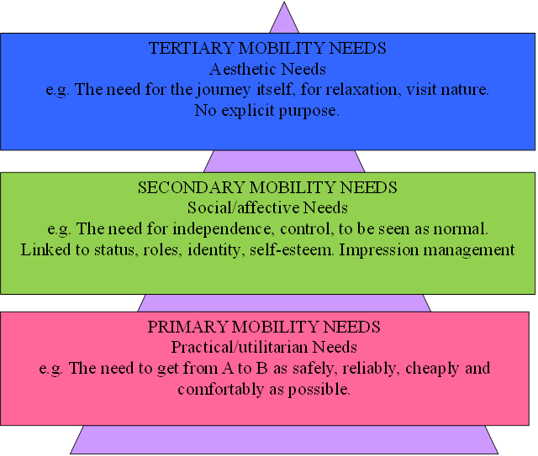
Figure 1: Hierarchy of travel needs in later life (after Musselwhite and Haddad, 2010)

Methods
Design
Semi structured interviews were carried out with 48 individuals over the age of 65 years to explore travel and mobility needs and behaviour. The research included three different groups selected on their usual mobility mode: (1) regular drivers (2) people who usually walk; (3) regular bus users and; (4) non-drivers who regularly rely on friends and family (who don’t live with them).
Participants
Participants were sought through the research network of older people in South Wales, United Kingdom, answering an advert for people in the four categories. People were placed into each category if they used that mode most often for their journeys. A cut off of 12 people in each category was sought. A total of 48 participants took part (see table 1) with an average age of 74.3 years, 31 were cohabiting with a partner, 11 lived alone and 4 lived in a residential care home (3 in an extra care facility, 1 care home) and 2 lived with their family (both with their children). They were asked to self-report their health on a scale from 1 very poor to 9 very good. An average of 6 on the scale was found overall with the highest average, indicating best average health, among the people who walked and lowest among the people getting lifts.
 | n | Age range (average) | Living arrangement | Health (self-score 1=poor to 9 =good)
Context 1: Drivers | 12 | 63-87 (73.3) | In couple, = 11  On own=1 | 6.5
Context 2: Bus users | 12 | 65-88(72.7) | In couple = 10  On own = 2 | 6.5
Context 3: Lifts from family and friends | 12 | 72-92 (78) | In couple =4  On own = 4  Residential home = 2  With family=2 | 5
Context 4: Walkers | 12 | 65-85 (71.1) | In couple =6  On own = 4  Residential home = 2 | 8
Total | 48 | 65-92 (74.3) | In couple =31  On own = 11  With family = 2  Residential home = 4 | 6
Table 1: Participants in the study.
Procedure and tools
Interviews took place in participant’s home or at an agreed public location and lasted around one hour. Participants were free to talk around set themes using apprenticing and abstraction style questions:
Apprenticing (Robertson and Robertson, 1999) allowed the participant to describe their everyday experience with mobility, for example the interviewer would ask “take me through a recent trip you went on step by step”.
Abstraction (Robertson and Robertson, 1999) asks the participant what would happen to their everyday mobility if their experience was different. It involves both counterfactual detail, to ask participants what if they themselves were different (for example if they were older, less mobile or less healthy) and scenario testing (presenting the scenario of the other two contexts, so, for example, for those walking, what would be the difference if they used community transport or drove for that trip).
Analysis
A common thematic analysis took place. Data was recorded and then transcribed word for word, and key themes highlighted. Etic (stemming from themes derived from previous theory, models and literature) and emic (stemming from the analysis of the data itself) coding was then employed on the data. Etic codes looked to place the data within categories of practical, psychosocial or aesthetic need based on Mussselwhite and Haddad’s (2010) model among the three different groups of participant and additional challenges to the model found through emic style analysis.

Findings
Findings from all four groups of older people are framed here around Musselwhite and Haddad’s three tier model (Musselwhite and Haddad, 2010). It is clear to see that, as expected, the car easily fulfils all three levels of need among older people, whereas walking, using public transport or getting lifts only find needs partly met, with psychosocial needs especially being neglected.
Utilitarian needs
For all groups the significant importance of the car in meeting utilitarian needs, such as carrying items and the ease of the door-to-door convenience, was frequently mentioned by drivers and missed by non-drivers,
“Bringing stuff back when you’ve been shopping. I mean I, we struggle to carry it now” (male, driver, aged 76)
How the car keeps people connected to the activities that they see as vital is frequently mentioned throughout the interviews, especially with regards to shopping and meeting appointments ,
“We have so many health things going on. We are in and out the hospital for appointments or down the doctors. Doing that now without a car. It’s how it takes up a whole day and it’s exhausting ” (male, bus user, aged 80)
Walking to do shopping or to visit the hospital or doctors was seen as difficult, if not impossible by many due to geographical distance or the physical effort,
“You just can’t do it. It mean they expect you’ll arrive by car so they schedule it like it” (female, walker, aged 78)
Those that did achieve shopping on foot as a pedestrian, had found ways to overcome the physical burden, either by going regularly or having the shopping delivered,
“It’s only me, so I don’t actually have a great deal to bring back, so all I do is go regularly. I enjoy the walk, so I like to do it daily if I’m feeling up to it and the weather’s not too bad” (female, walker, aged 74)
“The shop does this wonderful thing where I can shop and they bring it laer on in a van! So I can still walk, chose my shopping things and not have to carry it back. If I’m lucky the driver brigns it right in to the kitchen too” (Female, walker, aged 79)
Naturally to get shopping or visit services, getting lifts from friends and family was most common and satisfied most utilitarian needs,
“Having help. I mean we couldn’t do it without them. My daughter comes once a week and gets the shopping we need” (Male, friends and family help, aged 81)
Sometimes the help supplements carrying items for themselves,
“I’m lucky to have good neighbours, and they’re good friends too. They help me and get stuff in when I need it. The bigger things you know. Or sometimes on offer things, it’s the big things on offer I can’t carry and I miss out on. Treats like lemonade!” (Female, walker, aged 77)
Car drivers become very used to being able to use a car when they want to,
“It’s just so convenient to go when I want to. To have no timetable. I just can go to the shops anytime and return when I like” (female, driver, aged 77)
However, this is somewhat a perception as is indicated in some conversations about driver’s compensating for changes in physiology or health,
“I don’t drive when it’s busy or at night, now. That’s a blessing I don’t have to. I don’t really need to go out at those times anyway and if I do I’ll use a taxi or bus” (male, driver, aged 80)
This is somewhat missed for bus users and those getting lifts,
“You are reliant on how reliable the bus is. I mean they are every half hour in the day but they don’t seem to always run or stick to the timetable. There is, I guess, lots of waiting around for us, that you wouldn’t get in a car”
“I have to wait for Nancy to be ready. She can’t do Thursdays or the weekend either. We try to go shopping every Monday but I can’t just go when I want then see, like I could when I had a car” (female, lift from friends and family, aged 85)
Where friends and family weren’t available these needs were often met with a taxi more often than a bus,
“Taxi is expensive but once a week for shopping it’s idea. Get a good driver they’ll always bring stuff in for you too” (female, walker, aged 78)
People who walk regularly are more able to go when they want but it is dependent on a number of factors,
“Walking is quite free, free to use, free to go when you want to, in that sense, you can go when and where you want yes, up to a point. But awful weather or dangerous roads, no pavements and the like stop the routes I walk on” (male, walker, aged 74)
Personal safety was mentioned as being a concern for those walking and for using buses, but never those using cars, wither as a driver or getting a lift,
“I am worried about being attacked. You hear about it all the time. Old people are always vulnerable and when I’m walking I could be attacked yes I suppose I could. It does play on my mind a little but hey it hasn’t happened yet” (male, walker, aged 80)
Concerns about falls are there for those walking and using a bus too, but again not for people using a car. In fact the car was thought to mitigate falls
“The driver can be, you know, a bit unkind, can take off with us oldies still finding our seat and you can tumble over. It happened to Mrs Jones up the road” (female, bus user, aged 80)
“The pavements can be really bad. I did stumble and have a little fall. Took me a while to get back to it. I don’t know if it was because I was old or the pavement was bad. Probably both” (female, walker, aged 78).
“It’s an advantage of the car isn’t it. I’m not stable on my feet nowadays and getting on a bus or walking too far would be difficult for me. I have fallen a couple of times while walking. The car gets me as close as possible <to where I want to go> and that helps” (male, driver, aged 80)
Only walkers mentioned concerns about road safety,
“Cars nowadays go so fast, without a concern for us pedestrians. Crossing the road is a particular trouble for me. I don’t like walking or crossing near lots of cars” (male, walker, aged 80)
Drivers all stated they wouldn’t drive if they felt they were unsafe, even a few admitting they probably weren’t as good as they once were,
“I would stop immediately I didn’t feel safe. I know I’m probably a little slower and slower to react but I am still safe” (male, driver, aged 82)

Psychosocial needs
The independence and perceived freedom that driving gives individuals was frequently discussed and was lamented when people had to give-up driving. Walking places was sometimes mentioned in conjunction with independence, but independence was very much missing from people using buses or getting lifts. Getting lifts was very much seen as reducing independence and the feeling of a sense of being a burden was really felt,
“It’s the lost independence you know that’s the worse, that the car used to give you. I really miss that freedom. ” (male, bus user, aged 75)
“I can get lifts but I feel a burden. They don’t make me feel a burden. I just do! I just wish I could still drive myself!” (female, lifts, aged 83)
Driving and owning a vehicle was related to status,
“I drive the car I got when I retired. I worked for that. I’m proud of it.” (male, car driver, aged 74)
Using a bus was opposite to gaining status,
“Well I never saw myself using a bus, not when I had a car but now I do, I suppose there is a little embarrassment, people do rib me. But I actually enjoy it. Buses are much better these days” (male, bus user, aged 80)
Walking had some relationship to status as being seen as being fit enough to walk in later life was valued,
“Well I’m proud to be as fit as I am. I’m as fit as someone half my age and fitter than most youngsters these days.” (male, walker, aged 80)
The role of the car to help others was often mentioned by drivers but not through walking, using a bus or getting lifts from family and friends,
“I can help look after grandchildren, take and pick up from school, with the car you see and that way I feel I’m a real help, I’m really enjoying being a grandmother” (female, aged, 74)
People talk about the car that they drive in very passionate terms, how it is part of their life. This is not mirrored for those walking, using a bus or getting lifts,
“The car gives you a sense of freedom, of pride, something I connect to. It’s mine. I look at it and it’s taken me through all good times and bad, to France on holiday, to visit friends and family, to help my wife to and from hospital. I don’t want to lose it” (male, driver, aged 80)

Aesthetic needs
Difference between walking and the car is that even in utilitarian or practical trips, enjoyment of walking is mentioned much more frequently. Walking as a source of exercise made the walkers feel good, and gave them a chance to stop and chat. This wasn’t mentioned with driving,
“I do really enjoy the walk. I visit more shops than I need to. Stop and natter. Have a look round.” (male, walker, aged 76)
“The walking makes me feel better I suppose. I feel less stiff and even though I might feel tired afterwards I feel sort of refreshed. I don’t feel that driving, I always got stressed about parking and the traffic and it became such a worry” (female, walker, aged 80)
The car can connect people to aesthetics of the nearby places, with green (countryside, woodlands, parks) and blue (rivers, lakes, seaside) environments being visited or driven past, mentioned frequently in that sense it can be relaxing,
“Driving past the mountains or through the valleys, open road, all different weathers, all different seasons, it’s beautiful. God’s own country” (male, driver, aged 70)
There are mixed views over whether driving itself is relaxing,
“Driving isnt what it was. It is so busy now. And much less courtesy on the road” (male, aged 83, driver)
“I find driving is good for me. Helps me relax. I go for a drive when I’m feeling wound up. It’s a release. I put the radio on, listen to a good play or book” (male, driver, aged 85)
There are also mixed views on the bus, largely depending upon availability of the services in the area. Those who had frequent bus services tended to see the bus as a third space, as a place for chatting, socialising and visiting places for the sake of the journey. The social situation of the bus also mattered. If it was uncrowded or had people of similar backgrounds and ages then the bus was seen as relaxing and enjoyable, potentially satisfying aesthetic needs. If the bus was infrequent or crowded then it was simply used for utilitarian purposes,
“I love the bus. It’s a place I regularly see someone I know to chat to and I often use it to go to places for a cuppa tea and a cake, down to the seaside, nice service that” (female, bus user, aged 79)
“I use the bus to go to my club, have lunch and then come home. I can half a quick half of beer too then. And some more!” (male, bus user, aged 80)
“the bus takes so long to get anywhere decent, I’m only using it for the essentials” (male, bus user, aged 84)
Whether aesthetic needs are occasionally met by lifts from family and friends varied depending upon the relationship of the older person and the provider of the lift. More often than not it was felt that going out just to see the world going by was deemed unnecessary and not worthy of taking up the time of someone providing the lift,
“people did offer but I really didn’t want to, well it would mean people travelling a long way to come and get me and take me somewhere …..” (female, lift from family and friend, aged 89)
“Erm, I hadn’t even thought about it really to be honest, er, I probably could have asked two people, erm but I would have felt really cheeky asking” (female, lift from family and friend, aged 80)

Discussion
It is easy to place transport and mobility needs of older people around Musselwhite and Haddad’s (2010) three tier model. All three levels of need, practical, psychosocial and aesthetic are discussed in detail by the participants in the interviews. All three levels seem important to older people and their quality of life. This is especially evident when one of the level of needs is not being met by the current transport mode being used. Each level of need is not met in the same way by different modes of transport. Driving your own vehicle meets all three levels of need easily and this can be seen as a major attraction of the car (see figure 2).
Walking meets psychosocial needs and aesthetic needs well (see figure 3). However, walking does not satisfy practical needs well. The reason why such needs are not met by walking, however, are largely because of the dominance of a car-based culture, much of which could be changed by good planning and design. For example, the distances and the times of day needed to travel to meet healthcare obligations and appointments at hospitals and doctor surgeries means it is hard to travel to these on foot. Many urban areas across High Income Countries have seen an agglomeration of healthcare at the fringes of the central districts, built on cheap land, placing staff and facilities together, passing on the cost of transport and mobility to staff and patients. The easiest way to attend such healthcare is by car or possibly in some cases by bus. Older people have more healthcare appointments than other age groups and hence spend more time at such locations. Solutions include better planning to ensure healthcare is provided within walking distances of major conurbations. Planning, needs to value transport and accessibility and in particular placing accessibility on foot high up on the benefits when making decisions about agglomeration of healthcare. Healthcare appointments need to be made taking into account older people’s travel needs. They need to be allowed to make them at times of day when walking can occur, keeping older people from having to walk in the dark or in poor weather, for example. There also needs to be a re-focus on reducing the necessity to attend in person, perhaps through tele-health and tele-care facilities or having smaller satellite health clinics in local places for routine appointments (Musselwhite et al., in press).
People also struggle to walk to satisfy their shopping needs. Again, in High Income Countries out of town shopping centres, especially large supermarkets, based on accessibility by car and bulk buying are inaccessible on foot. Out of town shopping centres and large supermarkets have a knock-on effect on local shops, reducing the number of smaller supermarkets and convenience shops in neighbourhoods that are walkable too. This is, of course, circular in nature, so with fewer local shops, the less likely people are to walk, the fewer walking, the less likely shops are needed in the local area. Again, planning could change this, helping local shops to stay open with reduced rents or taxes, building in shops to planning conditions, as well as reducing the ease and the amount of out of town shops allowed. There were also some good examples were given, where shops will deliver the shopping for people, reducing the need to carry heavy items. Encouraging use of shopping online can also help. People who walk cannot always visit family and friends easily.
Accessibility for walking also needs to be improved at the microscopic level. There needs to be well kept pavements, free from clutter and away from busy traffic. These need to be maintained and gritted in poor weather. They need to be well-lit, and have benches, for resting, and trees, for shelter from sun or rain, along them.
Many people nowadays have friends and family dispersed around the country and without using motorised transport and staying connected with such people is hard. Older people are more likely than any other age group to say they would like to visit friends and family more often but mobility stops them doing so. Telephone and video calls (such as skype and similar) help people stay connected but generally raising awareness of the importance of family or friend visits and keeping people from being isolated and lonely is vital. Services provided to support people from being isolated and lonely need to take into account mobility and accessibility.
Using the bus with heavy items can be problematic and there are safety concerns about sharing with other passengers and most notably the bus driver driving the bus off before the person has sat down. There are examples of bus companies training their drivers to be age aware and to consider the needs of older passengers more. Gilhooly et al. (2002) found the highest barrier to public transport use amongst older people was personal security in the evening and at night, followed by transport running late and having to wait. A report using accompanied journeys in London has highlighted similar problems for older people including crowds at the bus stop or on the bus, not being able to sit on buses, fear of falling getting on and off buses and fear of falling over when the bus moves off (TfL, 2009). Broome et al. (2010) in an Australian study found that driver friendliness, ease of entry/exit and information usability were prioritised barriers and facilitators for older people on buses.
The psychosocial element tends to be absent once driving has ceased especially for public transport users and people who get lifts from family and friends. The independence and freedom is not only absent from people who mainly gets lifts, but there is an additional sense of being a burden on other people. This can be mitigated through reciprocation, the offer to cook or buy a meal or to offer payment for petrol or parking, for example, but this does not come close to the freedom associated with driving oneself. The ability to drive when and where you please is also lost in other forms of transport, even when people do not do that. This is termed the potential for travel (Metz, 2000) and no other transport quite affords such luxury. However, there is somewhat of a disconnect between perception of freedom that car offers and the reality which is often constrained. For example, older people talked about deliberately restricting their driving to times and roads they felt comfortable on, avoiding busy traffic, poor visibility, difficult turns or merges reducing the freedom of the car. Walking also offers similar perception of freedom to travel when people want but again restrictions on walking in poor weather or in the dark occur. Also, walking is restricted by how far physically the person can walk.
The dominance of the car as a desirable vehicle that satisfied human psychological needs is hardly matched by other modes. People are sold freedom, independence, esteem and identity through advertising and marketing by the car, that other modes just don’t match. Car companies spend huge resources on getting the aesthetics right targeting both psychosocial and aesthetic travel needs, making the car a desirable space to be in. Bus companies are beginning to do so, offering better quality interior, leather seating, air conditioning, climate control, large windows, ambient lighting, wifi, but more still needs to be done to get close to cars.
Aesthetic needs are best met by the car. People can travel to see the world going by, to see nature, to just get “out and about”. This is especially the case for people who drive themselves, but can occur with lifts from friends and family. There is anxiety about asking for lifts, viewing such travel as unnecessary and burdensome. Recognition that such “discretionary” travel is in fact important for health and wellbeing needs further emphasis (Musselwhite, 2017). Travel does not always have to have an explicit purpose for it to be worthwhile and valuable. The bus can serve this need and can be seen as a “third space”, a space for “people watching”, for watching the world go-by, for interacting with other passengers. However, the bus must be (perceived as) comfortable and accessible before this can happen. Aesthetic needs can be met by walking, if the public realm is well designed to allow it to happen. There must be space for people to walk, to sit and watch. Places need to be desirable to facilitate walking, as much as they are accessible (Musselwhite, in press). They must have character and identity, reflecting local culture and history to give people a sense of place and legitimacy to be there. There should be continuity to facilitate walking yet some mystery and intrigue to entice people in, to make people want to dwell.
Conclusion
Overall, it can be seen that driving satisfies all three levels of needs better than other modes do. Figures 2-5 show how far each need is met by each form of transport. Psychosocial needs are only met by driving and by walking. There is potential for aesthetic needs to be met by all modes of transport dependent on other factors. For walkers, this is getting an attractive and desirable public realm to walk in. For people getting lifts, this is making the people provide lifts understand how important a journey itself is or a journey to visit countryside or the seaside is. For those using buses, it is dependent upon having good quality bus services that serve attractive areas. Practical mobility needs can be met across all modes of transport, though there is greatest difficulty in doing this through walking, especially through modern day car-centric planning, followed by using the bus because of difficulty in carrying items and concerns over personal safety. In understanding services beyond the car, there is a need to address all three levels of need, most notably a need to address psychosocial needs that are limited in other modes of transport and ensuring aesthetic and practical needs can be met. Practical support is found quite widely, but without understanding the affective elements of car use will not fulfil older people’s needs and as a result will not necessarily help reduce negative health associated with giving-up driving. More of this support is needed as society becomes ever more geared around the car and future generations of older people will have used a car almost all of their adult life and geared their life around the car, making the move to alternative ways of travelling even more difficult.

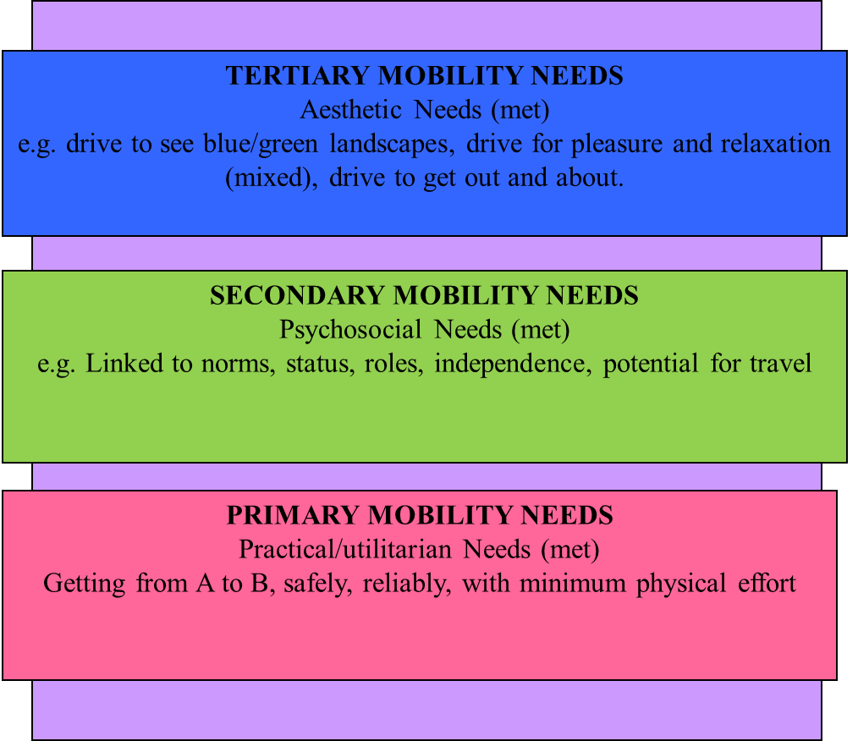
Figure 2: The car meets all three levels of Musselwhite and Haddad (2010) older people’s mobility needs

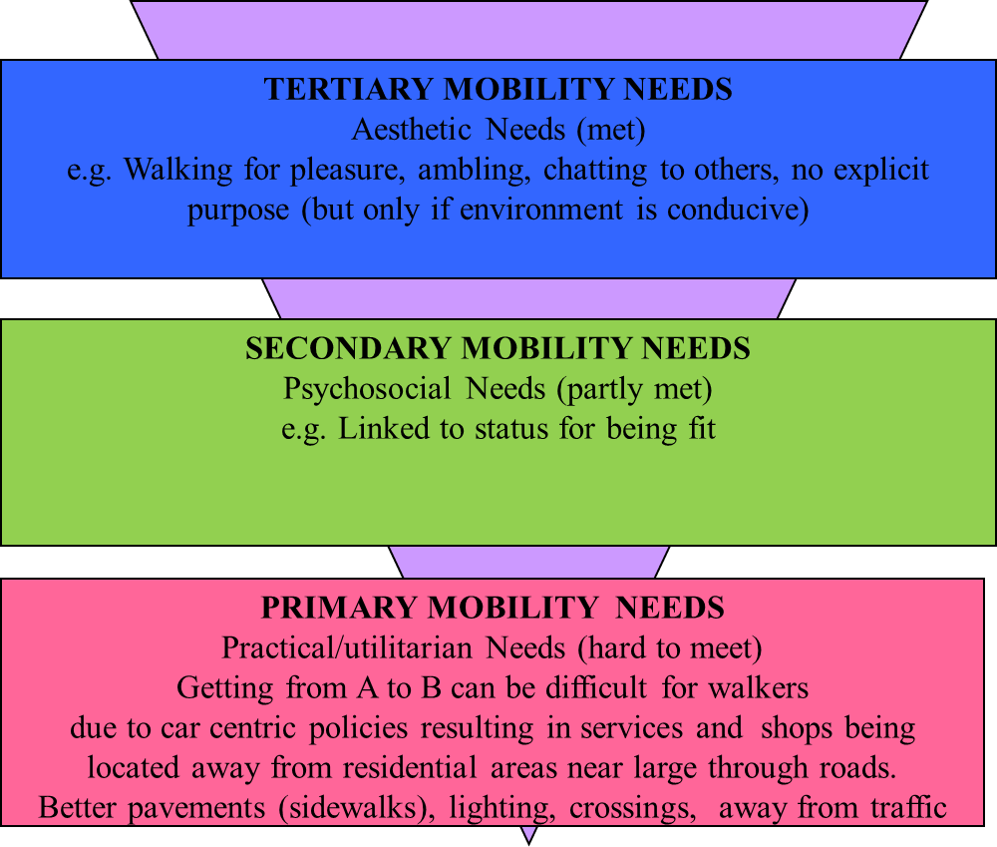
Figure 3: Walking meets aesthetic needs, some psychosocial needs but few mobility needs

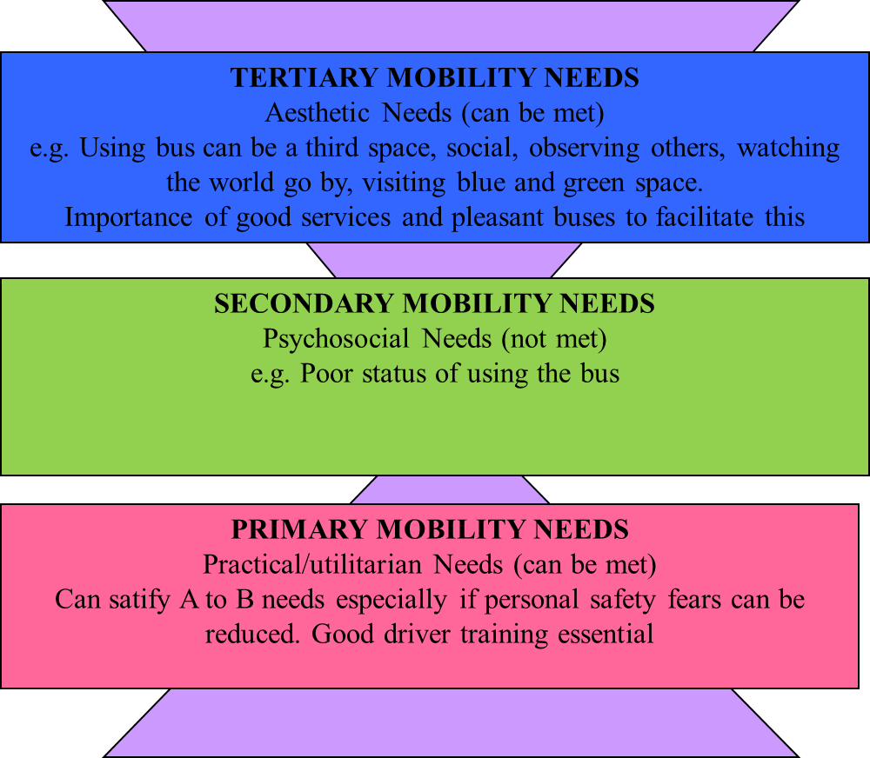
Figure 4: Using the bus can meet practical and aesthetic mobility needs but not psychosocial mobility needs of older people

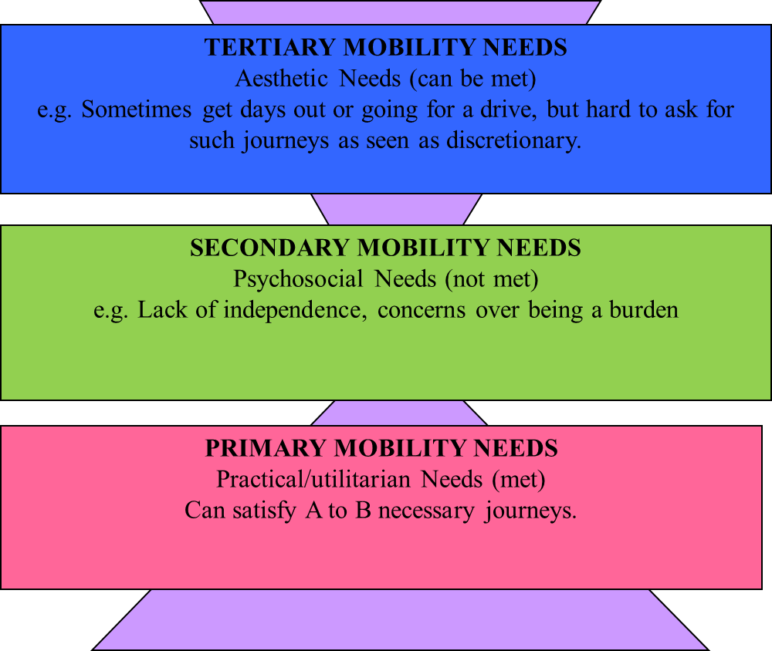
Figure 5: Getting a lift can meet practical mobility needs and sometimes can be aesthetic mobility needs but does not meet psychosocial mobility needs of older people.

References
Adler, G. and Rottunda, S. (2006) Older adults’ perspectives on driving cessation. Journal of Aging Studies 20(3), 227–235.
Anstey, K. J., Windsor, T. D., Luszcz, M. A., and Andrews, G. R. (2006). Predicting driving cessation over 5 years in older adults: Psychological well-being and cognitive competence are stronger predictors than physical health. Journal of the American Geriatrics Society, 54, 121-126
Arcury, T. A., Gesler, W. M., Preisser, J. S., Sherman, J., Spencer, J. and Perin, J. (2005) The effects of geography and spatial behavior on health care utilization among the residents of a rural region. Health Services Research 40, 135–156.
Ball, K., Owsley, C., Stalvey, B., Roenker, D. L., Sloane, M. E., and Graves, M. (1998). Driving avoidance and functional impairment in older drivers. Accident Analysis & Prevention, 30, 313-323.
Braitman, K. A., & Williams, A. F. (2011). Changes in self-regulatory driving among older drivers over time. Traffic Injury Prevention, 12, 568-575
Brayne, C., Dufouil, C., Ahmed, A., Dening, T. R., Chi, L. Y., McGee, M., & Huppert, F. A. (2000). Very old drivers: Findings from a population cohort of people aged 84 and over. International Journal of Epidemiology, 29, 704-707.
Broome K, Nalder E, Worrall L, and Boldy D. (2010) Age-friendly buses? A comparison of reported barriers and facilitators to bus use for younger and older adults. Australias J Ageing. 29(1), 33-8.
Chipman, M., Payne, J., & McDonough, P. (1998). To drive or not to drive: The influence of social factors on the decisions of elderly drivers. Accident Analysis & Prevention, 30, 299-304.
Davey, J. A. (2007) Older people and transport: coping without a car. Ageing and Society 27, 49–65.
Dellinger, A.M., Kresnow, M.J., White, D.D., Sehgal, M., 2004. Risk to self versus risk to others: how do older drivers compare to others on the road? Am. J. Prev. Med. 26 (3), 217–221.
DfT (Department for Transport, UK) (2016) Transport Statistics Great Britain: 2016. DfT: London. Available at: https://www.gov.uk/government/statistics/transport-statistics-great-britain-2016 (accessed 15 September 2017).
Edwards, J. D., Perkins, M., Ross, L. A. and Reynolds, S. L. (2009) Driving status and three-year mortality among community-dwelling older adults. Journal of Gerontology Series A: Biological Sciences and Medical Sciences, 64, 300–305.
Fonda, S. J., Wallace, R. B. and Herzog, A. R. (2001) Changes in driving patterns and worsening depressive symptoms among older adults. The Journal of Gerontology, Series B: Psychological Sciences and Social Sciences 56(6), 343–351.
Gallo, J. J., Rebok, G. W., and Lesikar, S. E. (1999). The driving habits of adults aged 60 years and older. Journal of American Geriatrics Society, 47, 335-341
Gilhooly, M.L.M., Hamilton, K., O’Neill, M., Gow, J., Webster, N., Pike, F. and Bainbridge, C. (2002) Transport and ageing: Extending quality of life via public and private transport. ESCR Report L48025025, Brunel University Research Archive.
Hakamies-Blomqvist, L. and Siren, A., (2003). Deconstructing a gender difference: driving cessation and personal driving history of older women. Journal of Safety Research 34, 383–388
Hakamies-Blomqvist, L. and Wahlström, B., (1998). Why do older drivers give up driving? Accid. Anal. Prev. 30, 305–312
Harrison, A. and Ragland, D. R. (2003) Consequences of driving reduction or cessation for older adults. Transportation Research Record 1843, 96–104.
Ling, D. J. and Mannion, R. (1995) Enhanced mobility and quality of life of older people: Assessment of economic and social benefits of dial-a-ride services. In: Proceedings of the Seventh International Conference on Transport and Mobility for Older and Disabled People, Vol. 1. DETR: London.
Marottoli, R. A., C. F. Mendes de Leon, T. A. Glass, and C. S. Williams. (1997). Driving Cessation and Increased Depressive Symptoms: Prospective Evidence From the New Haven EPESE. Journal of the American Geriatrics Society 45: 202–206.
Marottoli, R. A., Mendes de Leon, C. F., Glass, T. A., Williams, C. S, Cooney, L. M. and Berkman, L. F. (2000) Consequences of driving cessation: decreased out-of-home activity levels. Journals of Gerontology: Series B, Psychological Sciences and Social Sciences 55B(6), 334–340.
McNamara, A., Chen, G., George, S., Walker, R., & Ratcliffe, J. (2013). What factors influence older people in the decision to relinquish their driver’s licence? A discrete choice experiment. Accident Analysis & Prevention, 55, 178-184.
Metz, D. (2000) Mobility of older people and their quality of life. Transport Policy 7, 149–152.
Mezuk, B. and Rebok, G. W. (2008) Social integration and social support among older adults following driving cessation. Journal of Gerontolology Social Science 63B, 298–303.
Mollenkopf, H., Hieber, A. and Wahl, H-W. (2011) Continuity and change in older adults’ perceptions of out-of-home mobility over ten years: a qualitative-quantitative approach. Ageing & Society 31(5), 758–781.
Musselwhite, C. (in press). Creating a convivial public realm for an ageing population. Being a pedestrian and the built environment in C.Musselwhite (ed.). Transport, Travel and Later Life. Emerald Publishing.
Musselwhite, C.B.A. (2017) Exploring the importance of discretionary mobility in later life. Working with Older People, 21, 1, 49-58.
Musselwhite, C., Freeman, S. and Marston, H.R. (in press) An Introduction to the Potential for the Mobile eHealth Revolution to Impact on Hard to Reach, Marginalised and Excluded Groups in H. Marston, S.Freeman and C.Musselwhite (eds.), Mobile e-Health, Human–Computer Interaction Series, Springer. DOI 10.1007/978-3-319-60672-9_1
Musselwhite, C. B. A. and Haddad, H. (2010) Mobility, accessibility and quality of later life. Quality in Ageing and Older Adults 11(1), 25–37.
Musselwhite, C.B.A. and Shergold, I. (2013) Examining the process of driving cessation in later life. European Journal of Ageing 10(2), 89–100.
Office for National Statistics (2013b) National population projections, 2012-based. Available at: http://www.ons.gov.uk/ons/dcp171778_334975.pdf (accessed 15 September 2017).
Peel, N., Westmoreland, J. and Steinberg, M. (2002) Transport safety for older people: a study of their experiences, perceptions and management needs. Injury Control & Safety Promotion 9, 19–24.
Persson, D. (1993) The elderly driver: deciding when to stop. Gerontologist, 33, 88-91
Rabbitt, P., Carmichael, A., Jones, S., and Holland, C. (1996). When and Why Older Drivers Give up Driving. AA Foundation for Road Safety Research.
Ragland, D. R., W. A. Satariano, and K. E. MacLeod. 2005. Driving Cessation and Increased Depressive Symptoms. The Journals of Gerontology Series A: Biological Sciences and Medical Sciences 60: 399–403.
Rosenbloom, S. (2001) Sustainability and automobility among elderly: An international assessment. Transportation 28, 375–408.
Sims, J., Rouse-Watson, S., Schattner, P., Beveridge, A., Jones, K.M., 2012. To drive or not to drive: assessment dilemmas for GPs. Int. J. Fam. Med. 2012, Article ID 417512
Siren, A. and Hakamies-Blomqvist, L. (2009) Mobility and well‐being in old age. Topics in Geriatric Rehabilitation 25, 3–11.
Taylor, B. D. and Tripodes, S. (2001) The effects of driving cessation on the elderly with dementia and their caregivers. Accident Analysis and Prevention 33, 519–528.
TfL (2009) Older people’s experience of travel in London. Transport for London: London. Available at: http://www.tfl.gov.uk/cdn/static/cms/documents/older-peoples-transport-experiences-report.pdf (accessed 15 September 2017).
United Nations (UN) (2015) World Population Ageing. United Nations: New York. Available at http://www.un.org/en/development/desa/population/publications/pdf/ageing/WPA2015_Report.pdf (last accessed 15 September2017)
WRVS (2013) Going Nowhere Fast. Impact of inaccessible public transport on wellbeing and social connectedness of older people in Great Britain. Available at: http://www.royalvoluntaryservice.org.uk/Uploads/Documents/Reports%20and%20Reviews/Trans%20report_GB_web_v1.pdf (last accessed 15 September 2017)
Ziegler, F. and Schwanen, T. (2011) I like to go out to be energised by different people: an exploratory analysis of mobility and wellbeing in later life. Ageing and Society 31(5), 758–781.
Windsor, T. D., Anstey, K. J., Butterworth, P., Luszcz, M. A. and Andrews, G. R. (2007) The role of perceived control in explaining depressive symptoms associated with driving cessation in a longitudinal study. The Gerontologist 47, 215–223.

