Cronfa - Swansea University Open Access Repository_______________________________________________________________________
This is an author produced version of a paper published in:
Cronfa URL for this paper:
http://cronfa.swan.ac.uk/Record/cronfa26974
_______________________________________________________________________
(2016).
http://dx.doi.org/10.1108/IJEBR-12-2014-0227
_______________________________________________________________________
This item is brought to you by Swansea University. Any person downloading material is agreeing to abide by the terms of the repository licence. Copies of full text items may be used or reproduced in any format or medium, without prior permission for personal research or study, educational or non-commercial purposes only. The copyright for any work remains with the original author unless otherwise specified. The full-text must not be sold in any format or medium without the formal permission of the copyright holder.
Permission for multiple reproductions should be obtained from the original author.
Authors are personally responsible for adhering to copyright and publisher restrictions when uploading content to the repository.
http://www.swansea.ac.uk/library/researchsupport/ris-support/
Cronfa - Swansea University Open Access Repository_______________________________________________________________________
This is an author produced version of a paper published in:
Cronfa URL for this paper:
http://cronfa.swan.ac.uk/Record/cronfa26974
_______________________________________________________________________
(2016).
http://dx.doi.org/10.1108/IJEBR-12-2014-0227
_______________________________________________________________________
This item is brought to you by Swansea University. Any person downloading material is agreeing to abide by the terms of the repository licence. Copies of full text items may be used or reproduced in any format or medium, without prior permission for personal research or study, educational or non-commercial purposes only. The copyright for any work remains with the original author unless otherwise specified. The full-text must not be sold in any format or medium without the formal permission of the copyright holder.
Permission for multiple reproductions should be obtained from the original author.
Authors are personally responsible for adhering to copyright and publisher restrictions when uploading content to the repository.
http://www.swansea.ac.uk/library/researchsupport/ris-support/
Cronfa - Swansea University Open Access Repository_______________________________________________________________________
This is an author produced version of a paper published in:
Cronfa URL for this paper:
http://cronfa.swan.ac.uk/Record/cronfa26974
_______________________________________________________________________
(2016).
http://dx.doi.org/10.1108/IJEBR-12-2014-0227
_______________________________________________________________________
This item is brought to you by Swansea University. Any person downloading material is agreeing to abide by the terms of the repository licence. Copies of full text items may be used or reproduced in any format or medium, without prior permission for personal research or study, educational or non-commercial purposes only. The copyright for any work remains with the original author unless otherwise specified. The full-text must not be sold in any format or medium without the formal permission of the copyright holder.
Permission for multiple reproductions should be obtained from the original author.
Authors are personally responsible for adhering to copyright and publisher restrictions when uploading content to the repository.
http://www.swansea.ac.uk/library/researchsupport/ris-support/
Cronfa - Swansea University Open Access Repository_______________________________________________________________________
This is an author produced version of a paper published in :
Cronfa URL for this paper:
http://cronfa.swan.ac.uk/Record/cronfa26974
_______________________________________________________________________
(in press).
http://dx.doi.org/10.1108/IJEBR-12-2014-0227
_______________________________________________________________________
This article is brought to you by Swansea University. Any person downloading material is agreeing to abide by the terms of the repository licence. Authors are personally responsible for adhering to publisher restrictions or conditions. When uploading content they are required to comply with their publisher agreement and the SHERPA RoMEO database to judge whether or not it is copyright safe to add this version of the paper to this repository.
http://www.swansea.ac.uk/iss/researchsupport/cronfa-support/
Abstract
Purpose
The Holy Grail of leadership learning is to stimulate behavioural changes that continue beyond the learning environment into the workplace, ultimately leading to improved productivity and value. This study explores the interface between emotion and leadership learning and provides evidence from research undertaken in Wales (UK) to support further research on the use of emotion in this endeavour.
Approach
Unique access to a successful programme of guided leadership development for owner-managers of SMEs in Wales, UK, provided an opportunity to observe emotion being used and experienced by both learners and trainers. Literature reviews were used to inform initial inferences made during participant observations of a sample of the learners (N=91). Focus groups were undertaken with a sample (N= 27) of participants in order to determine the emotional impact and perceived effectiveness of the method by the learners.
Findings
The data corroborated the authors’ observations that emotion plays a role in the leadership practice of the learners and in the learning process. No appropriate conceptual model exists that describes this learning method or its mode of impact upon learning. A gap exists in the academic understanding of this observed social reality and multi-disciplinary research is required in order to further characterise and understand it.
Practical implications
Improvements in leadership have been consistently linked to improvements in firm performance. Bringing new insights that lead to effective learning and constructive behaviour changes in the leaders of SMEs and their employees could have profound positive impacts on entrepreneurial economies.
Originality/value
This novel perspective on leadership development within the life world of the entrepreneur moves away from the established literature which has traditionally focussed on cognitive or conative constructs, often focussed on the corporate or large organisation leader, and calls for further research into the synthesis of leadership, entrepreneurship and emotion.

Introduction
Effective leadership is one of the major factors of success in small and medium sized enterprises (SMEs) in the UK and Europe (Soriano and Martinez, 2007). Lack of leadership is cited as a cause of failure in firms and a risk to the national and regional economy. In 2008 the Welsh Assembly Government published its ‘Skills that Work for Wales’ report which stated:
“if we fail to improve workforce leadership and management skills and to apply those skills in the workplace, Welsh businesses will gradually find it more difficult to compete” (WAG, 2008).
The UK government has commissioned numerous reports in recent years which confirm the same (BIS LMNG, 2012; Keep et al, 2006; UKCES, 2010). Hayton (2015) points to entrepreneurship skills alongside leadership skills as being positively and directly associated with both turnover and productivity and that these skills lead to behaviours that mediate improvements in firm performance.
This lack skills is further compounded because in practice, many people who start up and cultivate SMEs do so without any formal prior entrepreneurship or business training and even fewer have exposure to formal leadership training before becoming the leader of their own organisation (Upton et al., 1995).
However, while there are many journal articles that discuss the types of leadership, (Bass, 1990; Dinh et al, 2014) and the importance of development (Day et al, 2014), the data for these typically comes from large companies. Leadership research is influenced by a tradition of leadership trait and model theories dating back to Socrates (Adair, 2009). This has led to over-simplification of the complex social reality of the leader. Thus the wider research around how leadership can be developed by entrepreneurs, how it can be taught and the factors that lead to successful learning has been largely neglected.
Minimal research agrees on what should be taught or developed Adair, 2009; Bolden and Terry, 2000) and even less on how leadership development for SMEs should be guided (Kempster, 2004). Understandably extant research has focussed on building on or breaking down existing theory and has a heavily quantitative focus (Stentz et al, 2012). None have been found that satisfactorily identify the link between emotion in learning with leadership development for entrepreneurs or the leaders of SMEs. This has left an opportunity to look at qualitative research into leadership and leadership development.
Since 2004, there has been a move towards integrated, non-instructional models of leadership learning in the UK (Kempster, 2004) and use of situational and experiential learning theory for entrepreneurs (Gibb, 1985; Rae, 1999). These learning types engage the learners in real world learning that relates to everyday experience.
In the field of adult education for SME leaders situated and experiential learning modes have been adopted widely in the UK on programmes like LEAD Wales, LEADER and GOLD. These programmes provide a social laboratory to observe affective and conative as well as a cognitive factors of leadership development – elements missing from the academic literature. This study introduces observations made during research into the LEAD Wales programme that supports calls in the literature for further research.
Background
This case study of the LEAD Wales programme explores the value of the affective element of learning in order to contribute to the literature regarding entrepreneurial leadership development. Previous research on this and its predecessor programme at Lancaster University (LEAD) (Henley and Norbury, 2011; Jones et al., 2012; Kempster and Cope, 2010) has focussed primarily on the characteristics of extant entrepreneurs and impacts of the pre-established learning model upon them or their firms (Henley and Norbury, 2011; Jones et al., 2012) rather than on effectiveness of pedagogies (Peters, 2010).
The LEAD Wales programme was funded to run at no cost to the participants in economically deprived areas of Wales. The target market for the programme is owner-managers or primary decision makers from micro and small companies in any business sector except agriculture or fisheries. These all fit within the term SME leader or entrepreneur.
The programme leant itself to the observation of emotion in entrepreneurial practitioner development as it utilised a mix of the non-traditional pedagogies and learning environments that have been used by others to incorporate emotive or emotional elements: peer-to-peer, experiential, situated, observed and formal learning (Peters, 2010; Pittaway (in press)). The participants were also exposed to the intentions and processes of research which is assumed to enhance credible participant-observation as well as open replies to questioning.
Emotion in leadership development
An initial literature review determined that the role of emotion in learning and teaching has become increasingly popular in the literature since the early 1980s. The contemporary theories on ‘emotional intelligence’ (Denzin, 1984; Gardner, 1983; Payne, 1985; Weiner, 1985) build on theories from psychology and neuroscience that non-intellectual aspects, such as emotion, have an impact on ‘intelligence’ or cognitive performance.
The role of these non-intellectual aspects in improving teaching specific to the field of entrepreneurship was rapidly introduced to practice. Kolb’s (1984) theories relating to experiential learning are regarded as the starting point for this work, in parallel with Gibb’s (1984) study on efficacy of peer to peer learning in educating established and nascent entrepreneurs. Shepherd’s (2003) study examining how to cope with negative emotions surrounding business failure started a wave of publications examining the role of emotion in learning from ‘entrepreneurial failure’ (a form of deep experiential learning and reflection) as well as using experience and emotion to impact more general entrepreneurship education. This work has evolved and is now a key element in the portfolio of innovative practices required for teaching entrepreneurship (Cope, 2011; Thorpe et al., 2009).
To evaluate the theories behind the design and delivery of a leadership development programme for entrepreneurs such as LEAD Wales, the authors undertook a narrative review of literature from the fields of leadership and education concentrating on the role of emotion in each and focussed on the context of the entrepreneur or entrepreneurial practitioner. The paucity of literature on the subject of emotion in leadership development for entrepreneurs led the authors to seek insights gained at the intersections between the component parts: interface 1 - emotion in education; interface 2 - leadership and education, and; interface 3 - emotion and leadership.
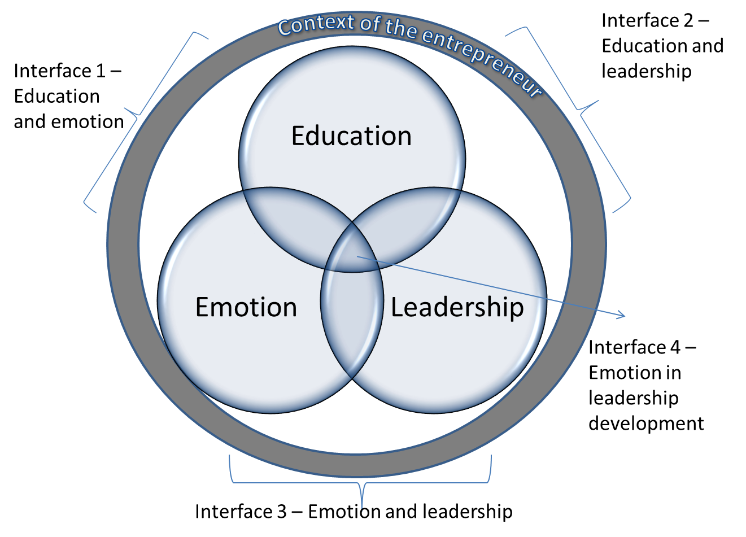
Figure 1. Diagram showing the four interfaces between education, emotion and leadership within the context of the entrepreneur (Huxtable-Thomas, 2016).
Table 1 summarises the extant literature on emotion in the context of the entrepreneur and emotion in teaching, as well as examining the research evaluating the role of emotion in leadership. No literature could be found which looked at the use of emotion when teaching or developing leadership in the context of the entrepreneur. This is described as ‘interface 4’ in Figure 1.

Table 1. Summary of a narrative literature review illustrated in Figure 1.
Topics | Summary | Sources
Interface 1  Emotion in (entrepreneurship) education. | The research is clear that emotion has a link with learning and that learning that includes an affective element is likely to be adopted and transferred into action more quickly and effectively.  Lackeus (2012) considers the interface of education, emotion and leadership in his review of literature around emotions in entrepreneurial education but fails to go into great depth on the role of emotion in leadership education for entrepreneurs. | Gibb (1987); Bagheri, and Lope Pihie (2013); Cope (2011); Cope and Watts (2000); Denzin (1984); Gardner (1983); Gibb and Scott (1985); Gibb and Ritchie (1982); Kolb (1984); Lackeus (2012); Payne (1985); Pittaway and Cope (2007); Pittaway and Rose (2006); Shepherd (2003); Shepherd (2004); Vail (1994).
Interface 2 Education and leadership | Research in this area is diverse, coming under three headings:  - The need for leadership education  - Methods of leadership education (focussing on the entrepreneur as leader)  - Reviews of entrepreneurial education including reference to leadership.  The research undertaken is limited and the diversity between suggests that fit at this interface points more towards a lack of cohesion than a comprehensive approach to research. The conclusions are that leadership development is of value to business and that it has been accepted that leadership can be learned (the leader as apprentice) the debate over whether leadership can be taught has not yet been satisfactorily answered. | Bolden (2001); Buller and Finkle (2013); Department for Business, Innovation and Skills Leadership and Management Network Group (2012); Hayton (2014); Hayton (2015); Henley and Norbury (2011); IfM Education and Consultancy Services Ltd (2010); Jones et al (2013); Jones et al (2012); Jones et al (2015); Kempster and Watts (2002); Kempster (2009); Kempster and Cope (2010); Peters (2010); Roomi and Harrison (2011); Rost (2000); Thorpe et al (2009); Walker et al(2007); Welsh Assembly Government (2008).
Interface 3 Emotion and leadership | Research has focussed around the use of emotion in improving business performance and conclusions are based on the management and use of emotion. Research focuses on the prevalence or otherwise of ‘emotional intelligence’ in successful leaders and the impact of emotion on decision making. | Northouse (2012); Butler and Chinowsky (2006); Goleman and Mckee (2002); Kahneman (2012); Kotter (1990).

Interface 1 - Emotion in (entrepreneurship) education
A search of the available literature turns up relatively few relevant papers specific to the subject of using emotion in teaching or influencing the leadership development of experienced entrepreneurs. Instead the literature looks at which of the emotional intelligence characteristics could be improved or taught, but not how to teach them. Similarly, Roomi and Harrison (2011) found that the literature was still agreeing and developing the characteristics of the entrepreneur but had not contributed in great depth or with certainty on the best practice for teaching entrepreneurship. The review found that emotive stimuli that might be suitable for use in teaching are not mentioned in any systematic way alongside leadership development. It is not apparent whether this is because it has not yet been established, because there is no demand for it or if, instead, the most relevant research forms the basis of proprietary training courses for which the content will be considered a trade secret. Regarding this, there is a lack of published research about ‘how’ to teach leadership development and an inevitable lack of findings about the outcomes of using emotion when teaching it. The most relevant literature was produced on the LEAD programme (Howarth et al, 2012; Kempster, 2009; Peters, 2010). However, this did not focus on the role of emotion in the learning process. This is further evidenced in a recent systematic review of entrepreneurial learning and entrepreneurial practice by Pittaway et al (in press).
While there was no relevant literature on the subject of emotions in leadership development for entrepreneurs, Lackeus (2012) published a review of emotions in entrepreneurial education. Although examining a different learning paradigm, this study provides a thorough review of previous research on emotions in entrepreneurial education as well as in other domains of research. Lackeus’s work was a relevant and comprehensive review of the literature that identified emotional intelligence being the only significant overlapping factor. Lackeus confirmed that the study of emotion in entrepreneurship education literature is in its infancy but, while citing the work of Gibb (1982, 1987), Kolb (1984) and Pittaway and Cope (2007), the emphasis remained on formal teaching as opposed to the peer to peer learning or experiential learning.
In the fields of pedagogy and psychology, the studies of double-loop learning (Argyris, 2002) and ‘slow thinking’ (Kahnemann, 2011) were relevant concepts but searches found any link to entrepreneurs focussed on cognitive not affective elements of decision making and reflection and considered these as ways of thinking, not ways of learning (Busenitz and Barney 1997; Busenitz 1999; Welch and Bussey, 2014).
It is not clear whether limited literature is due to the paucity of opportunities for new empirical research or limited interest or expertise in developing the subject. What is clear is that the study of emotions requires multi-disciplinary effort and a willing and captive audience of learners.

Interface 2 – (entrepreneurial) leadership and (entrepreneurship) education
Considering leadership in the context of the entrepreneur inevitably brings to mind ‘Entrepreneurial Leadership’. Roomi and Harrison (2011, p2) defined entrepreneurial leadership as “having and communicating the vision to engage teams to identify, develop and take advantage of opportunity in order to gain competitive advantage”.
Roomi and Harrison’s (2011) effectively summarised the literature on entrepreneurship education and leadership education. Despite a recommendation for further research into entrepreneurial leadership, little has been undertaken. From a multi-disciplinary perspective, research here has focussed on specific sectors, fields or cases (Bagheri and Lope Pihie, 2013; Buller and Finkle, 2013; Hancock et al., 2014). Much of the research for entrepreneurial leadership and entrepreneurial education has been on potential and early-stage ‘entrepreneurs’. There is some research to imply that improving leadership skills can improve performance of the experienced micro or small sized business owner (Bolden, 2001; Walker et al, 2007), however the impact of emotion in education on the entrepreneurial practitioner has minimal coverage. Even the most highly cited papers in the field such as Shepherd (2003) focus on the student or nascent entrepreneur with no mention being made of the established entrepreneur.
Interface 3 – emotion and leadership
Examples of peer reviewed research on emotion and leadership are limited although the subject is common in popular literature, for example Goleman and McKee (2002). That text posits a framework to describe the interface between emotional intelligence and leadership and ways in which to use emotional intelligence to optimise performance.
The most advanced developments in this interface have been in the area of ‘emotional labour’. Iszatt-White’s (2013) study on leadership as emotional labour examines multiple themes at the interface of leadership and emotion – management practice, organisational dynamics, change management and staff performance management. This multi-disciplinary study provides different perspectives on the leader but does not provide a whole picture. Iszatt-White demonstrates the range of possibilities for research into emotion and leadership, away from the traditional discipline of psychology, and demonstrates a multi-disciplinary approach where practice is informed by observation and development of new approaches.
A search of the literature illustrates few studies that mention using emotion in teaching or influencing the leadership development of experienced entrepreneurs. Instead the extant literature explores the emotional intelligence characteristics that could be improved or taught but not how to teach them, as previously noted by Roomi and Harrison (2011). The review found that emotive stimuli that might be suitable for use in teaching are not mentioned in any systematic way in the literature on leadership development. It is not clear whether this is because it has not yet been established, because there is no demand for it or if, instead, the most relevant research forms the basis of proprietary training courses for which the content will be considered a trade secret. Whatever the cause, there is a lack of research about ‘how’ to teach leadership development to entrepreneurs and an inevitable lack of findings regarding outcomes of using emotion when teaching it. Again, the most relevant literature was that produced on the LEAD programme (Howarth et al, 2012; Kempster, 2009) however this did not focus on the role of emotion in the learning process.
While the search demonstrated that emotion in leadership development of entrepreneurial practitioners is not an area that has been previously pursued, there are clues at each of the constructs as to how or why this could be done.
At interface 1 lie advances in experiential and situational learning developed for the nascent or potential entrepreneur which could be tested as methods to develop and teach leadership to the established entrepreneurial practitioner. At interface 2 is the acknowledged dearth of research into the entrepreneurial practitioner as a learner (comparative to the nascent or potential (student) entrepreneur) and the need to utilise diverse and multi-disciplinary approaches to understand the complexity of the situation. At interface 3 emotion is accepted as a construct in the context of understanding leaders and leadership as well as an essential element for practitioners aiming to improve their leadership practice although the literature fails to provide evidence of empirical research that concludes ‘how’ this will be achieved.
Having failed to find an answer in the extant literature a research question was posed:
“What are the merits of including emotion as a factor in leadership development for the leaders of SMEs in the UK?”
Using LEAD Wales a case study, the researchers set out to determine if learners felt that emotion(al) elements of learning played a credible role in their learning experience and if this led to sustainable changes in their leadership practice.
Research opportunity
The research team were integrated into the LEAD Wales programme. This gave them privileged access to the research sample, the delegates, during the most data-rich element of experiential learning. This level of access overcomes problems that are sometimes faced of research with this subject: extant entrepreneurs are often perceived to be reticent to participate or collaborate in research, particularly when the research does not have direct benefit for them or their enterprise.
A narrative review of the literature was informed by initial observations of behaviours and emotion observed in programme participants. Subsequent primary research took the form of a case study focussing on four groups or ‘cohorts’ of LEAD Wales participants, as examples of entrepreneurs participating actively in a leadership development programme.
Methods and data
Prior to deciding on the specific methods of data collection and analysis the research team confirmed their research paradigm. In agreement with the literature it was determined that quantitative research, although traditionally used to determine the effectiveness of learning through direct feedback from learners, is ineffective in addressing emotion. Equally, qualitative collection and analysis of observations and narratives provided only one element of the picture. The authors found that using a case study approach, populated with multiple qualitative methods provided enough data to triangulate whether the perceived responses were reliable.
The research adopted a pragmatic approach which gave the researchers an element of freedom in choosing the methods utilised, enabling different qualitative techniques of data collection to be used sequentially but analysed together, recognising their complementary nature. The research borrows from, but is not entirely encompassed by a number of concepts identified in the literature review:
Pedagogy and education | Situational learning,  Experiential learning,  Theory of multiple intelligences  Learning theory (including the theory of reasoned action)
Cognitive psychology | Theories of emotional processing  Psycho-physiological constructs  Relationship between affect and cognitive performance  Theory of planned behaviour
Management theory and social science | Situational, Authentic, Resonant and Entrepreneurial Leadership  Emotional labour  Leadership development theories (including the leader-as-apprentice)

During the research design and literature review, the lack of a suitable single conceptual framework that could encompass or explain the link between emotion and leadership development was confirmed. This study is the start of a case for a new conceptual framework combing work from all the fields listed.

Aims
At the time that the research was being undertaken data had been collected from the following sources for a wider complex of multi- and mixed-method studies aimed at determining the impact of leadership development on extant entrepreneurs:
- Initial insights from observation
- Participant observation
- Survey questionnaires of all participants at the beginning and end of the programme (100% sample) (the free text answers were used in the documentary analysis of this research)
- Historical biographical interviews with volunteer delegates from cohorts in the early stages of the programme (these were used in the documentary analysis of this research)
- Focus groups from each cohort of delegates up to 8 volunteers up to 12 months after they completed the programme

The mechanism through which the data collection was planned and mapped is included in the paper Huxtable et al (2015).

Approach
No suitable previously verified or tested methodology was available so a multi-method approach was used in order to provide data for triangulation and to inform further study.
The research took the form of inductive reasoning – using the format identified by Wheeldon and Ahlberg (2012).
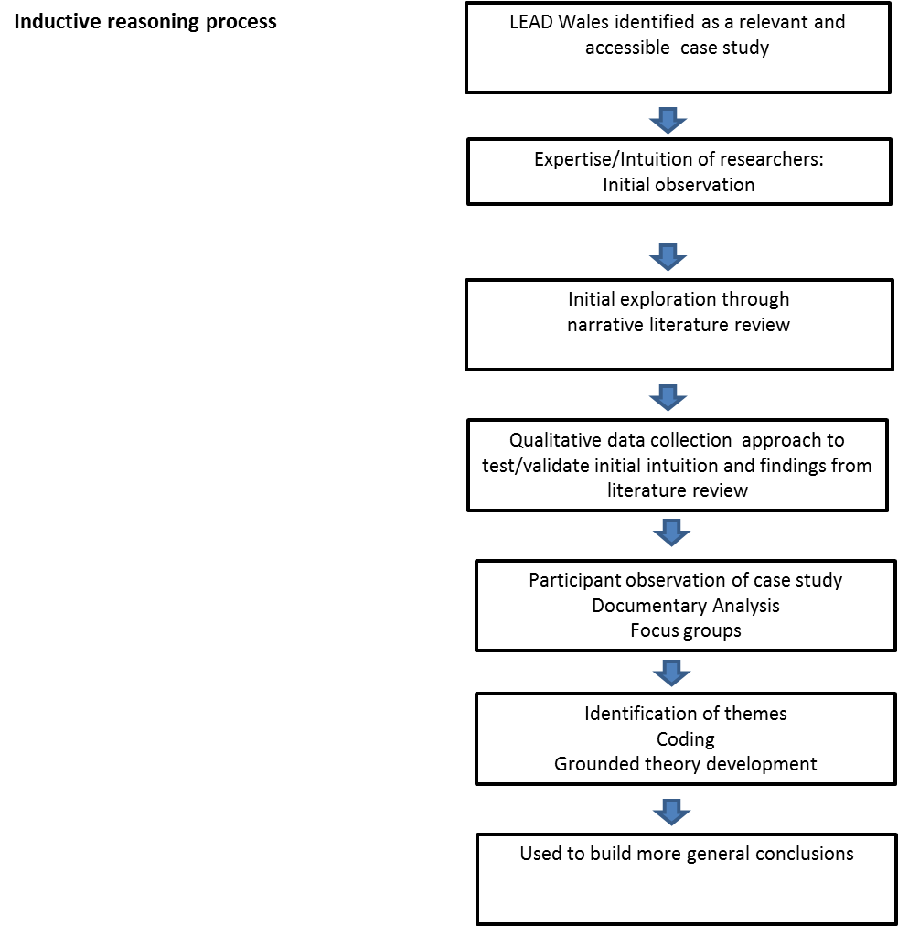
Figure 2. Inductive research approach (after Wheeldon & Ahlberg, 2013).

The study sample available at each phase of data collection is shown below:
 | Participant observation | Focus groups | Bibliometric data
Number in sample | 91 individuals in four cohorts | 27 individuals in seven groups | Data from 549 participants polled.
Ethnic background | 93.5% White 6.5% BME | 100% White | 89% White 11% BME
Gender ratio m:f | 60:40 | 50:50 | 60:40
Age range of participants | 21-68 | 24-59 | 21-72

The participants in the LEAD Wales programme are considered to be ‘self selecting’ as a survey sample because these individuals have already identified and accepted a development need (Jones et al, 2012). However, as part of an exploratory study into the field, these participants can be considered to be a valid representative sample of SME leaders in Wales who seek leadership development. The smaller samples were representative of the larger sample of 549 participants.

Data collection
Initial insights from observation and assessment of bias
This research was stimulated by observations made of individuals that had completed the learning and the way in which they described the experience in emotional as well as cognitive and professional terms. The initial observations were of current and past delegates and course facilitators. The researchers were motivated to consider the role of emotion in leadership development by the weight of anecdotal evidence which suggested that emotion was being actively used by facilitators to embed learning and to make the course content relevant to the learners, in this case entrepreneurial practitioners in leadership positions. Through a period of reflective analysis, the researchers questioned their assumptions and identified the inductive research approach in Figure 2 as appropriate to develop a theory for later hypothetico-deductive research.
Narrative literature review
The search brief was wide in order to encompass the conclusion implicit in Roomi and Harrison’s (2011): the multi-disciplinary nature of work that involves entrepreneurs. The literature review investigated whether this three-part intersection was already an established area of study and sought insight into the observations made in order to provide context and development for later data collection elements. The available literature showed that the subject “emotion in leadership development of entrepreneurs” had not been addressed. As a result the study sought insights by examining analogues of the actors and concepts involved i.e. education, leadership and emotion in the context of the entrepreneurial practitioner.
The initial literature review was undertaken to identify common themes relating to the role of emotion in entrepreneurship or leadership education for experienced leaders of SMEs. Searches within specialist metasearch engines were performed using all possible combinations of the key words ‘emotion’ ‘education’ ‘entrepreneu*’ and ‘leader*’. Analysis of abstracts from the first 25 papers returned from each search informed two further keyword searches for combinations of ‘emotion’ and ‘learning’ and/or ‘pedagog*’ as well as ‘leader*’ and ‘learning’ and/or ‘pedagog*’. The use of the wildcard symbol (*) allowed for the widest search as did use of databases from multiple disciplines including Google Scholar, Web of Science, JSTOR and EBSCO. Multi- and inter-disciplinary search engines were the prime source as the subjects under study had already been identified within the disciplines of business, psychology and education. Google Scholar provided access to working and conference papers that provided patterns of frequently used citations and directions of exploration in contemporary study albeit without peer review. Popular citations from relevant papers were examined until repetition of key themes or approaches from up to date references reached saturation point. Findings from the literature are included in the Table 1.
Participant observation
Data was sought through a programme of participant observation of four ‘cohorts’. Each cohort had between 20 and 24 adults between 22 and 60 years of age, a 60:40 split of men to women, and a mix of business types, business sizes and business aspirations. These diverse groups were representative of SMEs in the region, with the only factor common to all being the willingness to sign up to and attend a leadership development programme. Participant observation was undertaken during the initial three days of the two cohorts’ leadership development. Initial participant-observation took place between March and May 2013. The findings were refined during analysis of observation between May and June of the same year. Initial triangulation of the observation was undertaken using narrative literature review, information from focus groups and documentary analysis of feedback.
The participant observation activity involved the observer participating in activities as a delegate. The role and purpose of the participant observer was shared with the study population and participant observation activity was carefully monitored for Hawthorne type effects. By integrating fully with the cohort from their first interaction with the programme in the role of delegate, and by participating in the group from the outset during which trust and openness was established, the participant observer aimed to experience as well as observe activities in order to monitor potential for observer bias as well as impact on the behaviour of the observed delegates. Confirmation interviews with staff suggested delegate behaviours and responses represented a norm for groups of this type where no participant-observers were present.

Two further cohorts were observed using the same method over the next 12 months. Observations were documented through comprehensive note taking and a reflective journal kept by the participant-observer.
Assessment of historical data
Analysis of documentary evidence from questionnaires was undertaken to seek incidences of ‘emotion’ words or phrases. This approach assumes an idealistic approach in which perceptions of participants, and observer as a participant, are considered valid in providing insight into complex processes that occur during social and human events.
Prior to undertaking primary research with delegates, a search for incidences of emotion words (see Table 2) in previous research questionnaires was done to test for use of emotion words as a validator of the initial and participant observations of behaviour. This proved to be the case and documentary information for a total of 15 additional cohorts was analysed. These included written notes produced by delegates or facilitators from action learning sets, learning, reflection and masterclasses. Bibliometric analysis was completed for terms that can be considered indicators of emotional elements in the teaching, learning or practice of leadership, based on frequency and context of key words.
Focus groups
Focus groups were undertaken with 6 cohorts. Data was collected through recordings of group interviews. Focus groups contained between four and six individuals and lasted between 180 and 240 minutes. The groups were facilitated by the researcher who had working knowledge of the programme and venues attended by the participants. The focus groups took the form of open and frank discussions between delegates, lightly facilitated by the researcher to retain focus on the impact that the programme had upon them and as a result the changes that had been made in their enterprise.
Data was transcribed manually and written notes of body language taken by an observer used to further verify meaning. Both were included in NVivo and used to code outcomes.

Results and analysis
After initial observations in September 2013, observer’s journal was coded using a grounded theory approach. An initial list of codes (n=79) were divided into twelve categories (Table 1) of which ‘emotion’ was the category that contained the most individual codes and responses.
First phase – Coding categories identified from the initial observations prior to September 2013. | Number of codes
Emotion | 31
Elements of the programme | 11
Experiential learning | 2
Impetus (kick) | 4
Habits/behaviours | 2
How learning gets transferred into the business | 4
What did you learn? | 9
Trust | 4
Role of diverse members in groups | 4
Reflecting | 3
Culture/ values | 2

The observations relating to emotion were most numerous. Observations here related to behaviours and body language changing from what may be described as cautious, protective, shy or defensive to behaviours and attitudes that suggested trust, openness, generosity or sharing. Specific examples included change in behaviour observed between that on the morning of induction and that seen on the first day of the experiential sessions. During both exercises, participants were encouraged to share information about themselves. In the initial session participants were hesitant, however at the end of induction day and again at the end of the ‘overnight experiential’ participants were eager to share their thoughts.
This change in behaviour had been observed anecdotally by facilitators in the 12 sessions that they had participated in previously and appeared to result consistently from the teaching methods and content used.
Analysis of participant observation
The notes from the initial period of observation, undertaken over 24 hours for each cohort, were coded using the 32 emotion codes first identified in Phase 1. These were used to inform the development of theory relating to the role of emotion in this type of leadership development intervention with a group of experienced leaders in micro or small business enterprises. Subsequent to the initial theory development, a further two cohorts were observed. Findings from these observations led to no new codes and supported the belief that saturation had been reached and the original codes have remained unchanged for this study.
In recording the emotions observed and stated by the delegates, words that described emotions (happy, frustrated) and words that described the state of being emotional (‘I feel’, isolation, stress, anticipation), as well as words or phrases relating to constructs that have strongly emotional overtones, such as family and security were collected in the initial coding stage and these remained throughout the coding of emotions as they were all considered to be valid and distinct parts of the emotional self being observed.

Second phase – codes identified under the category ‘emotion’
Anticipation | Great/good/freeing/cathartic/fantastic/ super/amazing
Anxiety/anxious | Happy/happiness/joy
Apprehensive | Hope
Boredom | I feel/ i felt
Bouncing/full of beans | Let go
Care | Love
Comfortable | Nervous
Confidence | Passion
Content/ed | Relax
Emoti* | Relief
Excited | Security
Family | Stress
Fear/terrified etc | Terrible/awful/horrible/hated it
Freedom | Trepidation
Frustrat* ed/ion/ing | Uncomfortable
Fun | Using/coping with emotion in the enterprise

Participant observations from the experiential sessions provided notes rich in incidences of emotion. In initial activities, while describing their companies, or their relationship to their companies, the majority of participants used expressive words that were both emotive and suggested an emotional rather than rational link to their businesses and their personal development. The types of emotion observed were diverse and covered almost the full gamut of emotions described by various authors, but most simply in Plutchik’s (1980) Wheel of Emotions. Most prevalent were the codes where delegates reported ‘feeling’ and ‘emotion’. Clear incidences of the words frustration, isolation, (seeking) happiness and confidence occurred in each cohort of participants, with lack of confidence, or the need to regain confidence being the most prevalent single emotion reported.
Two types of emotional state change were identified in participants. The ‘simple’ change which is expected as a result of any engaging learning environment: from trepidation, anxiety, boredom, disgruntlement or anticipation to relief, buoyancy or happiness as a result of completing the activity. The more complex changes were specific to, and intended as a result of, emotive stimuli – these were occasionally ‘positive’, such as excitement, passion or optimism; however many included negative emotions such as anger, frustration or shame. The observed aim of these activities were to bring to the surface emotional states (in themselves or observing others) that are known to lead to extended behaviours in the workplace and to provide a safe environment in which to reflect upon, discuss and be taught models for coping with them.
Fear of failure appeared to be a driving force for many of these entrepreneurs. For many, their business was their first attempt at entrepreneurship, they had been involved since start up and so they had limited experience of business failure but expressed a deep seated urge to avoid it. Not just because the business was their main source of income but apparently because it was linked so completely to their sense of personal achievement and self-identity.
Participants’ stated reasons for joining the programme included facing a change that required a new approach or adjustment in order to avoid ‘failure’. These changes were often described as journeys or barriers and were associated with feelings of lack of confidence that were linked to the entrepreneur’s self-identity. Phrases like ‘I knew what I was doing when it was just two of us’, ‘I don’t feel like a leader, but I have people that follow me’ and ‘I feel like a fraud’ were typical of conversations between participants that display that lack of confidence. Conversations held with participants during participant observation confirmed that the delegates were emotionally, as well as financially, attached to their businesses. The entrepreneurs felt personally responsible for their organisations and identified the success or otherwise of that organisation as their own personal achievement. Anecdotally, this lack of confidence was often more difficult for those who had previous experience in leadership roles in corporate or public sector organisations. The phrase ‘without a safety net’ was used by one participant to describe the difference between the corporate world and that of the entrepreneur and solicited agreement from the other participants in that cohort.
The second day of the experiential activity contains two emotive and potentially frustrating activities. On all occasions observed a proportion of participants stated that they were ‘drained’ or complained of headaches or did not join with the other members during the lunch that followed.
No participants complained or made negative comments specifically about the content, however participants in both observed cohorts stated later on that they were feeling upset or still felt ‘shaken up’ as a result of the activities. Some participants stated these feelings even though they had not been directly targeted by the activities to act in an overextended way. Observing the turmoil that affected their peers appeared to be emotive in its own right.
A key finding was that participants had accepted that they were being manipulated into these emotive situations and activities in order to learn something. Their continued willingness to participate in plenary and discussion sessions after these difficult or frustrating activities suggests that they were at least curious about the outcomes and at most they trusted the facilitators to guide them towards useful outcomes.
Bibliometric analysis
Open responses to questionnaires completed after the programme were measured using a descriptive frequency analysis. Incidences of repeated words were first noted using the online ‘word cloud’ software ‘Wordle’. This tool, a free online graphic generating tool utilises an algorithm which assigns word counts to text and displays it graphically where the 100 most frequently used words are displayed, with larger size representing comparative frequency. A corrected version of the word cloud with the words ‘and’ ‘they’ ‘the’ and ‘you’ removed is included below in Figure 3. This tool was used in lieu of access to more expensive bibliometric software. Although requiring some significant interpretation as a research tool on its own, this graphic provided an indication of the relative word count of key words in relation to others used by the respondents as they exited from the programme.
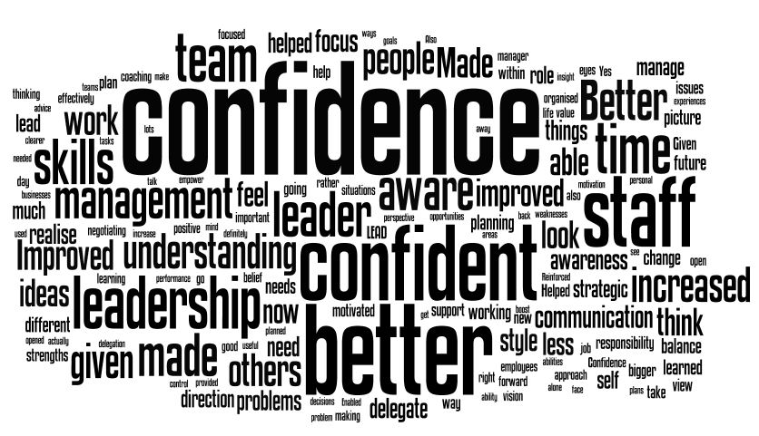
Figure 3. Word cloud generated from open responses to the question ‘how do you feel that participation in LEAD Wales has affected you as a business leader?”
Used independently, the meaning gained from this type of graphic bibliometric is limited; confident or confidence could be positive or negative, and other key words such as ‘leader’, ‘leadership’, ‘delegate’, ‘negotiate’, ‘staff’, ‘management’ and ‘time’ are all objective terms used to describe the delegate’s role or workplace and to be expected in reporting against the contribution of a leadership programme. However, graphic bibliometrics like this can be used to pick out the unexpected – in this case the use of the words ‘aware’ and ‘awareness’ which suggested that reflection was significant and novel enough to mention.
Focus group analysis
Transcripts from the Focus Groups were used to further test themes identified in the Participant Observation. This activity added no new themes – however the discussion turned up some specific findings relating to the use of emotion in learning. The following transcript extracts add weight to the research premise:
(Delegate A) The emotional side of it actually drives home the learning. You can sit down and you can read a text book, and you can learn all about theories [pause] if you’ve got an emotional element as well it really drives home the learning I think.
(Delegate B) You always remember your first driving lesson, or the first time you crashed your car. It’s such an intense experience that you remember it, and we all remember doing the [overnight experiential]. If someone said ‘oh, do you remember what text book you read at university to get your first exam?..’ I haven’t got a clue! But I remember the overnight. It’s the emotional element that really makes it stick in your head.
(Delegate C) It’s the vocational aspect of learning, as in hands on. Because I think it’s probably to do with the game connection, because you are doing it, it’s going to stick.
(Delegate D) With emotion there’s an element of fear factor for a start. Because you’re with a group of new people, you haven’t met them long, you’re doing something for example blindfolded, in relationship to that. The trust factor is quite... you’re up there, aren’t you? Not wanting to fail, and so there’s that element of risk, creates the anticipation of – did I, or did I not fail, pass or whatever the case may be and that’s what breaks the barriers down in the group so that you can then rely on each other quite quickly, cos you’ve got to, and you can do that. I think that was achieved very, very quickly on the two days that we had.
(Delegate A) I hated some of the exercises! I just thought ‘what am I doing here?’ but then it was afterwards, once you had done the exercise and then they explained, right – what have you learnt? Then you go ‘well actually, that makes sense’.
Emotion was a valid part of the learning for the delegates. In every group, activities and the associated emotions were still vividly remembered as well as reflections upon them.

Theory development
Utilising the findings from the various stages of research into the participants provides some key aspects of this theory development.
The study of emotion in itself can be undertaken from social, behavioural, neuro-scientific or psychological stances, but is appears from the literature that considering emotion in leadership development for entrepreneurs is best addressed from a multi-disciplinary standpoint. Added to this the comparatively small amount of research undertaken outside of business/management field into the way that entrepreneurs learn, further focussed on how it appears impactful for them to develop leadership skills leads to only one reasonable conclusion. That a starting point is required from which various branches of research can flow.
Observations of delegates learning suggested that the participants were both familiar and comfortable describing their personal entrepreneurship utilising emotional terms – particularly relating to their feelings of self-confidence and their sense of self. The observations evidenced that SME leaders were comfortable using this vocabulary and sharing their feelings with others in the learning environment, making it a valid method for more general use. The apparent effectiveness of the learning method in a relatively short period of time supported this.
Data from the participant observation and focus groups suggested that the reasons that the words aware and awareness being so prevalent in the bibliometric analysis at the end of the programme could be related to the design and intentions of the experiential sessions: The experiential sessions included various activities and role plays that resembled typical team building or developmental games or exercises but that also were designed to provide immediate behaviours and actions to reflect upon and importantly to plan strategies to cope with.
The focus groups provided little new data to the examination of emotion in the leadership development programme but did suggest a surprising awareness of the role of the experiential learning preparing for further learning. Focus group members found that these sessions were instantly memorable and provided a motivation for later, more didactic, learning and adoption of new behaviours and leadership strategies.
When asked to reflect on their learning experience, participants in their feedback described these sessions as ‘cathartic’ ‘group therapy’ or simply ‘I’m not alone any more’. These are words that might more usually be associated with coaching (which plays a role later in the programme), mentoring or therapy than business or leadership development described in corporate organisational theory.

Synthesis
Contrary to expectation, the experiential pedagogies observed in the study were used to encourage ‘overextended’ behaviours in participants that would normally only be seen when the participant was under stress in their role as leader. These sessions were interspersed with discussions and plenary sessions led by facilitators as well as opportunities for private or group reflection. This approach provided a rare opportunity for them to stand outside themselves and reflect upon their default or extended behaviours and those of others. The results of the study show that the experiential methods include the concept of emotional as well as objective or cognitive learning. The participant observation and later focus group verification showed that the experiential activities evoked an emotional response. The frequency of emotion words used by participants describing and discussing these activities suggests that they are effective in doing so for most.
Participant acceptance of being placed into emotive experiential situations appears to be the start of a journey towards greater awareness. When considered with the observed and stated improvements in confidence a link is implied between being made more aware of themselves and the participants’ thoughts about their leadership. Further, the delegates suggested that behavioural changes stimulated by the programme continued beyond the learning environment into the workplace,
The research question initially posed was “What are the merits of including emotion as a factor in leadership development for the leaders of SMEs in the UK?”
The theory put forward is that when emotion is an explicit element in pedagogies for leadership learning by entrepreneurs it leads to learning being retained and used in the workplace more effectively. This ‘fourth interface’ is believed to be relevant in the life world of the entrepreneur because of the emotional attachment and sense of self identify that the entrepreneur associates with their role as leader of a business.
Research into the field of entrepreneurs and entrepreneurship can be described as an almost completed jigsaw puzzle, with the gaps clearly defined by the pieces already in place. This is not true of the interface of emotion and leadership – this study suggests that there are pieces in another box that has yet to be opened.

Practical implications
Improvements in leadership have been consistently linked to improvements in firm performance. Bringing new insights that lead to more effective learning and constructive behaviour changes in the leaders of SMEs and their employees could have profound positive impacts on entrepreneurial economies. The LEAD Wales programme, as well as other similar programmes, provides evidence that support this, however the evidence presented here is a starting point to create more effective leadership learning paradigms, not an answer.

Study limitations and future research
This type of ‘opportunistic’ research is limited for a number of reasons (Creswell and Plano-Clarke, 2007; Stake, 1995) in that it is biased by the willingness of the observed sample to participate in the research and in the type, format and availability of data. However, the results are considered to be meaningful in the context of a social constructivist research philosophy and in providing insights suitable for theory development. Further study is needed to confirm how general the findings of this study are to a wider population.

A second area for future research is suggested using a psychological as well as cognitive approach to study the emotions experienced by entrepreneurs during emotive experiential learning. This will require open and honest contribution of a number of individual participants as well as a multi-disciplinary approach by a team of researchers in order to do the findings justice.
A third area relates to Identity construction in entrepreneurs. While this is a well established field of study, the emotions perspective is itself in its infancy (Markowska et al, 2015) and requires further study. Including this concept in future research would provide a more complete picture of the true life world of the entrepreneur.

References
Adair, J. (2009), How to Grow Leaders: the seven key principles of effective leadership development, 2nd Edition, Kogan Page, London.
Argyris, C. (2002), Double-Loop Learning, Teaching, and Research. Academy of Management Learning and Education, Vol 1, No. 2, pp206-218.
Bagheri, A. and Lope Pihie, Z. A. (2013), Role of University Entrepreneurship Programs in Developing Students’ Entrepreneurial Leadership Competencies: Perspectives From Malaysian Undergraduate Students. Journal of Education for Business, Vol 88, pp. 51-61.
Bolden, R. (2001), Leadership Development in Small and Medium Sized Enterprises, Centre for Leadership Studies, University of Exeter.
Buller, P. F. and Finkle, T. A. (2013), The Hogan Entrepreneurial Leadership Program: An innovative model of entrepreneurship education. Journal of Entrepreneurship Education, Vol 16, pp. 113.
Burns, J. M. (1978), Leadership, Harper and Row, New York.
Busenitz, L. W. (1999), "Entrepreneurial risk and strategic decision making it’sa matter of perspective." The Journal of Applied Behavioral Science, Vol 35, No 3, pp 325-340.
Busenitz, L. W. and J. B. Barney (1997), "Differences between entrepreneurs and managers in large organizations: Biases and heuristics in strategic decision-making." Journal of business venturing, Vol 12, No 1, pp 9-30.
Butler, C. and Chinowsky, P. (2006), “Emotional Intelligence and leadership behaviour in construction executives”, Journal of Management in Engineering, Vol. 22, No 3, pp.119-125.
Cook, T.D. and Campbell, D.T. (1979), "Chapter 2: Validity", in Cook, T.D. and Campbell, D.T. (Eds.), Quasi-Experimentation: Design and Analysis Issues in a Field Setting, Rand McNally, Chicago, pp.37-94.
Cope, J. (2011), “Entrepreneurial learning from failure: An interpretative phenomenological analysis”, Journal of Business Venturing, Vol. 26, No 6, pp. 60–62.
Cope, J. and Watts, G. (2000), “Learning by doing – an exploration of experience, critical incidents and reflection in entrepreneurial learning”, IJEBR, Vol. 6, No. 3, pp.104-124.
Creswell, J. W. and Plano Clark, V. L. (2007), Designing and conducting mixed methods research, SAGE Publications Inc.
Denzin, N.K. (1984), On understanding emotion, Jossey-Bass Inc, California.
Department for Business, Innovation and Skills Leadership and Management Network Group (LMNG) (2012) Leadership and Management in the UK: the key to sustainable growth. A summary of the evidence for the value of investing in leadership and management development, Ref: 12/923. UK Government. July 2012.
Gardner, H. (1983), Frames of Mind. Basic Books, Philadelphia.
Gibb, A.A (1984), “Developing the Role and Capability of the Small Business Adviser” Leadership and Organisation Development Journal, Vol. 5, No. 2, pp.19-27.
Gibb, A.A. (1987), “Education for Enterprise: Training for Small Business Initiation - Some Contrasts”, Journal of Small Business and Entrepreneurship, Vol. 4, No. 3, pp. 42-47.
Gibb, A.A and Ritchie, J. (1982), “Understanding the Process of Starting Small Businesses”, International Small Business Journal. Vol.1, No. 1, pp. 26-45.
Gibb, A. and Scott, M. (1985), “Strategic Awareness, personal commitment and the process of planning in the Small Business”, Journal of Management Studies, Vol. 22, No. 6, pp. 597-631.
Goleman, D. and Mckee, A. (2002) The new leaders: Transforming the art of leadership into the science of results. Little Brown, London.
Hancock, B., Hmieleski, K. and Smilor, R. (2014), Honoring the entrepreneurial journey: a strengths-based approach to the undergraduate entrepreneurship program at TCU. Annals of Entrepreneurship Education and Pedagogy, 2014, pp. 332.
Hayton, J. (2015), Leadership and Management Skills in Small and medium sized business: BIS research paper 211 (non-technical report), Department for Business Innovation and Skills.
Hayton, J. (2015) Leadership and Management Skills in Small and medium sized business: BIS research paper 224 (technical report), Department for Business Innovation and Skills.
Hebert, R.F. and Link, A.N. (1989), “In search of the meaning of entrepreneurship”, Small Business Economics, Vol. 1, No. 1, pp. 39-49.
Henley, A. and Norbury, H. (2011), “An intervention to raise leadership effectiveness among SME owner-managers in Wales: an initial assessment”, Entrepreneurship and Innovation, Vol. 12, No. 4, pp. 283-295.
Hooper Greenhill, E. (2004), “Measuring Learning Outcomes in Museums, Archives and Libraries: The Learning Impact Research Project (LIRP)”, International Journal of Heritage Studies, Vol. 10, No. 2, pp. 151-174.
Huxtable-Thomas, L.A., Hannon, P.D. and Thomas, S.W. (2015) ‘Using a Mixed Method ‘Petri-Dish’ diagram to determine complex impacts of leadership development in extant entrepreneurs’, in Proceedings of the 14th European Conference on Research Methodology for Business and Management Studies, ed Bezzina, F. and Cassar,V, ACPI, UK, pp 218-224.
IfM Education and Consultancy Services Ltd (2010), Stimulating growth and employment in the UK economy. Lessons from practical engagement with industry: A new priority and approach for direct business support for manufacturing SMEs, IfM ECS, Cambridge.
Jones, K., Henley, A., Sambrook, S. and Norbury, H. (2013), “Learning to Lead for Business Growth: Implications for Supporting SMEs in Wales”, Contemporary Wales, Vol. 26, pp. 1-23.
Jones, K., Sambrook. S., Pittaway, L., Henley, A., and Norbury, H. (accepted, forthcoming) “Action Learning: How Learning Transfers from Entrepreneurs to Small Firms”, Action Learning: Research and Practice, In press.
Jones, K., Sambrook, S., Henley, A. and Norbury, H. (2012), “Higher Education Engagement in Leadership Development: Using Autobiographical Narrative to Understand Potential Impact”, Journal of Industry and Higher Education, Vol. 26, No. 6, pp. 461–472.
Kahneman, D. (2012), Thinking, fast and slow, Allen Lane, London.
Kempster, S. (2009), How managers have learnt to lead, Palgrave Macmillan, Hampshire, UK.
Kempster, S. & Cope, J. (2010), “Entrepreneurs' and managers' leadership roles compared: Context is what matters. What a person does trumps who they are”, Development and Learning in Organizations: An International Journal, Vol. 24, No. 4, pp. 30-32.
Kempster, S. & Watts, G. (2002), “The entrepreneur as leader: an exploration of leadership development among small business owner-managers”, paper presented at ISBA National Conference, November 2002, Brighton, UK.
Kolb, D.A. (1984), Experiential learning: experience as the source of learning and development. Prentice Hall, New Jersey.
Kotter, J. (1990), “What Leaders Really Do”, Harvard Business Review, Vol. 68, No. 3, pp. 103-112.
Kuratko, D.F. (2009), Entrepreneurship: Theory, Process, Practice, South-Western Cengage Learning, Ohio.
Lackeus, M. (2012), “Emotions in Entrepreneurial Education: A literature review”, Paper presented at Institute for Small Business and Entrepreneurship Annual conference, Dublin, 2012.
Markowska, M., Härtel, C.E.J., Brundin, E. and Roan, A. (2015), A Dynamic Model of Entrepreneurial Identification and Dis-Identification: An Emotions Perspective, in Härtel, C.E.J., Zerbe, W.K. and Ashkanasy, N.M. (ed.) New Ways of Studying Emotions in Organizations (Research on Emotion in Organizations, Volume 11) Emerald Group Publishing Limited, pp.215 – 239.
NESTA (2009), The vital 6 per cent. How high-growth innovative businesses generate prosperity and jobs, NESTA, London.
Northouse, P.G. (2012), Leadership: Theory and Practice, Sage Publications, USA.
Payne, W. L. (1985), A study of emotion: Developing Emotional Intelligence, Self Integration, Relating to Fear, Pain and Desire (Theory, Structure of Reality, Problem-Solving, Contraction/Expansion, Tuning in/Coming Out/Letting Go), Union for Experimenting Colleges and Universities.
Peters, S. (2010), “Where does the learning take place? Learning spaces and the situated curriculum within networked learning”, in Dirckinck-Holmfield, L., Hodgson, V., Jones, C, de Laat, M., McConnell, D. and Ryberg, T. (Ed), Proceedings of the 7th International Conference on Networked Learning.
Pittaway, L. And Cope, J. (2007), “Entrepreneurship Education: a systematic review of the evidence”, International Small Business Journal, Vol. 25, No. 5, pp. 479-510.
Pittaway, L. and Rose, M. (2006), “Learning and Relationships in Small Firms”, International Small Business Journal, Vol. 24, No. 3, pp. 227-231.
Pittway, L., Huxtable-Thomas, L.A., and Hannon, P.D. (in press) Entrepreneurial Learning and Entrepreneurial Practice. In: The Sage Handbook of Entrepreneurship and Small Business. Sage, New York.
Plutchik, R. (1980), Emotion: a psychoevolutionary synthesis, Harpercollins College Division.
Quince, T. (2001), Entrepreneurial Collaboration: Terms of Endearment or Rules of Engagement? Working Paper 207, ESRC Centre For Business Research, University of Cambridge.
Rae, D. (1999), The entrepreneurial spirit. Learning to unlock the value, Blackhall, Ireland.
Roomi, M.A and Harrison, P. (2011), “Entrepreneurial Leadership: What is it and how should it be taught?” International Review of Entrepreneurship, Vol. 9, No. 3, pp. 1-44.
Rost, J. (2000), “Leadership Education in Colleges: Toward a 21st Century Paradigm”. Journal of Leadership & Organizational Studies, Vol. 7, No. 1, pp. 1-3.
Shane, S.A. (2003), A General Theory of Entrepreneurship: The Individual-opportunity nexus. Edward Elgar Publishing, UK.
Shepherd, D. A. (2003), “Learning from Business Failure: Propositions for grief recovery for the self-employed”, Academy of Management Review, Vol. 28, No. 2, pp. 318-328.
Shepherd, D. A. (2004), “Educating Entrepreneurship Students about Emotion and Learning from Failure”, Academy of Management Learning & Education, Vol. 3, No. 3, pp. 274-287.
Soriano, D.R. and Martínez, J.M.C. (2007), “Transmitting the entrepreneurial spirit to the work team in SMEs: the importance of leadership”, Management Decision, Vol. 45, No. 7, pp.1102–1122.
Spence, K.W. & Spence, J.T. (1967), The psychology of learning and motivation: Advances in research and theory, Academic Press, New York.
Stake, R. E. (1995), The Art of Case Study Research, Sage, Thousand Oaks, California.
Thorpe, R., Cope, J., Ram, M. and Pedler, M. (2009), “Leadership Development in small- and medium-sized enterprises: the case for action learning”, Action Learning: Research and Practice, Vol. 6, No. 3, pp. 201-208.
Upton, N.B., Sexton, D.L. and Moore, C. (1995), “Have we made a difference? an examination of career activity of entrepreneurship majors since 1981”, Frontiers of Research, paper presented at Babson College-Kauffman Foundation Entrepreneurship Research Conference.
Vail, P. L. (1994), Emotion: The On/Off Switch for Learning. Modern Learning Press.
Walker, E., Redmond, J., Webster, B., and Le Clus, M. (2007), “Small business owners: too busy to train?”, Journal of Small Business and Enterprise Development, Vol. 14, No. 2, pp. 294–306.
Weiner, B. (1985), “An attributional theory of achievement motivation and emotion”, Psychological Review, Vol. 92, No. 4, pp. 548-573.
Welch, J. and L. Bussey (2014). Leadership dispositions and the measurement gap: A literature review. AERA Annual Conference, Philadelphia, PA.
Welsh Assembly Government (2008) Skills that Work for Wales: A skills and employment strategy and action plan. Department for Children, Education and Lifelong Learning and skills.
Wennekers, S. and Thurik, R. (1999), “Linking entrepreneurship and economic growth”, Small Business Economics, Vol. 13, No. 1, pp. 27–56.
Wheeldon, J. and Åhlberg, M.K. (2012) Visualising Social Science Research: Maps, Methods & Meaning, Sage, London.

Hawthorne effects are used in this instance to describe the phenomenon in social and qualitative research of the impact that being observed can have on the observed group or individual. While subsequent assessment of the original Hawthorne studies criticise the findings of that particular study, ‘Hawthorne effects’ has become short hand for behavioural change in whole or in part as a result of being observed.

